Background
During 2019/20 East Gippsland Catchment Management Authority (EGCMA) and Victoria State Emergency Services (VICSES) initiated two research projects.
The aim of these research projects was to create a tool to better support the East Gippsland communities with flood intelligence and accurate flood products to ensure that those communities who may become flood affected receive more timely, tailored and relevant information.

Flood Class Level Review Project:
A review of existing flood class and historic water levels was performed for streamflow gauging stations across catchments in East Gippsland, these included Tambo, Snowy, Mitchell, Cann, Bemm, Genoa, Buchan, Dargo Rivers.

This review was completed in line with the key objectives of the 2017 East Gippsland Floodplain Management Strategy to “Review flood class levels at all East Gippsland river gauge locations, advise Bureau of Meteorology (The Bureau) of new levels, include in the Municipal Flood Emergency Plans (MFEP) and ensure extensive community consultation”

The project review was completed by Water Technology at the request of East Gippsland Catchment Management Authority (EGCMA) in February 2020.

East Gippsland Flood Intelligence and Mapping Project
Water Technology was commissioned by the Victoria State Emergency Services (VICSES) to review and provide flood mapping and intelligence to inform the Municipal Flood Emergency Plan (MFEP) and Local Flood Guides (LFG’s) for associated townships fall under the Flood Class Level review within East Gippsland. These townships included: Swift’s Creek, Orbost, Bairnsdale, Cann River, Bemm River, Genoa, Buchan and Dargo.

Specified outputs were in line with identified objectives from the 2017 East Gippsland Floodplain Management Strategy (EGFMS) to “Prepare LFG’s to build and maintain community resilience in priority locations and extract flood intelligence and update MFEPs”.

This data review documents key items of intelligence from three major flood studies completed over the last five years for the Mitchell, Tambo and Snowy rivers along with other research conducted especially for the high-risk communities identify.

Consultation
VICSES, EGCMA and East Gippsland Shire Council (EGSC) are committed to providing East Gippsland communities with tailored and relevant information to bolster community resilience before, during and after flood and storm events.
Community consultation is a vital step for each of the above mentioned projects, as the feedback will assist accuracy, community involvement and support for final products e.g. validating changes to existing flood class levels, and the development of new FCL’s in areas where there is no flood mapping data.
Community engagement may also help to avoid any confusion that could occur during future floods when the new FCL’s are actioned for the first time. The draft Local Flood Guides were presented and discussed with these key groups and flood mapping (completed by Water Technology) was reviewed against their lived experience.
Knowledgeable key community members were contacted and asked to take part in targeted community meetings in 2022. Agency staff also attended home visits and one on one conversations with some attendees to discuss their experience with flood in their region.

Collaboration
Stage one of these projects are now finalising and the below changes have now gone into place with the Bureau adopting the recommendations and all future forecasting being inline with the below table:
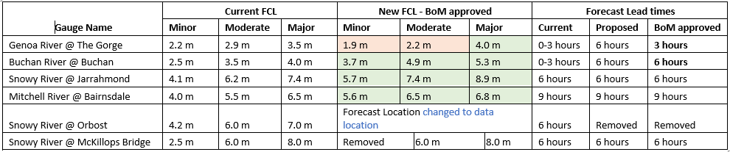
EGCMA, VICSES, The Bureau and EGSC are joining forces for the community rollout phase, for these identified projects.

Communicate/Inform
Following community consultation, engagement with the East Gippsland communities was initiated via the following methods:
- Media release, published by James Yeates Media – across Bairnsdale Advertiser, Snowy River Mail and Lakes Post, introducing the projects at hand, what this means to the East Gippsland communities and inviting interested parties to contact us via floodinginfo@ses.vic.gov.au
Finalisation and rollout of the Supporting Resilience products will be distributed to communities through the following channels:

Print Media and Publications

Print Media Outlets – Development of a media release for each project, summarising the FCL Review Project and the East Gippsland Flood Intelligence and Mapping Project with relating outputs/products.

Social media – Design of social media tiles for each community including “before” and “now” FCL’s

Publish tiles on SES East Region, EGCMA and East Region Unit pages relating community pages, tagging key agencies including: Local Councils, CFA, FRV, FFMV, DELWP, VicPol, AV, Red Cross, VicRoads, Volunteering Victoria networks

Radio Broadcasting - Collaboration with ABC Gippsland, ACE Radio and REGFM.

Radio interview - explanation of the project outputs, communities involved and key messages.

Television – Invitation to regional news teams for news segment. Synopsis and interview.

Website - Project summary with related product links to be published on VicSES website.

Related Links
Local Flood Guides https://www.ses.vic.gov.au/plan-and-stay-safe/flood-guides/east-gippsland-shire-council
Bureau of Meteorology: http://www.bom.gov.au/
Victoria State Emergency Service Webpage: https://www.ses.vic.gov.au/

