Dadswells Bridge
Local Flood Guide
Flood information for the Mt William Creek at Dadswells Bridge




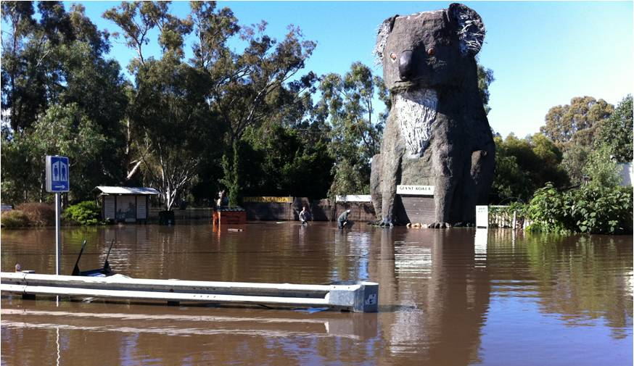
Dadswells Bridge
For flood emergency help call
VICSES on 132 500

The Big Koala at Dadswells Bridge, January 2011

Dadswells Bridge
Dadswells Bridge is located in western Victoria in the Horsham Rural City Council and Northern Grampians Shire Council, to the north of the Grampian National Park. The map below shows the flood extent of the January 2011 event in Dadswells Bridge, which measured 2.65 metres on the Lake Lonsdale stream gauge.
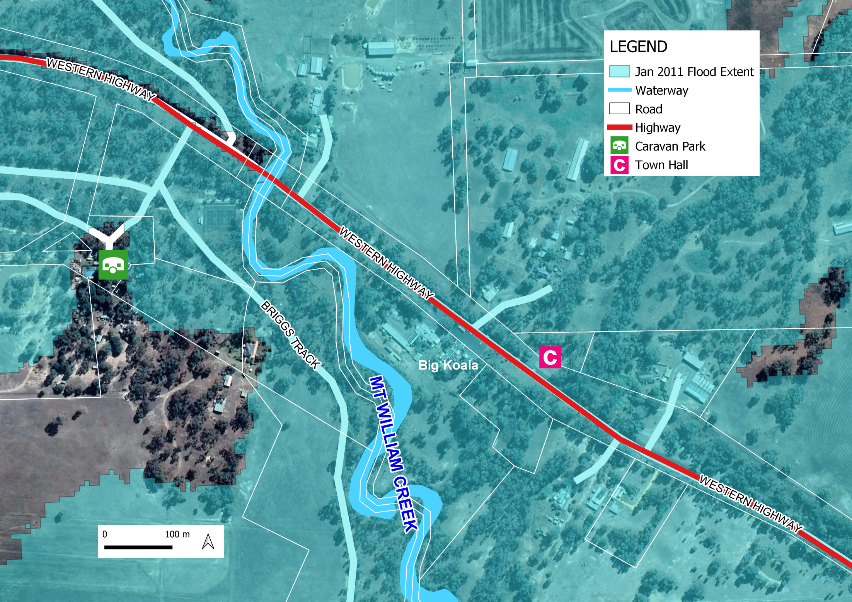Disclaimer: this map by Victoria State Emergency Service for the purpose of disseminating emergency management information. The contents of the information has not been independently verified by Victoria State Emergency Service. No liability is accepted for any damage or loss caused by errors in this information. Flood risk information is provided by the Wimmera Catchment Management Authority.
Are you at risk of flooding?
Mt William Creek drains the eastern ranges of the Grampians National Park and flows north from Mt William towards Dadswells Bridge. Flooding can take 1 to 3 days to arrive in Dadswells Bridge from the start of heavy rainfall in the upper Mt William catchment. Most of the floodwater from Mt William Creek flows into Lake Lonsdale.
During flood events Lake Lonsdale often spills into Mt William Creek, causing significant flood impacts downstream at Dadswells Bridge. Flooding may take 8 to 12 hours to arrive in Dadswells Bridge from spills in Lake Lonsdale. The size of the flood event at Dadswells Bridge is dependent on rainfall and level of Lake Lonsdale prior to a flood event. Current Lake Lonsdale levels can be found at the GWMWater website storagemanager.com.au/reservoir-levels-and-other-information/
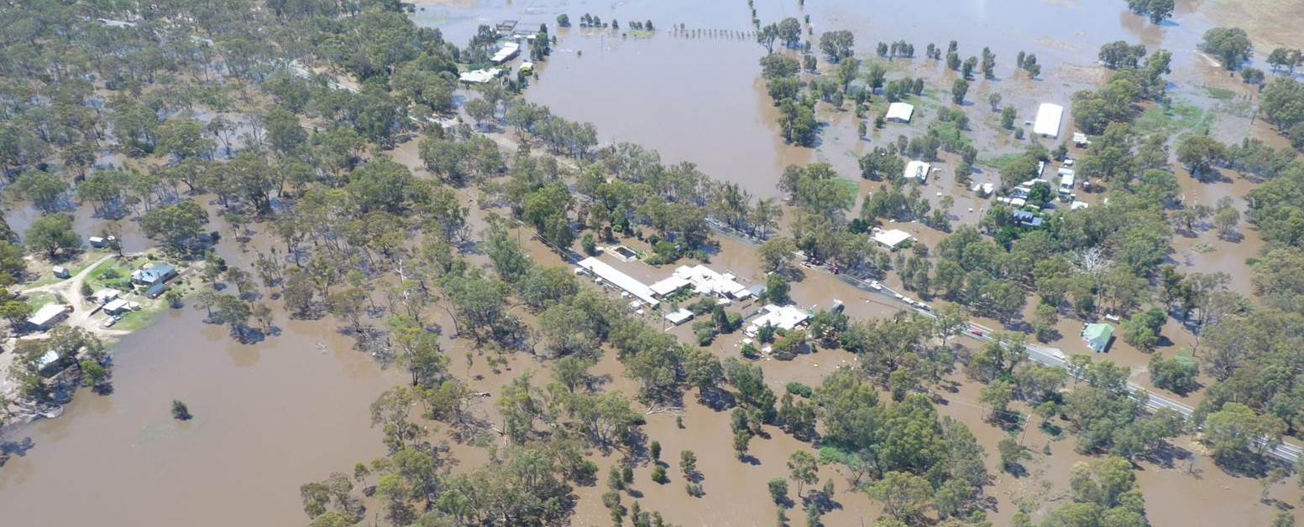

Flooding at Dadswells Bridge during the January 2011 flood.

Lake Lonsdale
Lake Lonsdale is a large shallow lake located on the Mt William Creek, 20km upstream of Dadswells Bridge. Lake Lonsdale plays a significant role in supplying environmental water and is highly valued for its recreational use. When full Lake Lansdale has a storage capacity of 65,480 ML. Lake Lonsdale has a long history of spilling into Mt William Creek, flooding Dadswells Bridge.
The January 2011 flood event was the largest event on record. During January 2011 Lake Lonsdale’s peak spill was 38,527 ML/day for several days. This spill caused significant flooding at Dadswells Bridge, flooding houses, cutting access to the Western Highway in several places, having significant impacts on local businesses. The Lake Lonsdale stream gauge downstream of Lake Lonsdale is used to monitor flood flows into Mt William Creek. It is important to note that this stream gauge has a low level of accuracy.
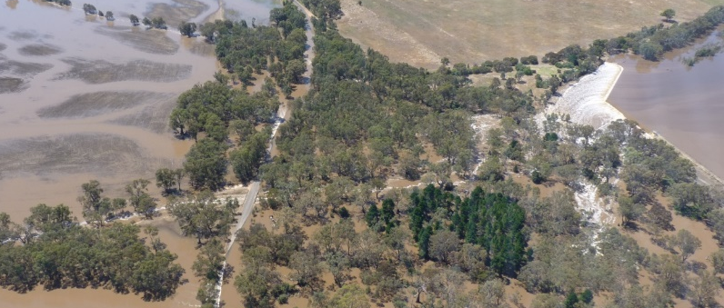

Lake Lonsdale spilling during January 2011 flood event.

Did you know?
Dadswells Bridge has a history of flooding, significant flood events have occurred in 1911, 1912, 1922, 1956, 1957, 1974, 1975, 1990, 1993, 2010 and 2011. In January, 2011, Dadswells Bridge experienced its largest ever flood when Mt William received 279 millimetres of rainfall over four days, with 146 millimetres falling on the 14th of January.
- It took more than 2 days for floodwater in Mt William Creek to travel from Mt William to Dadswells Bridge.
- The Western Highway was closed at Dadswells Bridge for more than 2 days.
- More than nine buildings were inundated above floor, including the Town Hall, Indian Restaurant, the Big Koala, Koala Motel, Dadswells Bridge Caravan Park, Turkey Farm buildings, and several houses.
- The Lake Lonsdale stream gauge peak (highest recorded level) was 2.65 metres.

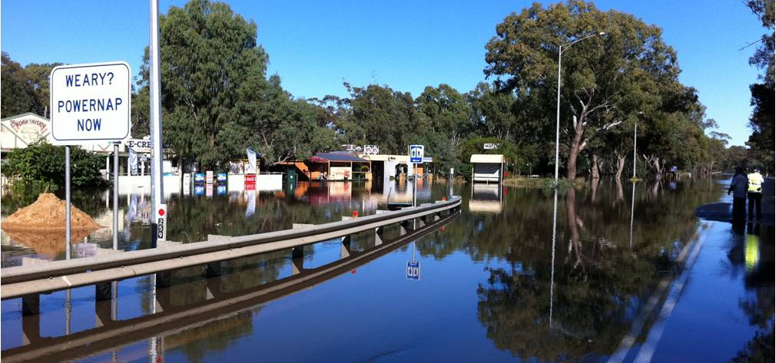

Flooding at Dadswells Bridge during the January 2011 flood.

Staying Informed and Further Information

- Current warnings (VicEmergency) emergency.vic.gov.au 1800 226 226
- Bureau of Meteorology (BoM) bom.gov.au/vic/warnings 1300 659 217
- VicRoads Traffic traffic.vicroads.vic.gov.au
- Emergency Broadcasters ABC 594 AM
Mixx 101.3 FM
- VICSES Social Media facebook.com/vicses
twitter.com/vicsesnews
- Preparing for Flood Emergencies ses.vic.gov.au/get-ready
- Creating an Emergency Plan redcross.org.au/prepare
- Catchment Management Authority https://wcma.vic.gov.au/ (03) 5382 1544
- Horsham Rural City Council https://www.hrcc.vic.gov.au/Home (03) 5355 0200
- Northern Grampians Shire Council https://www.ngshire.vic.gov.au/Home (03) 5358 8700
- National Relay Service (NRS) relayservice.gov.au
Life-threatening Emergency
000

Mt William Creek flood levels at Dadswells Bridge
Dadswells Bridge generally floods due to heavy rainfall upstream, surrounding Mt William and the eastern ranges of the Grampians National Park.
There are two rainfall/river stream gauges within the Dadswells Bridge area, these include:
- Rainfall gauge located at Mt William, Grampians National Park
- River height on Mt William Creek, downstream of Lake Lonsdale

Monitoring these rainfall and stream gauges will provide early clues of possible flooding. The Bureau of Meteorology (BoM) does not issue river height predictions for Dadswells Bridge. To monitor the Dadswells Bridge flood risk refer to the Lake Lonsdale stream gauge height go to the BoM website bom.gov.au/vic/flood/

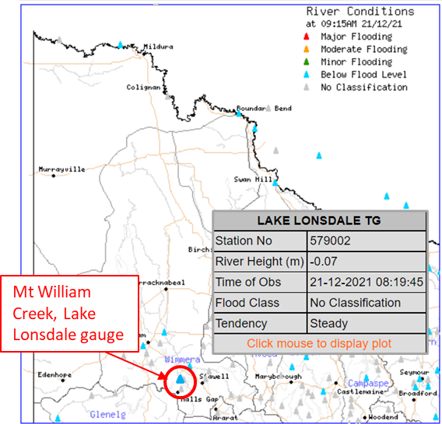
- Select ‘River Conditions’ (above the map)
- Click on Wimmera on the right.
- Find the Lake Lonsdale gauge and hover over it.
- Compare river height to the stream gauge heights on the table below to determine if flooding is likely.

The table below provides an indication of what flood impacts Dadswells Bridge can expect at Lake Lonsdale stream gauge heights, including when your access may be cut off and when your property may be affected. The Lake Lonsdale stream gauge is located downstream of Lake Lonsdale, along Mt William Creek.

Lake Lonsdale Stream Gauge Height (metres) | Flood Impact
2.7 m | Flooding along the Western Highway may be greater than 0.5m. No additional buildings are flooded above floor.
2.65 m | January 2011 flood level (flood extent show on page 2 map)  Lake Lonsdale spilled, causing significant flooding in Dadswells Bridge. The Western Highway was closed for more than 2 days. Dadswells Bridge was evacuated  More than 9 buildings were inundated above floor, including the Town Hall, Indian Restaurant, the Big Koala, Koala Motel, Dadswells Bridge Caravan Park, Turkey Farm buildings and several houses.
2.54 m | Flooding along the Western Highway may be greater than 0.4m.
2.38 m | 3 additional buildings are flooded above floor, including a shop, a house and a shed on the Western Highway. The Western Highway is impassable to traffic, flood depth up to 0.35m. Flooding may also cut access to houses and businesses along the Western Highway, isolating houses in Dadswells Bridge and surrounding areas.
2.2 m | Proposed Major flood level
2.0 m | 4 buildings are flooded above floor along the Western Highway including the Indian Restaurant, the adjacent Motel and two houses.  Most properties in Dadswells Bridge are impacted by flooding. Shallow flooding overtops Stapledons Road and Crutes South Road, depth up to 0.15m
1.8 m | Proposed Moderate flood level
1.4 m | Shallow flooding impacts many farms surrounding Dadswells Bridge and may cut access to minor roads and racks.
1.0 m | Proposed Minor flood level
0.85 m | Flooding starts to breaks out of Mt William Creek onto adjacent farmland.

Lake Lonsdale spilling during January 2011 flood event.


Flood warnings and emergency checklist

Bureau of Meteorology Warnings

Warnings are issued by the Bureau of Meteorology (BoM) to tell people about possible flooding.

A Flood Watch means there is a developing weather pattern that might cause floods in one or two days. This service covers the whole state.

A Flood Warning means flooding is about to happen or is already happening. There are minor, moderate and major flood warnings. This service is only available where flood warning systems are in place.
  A Minor Flood Warning means floodwater can: |   A Moderate Flood Warning means floodwater can: |   A Major Flood Warning means floodwater can:
Spill over river banks and cover nearby low lying areas. | Spill over river banks and cover larger areas of land. | Cause widespread flooding.
Come up through drains in nearby streets. | Reach above floor levels in some houses and buildings. | Many houses and businesses are inundated above floor level.
Require the removal of stock in some cases. | Require evacuation in some areas. | Cause properties and whole areas to be isolated by water.
Cover riverside camping areas and affect some low-lying caravan parks. | Affect traffic routes. | Closes major roads and rail routes.
Cover minor roads paths, tracks and low level bridges. | Require the removal of stock in rural areas. | Require many evacuations.
Affect backyards and buildings below floor level. |  | Affect utility services (power, water, sewage etc).
Severe Thunderstorm Warnings
Thunderstorms are classified as severe when there is potential to cause significant localised damage through wind gusts, large hail, tornadoes or flash flooding. Severe Thunderstorm Warnings are issued to the community by BoM.
Severe Weather Warnings
These warnings are issued to the community by BoM when severe weather is expected that is not directly related to severe thunderstorms or bushfires. Examples of severe weather include damaging winds and flash flooding.
Flash Flooding
- Flash Flooding can occur quickly sue to heavy rainfall. You may not receive an official warning.
- Stay informed- monitor weather warnings, forecasts and river levels at the BoM website and warnings through
VicEmergency.

VICSES Warnings
VICSES utilises the VicEmergency app, website and hotline to distribute flood warnings and emergency information in Victoria. You can also access this information through our social media channels and emergency broadcasters.
VICSES warnings aim to provide you with information to help you make good decisions to protect yourself and your family.
The warning level is based on severity, conditions and the likelihood of community impact.
WARNING LEVELS
 | EMERGENCY WARNING  You are in imminent danger and need to take action immediately. You will be impacted. A Major flood warning usually fits into this category.
 | WARNING (WATCH AND ACT)  An emergency is developing nearby. You need to take action now to protect yourself and others. A Moderate flood warning usually fits into this category.
 | ADVICE  An incident is occurring or has occurred in the area. Access information and monitor conditions. Can also be used as a notification that activity in the area has subsided and is no longer a danger to you. A Minor flood warning or Flood Watch usually fits into this category.
ADDITIONAL MESSAGES
 | PREPARE TO EVACUATE/ EVACUATE NOW  An evacuation is recommended or procedures are in place to evacuate.
 | COMMUNITY INFORMATION  Updates for communities affected by an emergency.  Can also be used as a notification that an incident has occurred but there is no threat to community.
 | EMERGENCY ALERT  During some emergencies, communities may be alerted by the sounding of a local siren, or by sending an SMS to mobile phones or a voice message to landlines.

Your emergency plan
Emergencies can happen at any time, with little warning. People who plan and prepare for emergencies reduce the impact and recover faster.

Taking the time to think about emergencies and make your own plan helps you think clearly and have more control to make better decisions when an emergency occurs.
Visit redcross.org.au/prepare start creating your plan.
- Remember, you may not receive any official warning.
- Emergency assistance may not be immediately available. Be aware of what is happening around you to stay safe.
- Never wait for a warning to act.

Emergency Kit
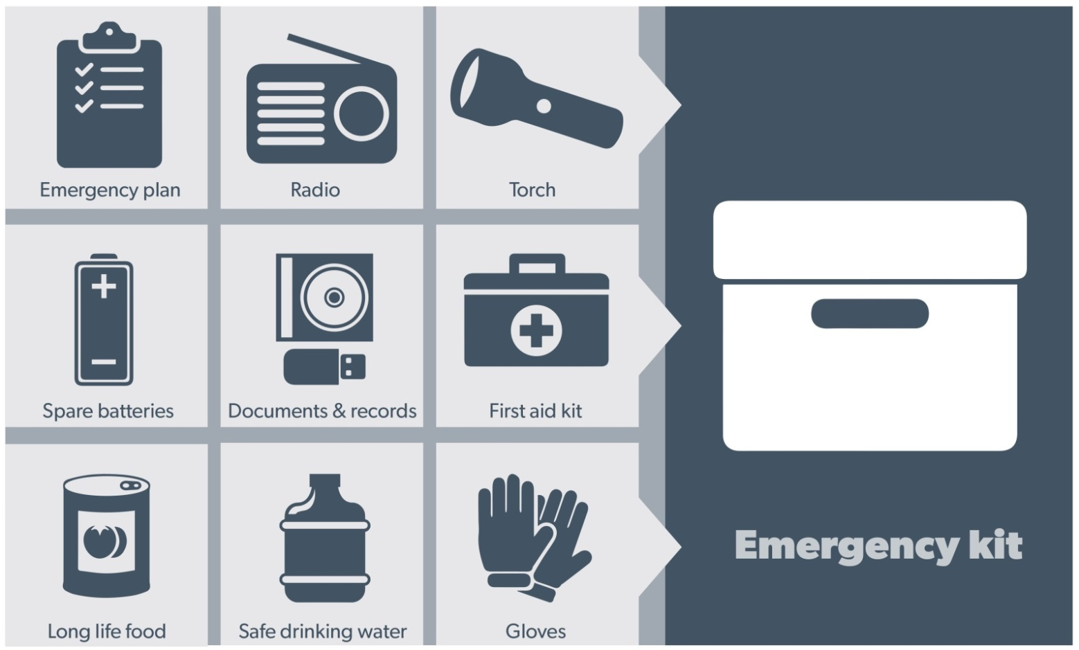
Visit Emergency Toolkit for more information
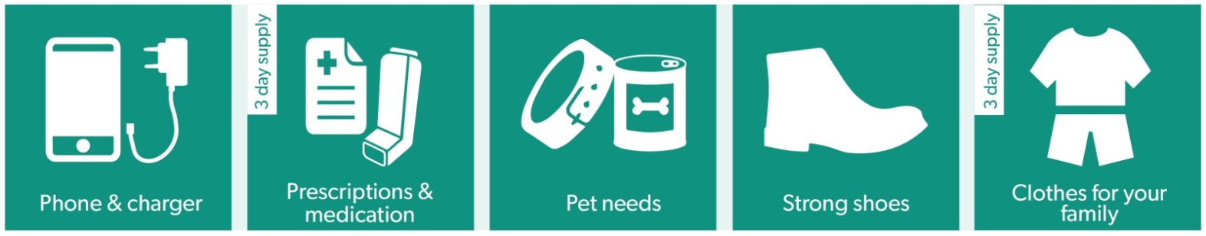
Every home and business should have a basic emergency kit with a supply of 3 days:
Check your kit often. Make sure things work. Replace out of date items.

When a warning is issued, have ready for use or pack into your kit:

I need to add:
- Special needs (eg, babies,
- Elderly)
- Photos
- Family keepsakes
- Valuables
- Other

Write your list here. Tick items as you pack them into your kit

Emergency Checklist

- Check if your insurance policy covers flooding.
- Keep this list of emergency numbers in your mobile phone
- Download the Vic Emergency app on your mobile phone.
- Put together an emergency kit and prepare a home or business emergency plan, see redcross.org.au/prepare

Before Flooding
- Leaving early before flooding occurs is always the safest option. Evacuating through floodwater is very dangerous and you may be swept away.
- Stay informed- monitor weather warnings, forecasts and river levels at bom.vic.gov.au and warnings through emergency.vic.gov.au.
- Secure objects likely to float and cause damage.
- Listen to the radio and check the VICSES website for information and advice.
- Go over your emergency plan. Pack clothing and other extra items into your emergency kit and take this with you if you evacuate.
- If you are staying in a caravan, move to higher ground before flooding begins.

During Flooding
- Make sure your family members and neighbours are aware of what is happening.
- Conditions change rapidly; roads and escape routes can be covered or blocked.
- Put household valuables and electrical items as high as possible.
- Turn off water, gas and electricity at the mains.
- Seek shelter indoors, away from floodwater.
- If floodwater comes inside, move to a higher point such as a kitchen bench or second storey.
- Stay away from trees, drains, low-lying areas, creeks, canals, culverts and floodwater.

Evacuating in Flooding
- Flood water is dangerous. Stay safe by never entering flood water. It can take just 15cm of water to float a car.
- Find alternative travel routes if roads or underpasses are flooded.
- Be aware of driving hazards, such as mud, debris, damaged roads and fallen trees. If driving conditions are dangerous, safely pull over away from trees, drains and floodwater.

After Flooding
- For recovery information, contact your local council, go to the VicEmergency Relief and Recovery- emergency.vic.gov.au/Relief page or call the VicEmergency Hotline (1800 226 226).
- Have all electrical and gas equipment professionally tested before use.
- Stay away from damaged and flooded buildings, fallen trees and powerlines, and damaged roads. Drive slowly, obey all road signs and never drive through floodwater.
- When cleaning, protect your health and safety. Wear strong boots, gloves and protective clothing.

For VICSES emergency assistance, call 132 500, or Triple Zero (000) in life threatening emergencies.

