Hume
Local Flood Guide
Flood information for the City of Hume
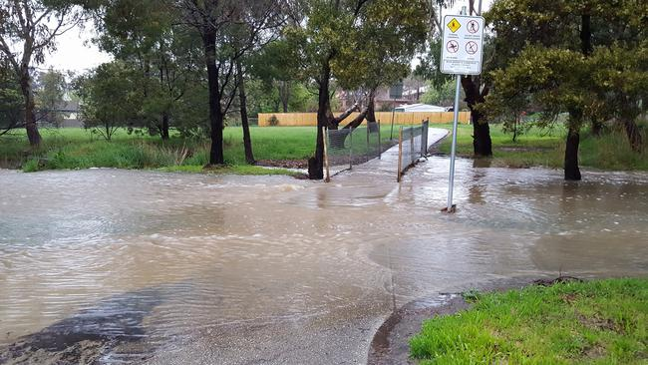
City of Hume
CMA Logo
For flood emergency assistance call
VICSES on 132 500



City of Hume
The City of Hume is on Melbourne’s north-western urban-rural fringe, covering an area of 504 square kilometres. It is situated between 15 and 45 kilometres from Melbourne’s CBD. Approximately 65 percent of the municipality is rural, 25 percent urban and 10 percent is occupied by Melbourne Airport.

Hume is bounded by the foothills of the Macedon Ranges, Merri Creek, the Western Ring Road, Maribyrnong River and Calder Freeway. Major waterways in addition to these include Jacksons Creek, Emu Creek, Deep Creek and Moonee Ponds Creek. These are all north-south draining creeks and, with the exception of Moonee Ponds Creek, flow into the Maribyrnong River.

The two main types of flooding experienced in the City of Hume are riverine (river or creek bank being overtopped) and overland (stormwater exceeding the capacity of the local drainage network). This occurs mainly as a result of intense storm events. Erosion of rural catchments is a significant problem in the municipality, which can be exacerbated by overland flow and localised flooding.

The following maps show the expected flooding in a 1% flood in the Hume municipality. A 1% flood means there is a 1% chance of a flood this size occurring in any year.
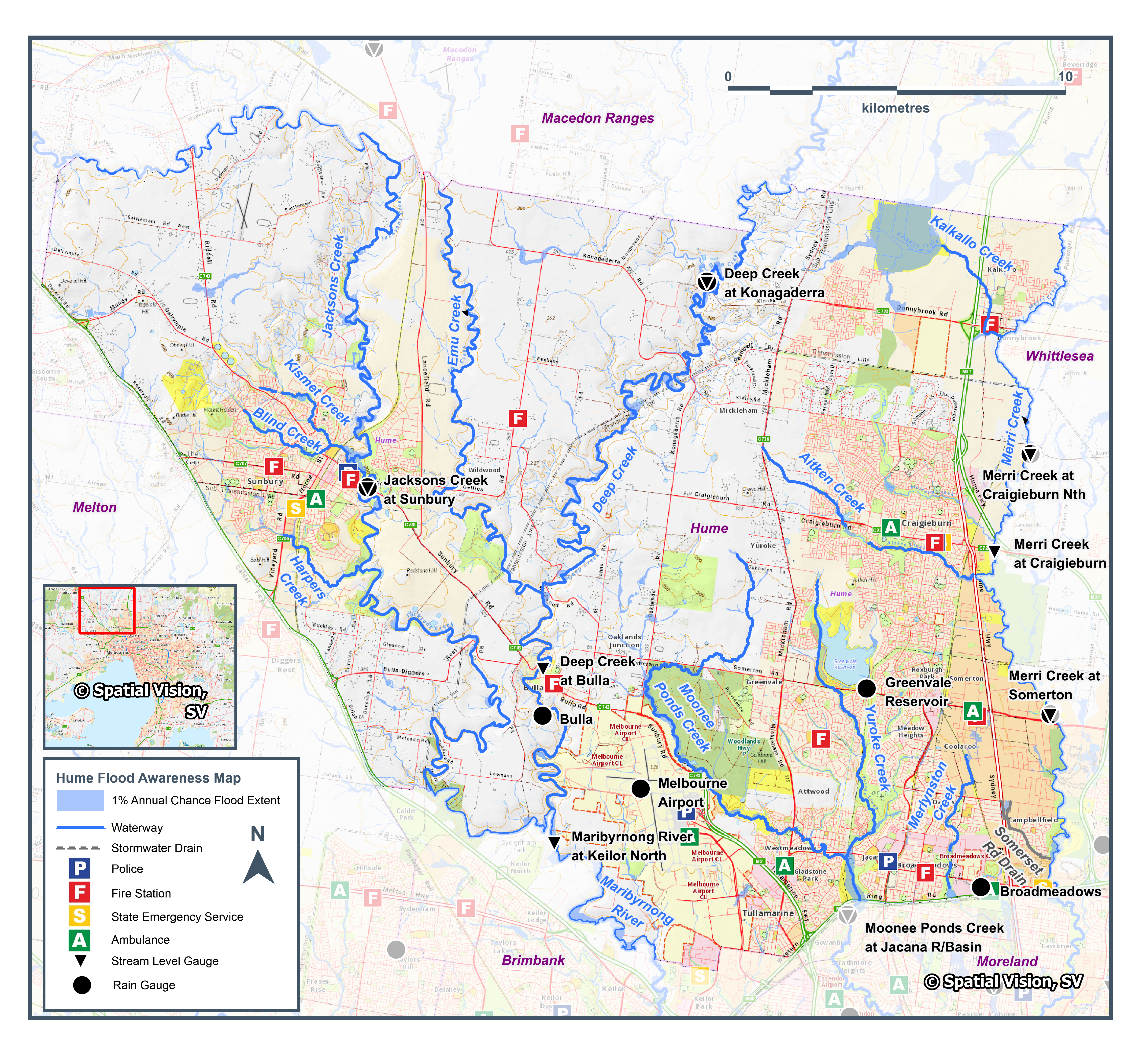
Disclaimer
Include a map as a high resolution JPEG to be inserted here.
This map publication is presented by Victoria State Emergency Service for the purpose of disseminating emergency management information. The contents of the information have not been independently verified by Victoria State Emergency Service. No liability is accepted for any damage, loss or injury caused by errors or omissions in this information or for any action taken by any person in reliance upon it. Flood information is provided by Melbourne Water

Are you prepared for a flood?

This guide contains important information on the key agencies that can provide assistance, where to find flood warning and storm information, helpful websites, and practical information on how to can be better prepared.

Experience shows that those who plan and prepare for emergencies can reduce the impact of the emergency and can recover quicker afterwards.

Further information on ‘Preparing for Flood Emergencies’ is also available at ses.vic.gov.au/get-ready

Are you at risk of flood?

Jacksons Creek:
Jacksons Creek is the prominent watercourse in the Sunbury area flowing from the northwest where it enters Hume City and forms the council’s northern border before heading south through Sunbury. From Sunbury, Jacksons Creek continues south where it becomes the Maribyrnong River at the southern border of the Municipality. There are several waterways connected to Jacksons Creek that make their way through Sunbury Township including Kismet, Blind and Harpers Creeks. High Intensity, short duration rainfall events can cause flash flooding in and around these waterways and stormwater drains, while prolonged rainfall may see Jacksons Creek flood.
Properties that may be impacted by flooding in Sunbury during a 1% AEP event include:
Aldridge Drive | Heysen Drive | Macedon Street
Powlett Street | Racecourse Road | Ramsay Court
Reservoir Road
Community Infrastructure that may be impacted by flooding in Sunbury includes:
- Salesian College Grounds | - Rupertswood Cricket Oval | - Kismet Creek Bicycle Trail
- Blind Creek Walking Trail | - Reservoir Rd, at Stockfield Street

Deep Creek & Emu Creek:
The Deep & Emu Creeks and surrounding rural areas of Wildwood, Mickleham, Oaklands Junction and Bulla form the central part of the municipality of Hume City. The two creeks flow in a southerly direction from the Shires of Macedon Ranges & Mitchell where they converge approximately 4km upstream of Bulla township. Deep Creek continues south through Bulla before joining the Maribyrnong River. Rural farmland largely abuts the creeks and thus there is little impact expected to property with no floodplains in the region. A number of minor roads may become flooded from the creeks during a 1% AEP event including Quartz Street and Wildwood Road South in Bulla.

Moonee Ponds Creek & Yuroke Creek:
Moonee Ponds Creek and the adjoining suburbs of Westmeadows, Attwood, Gladstone Park, Jacana and Broadmeadows are located approximately 15km north of Melbourne in an established residential area. Moonee Ponds Creek is the prominent watercourse in the area, flowing from the northwest at Oaklands Junction within Hume City Council. Yuroke Creek is a branch of Moonee Ponds Creek and flows from the north in Greenvale, connecting with Moonee Ponds Creek along the border of Jacana and Gladstone Park.
The Jacana Retarding Basin is a large wetland at Jacana which straddles the border between Hume City Council and the City of Moreland. High Intensity, short duration rainfall events can cause flash flooding in and around the stormwater drains that connect Moonee Ponds Creek and Yuroke Creek, while prolonged rainfall may see either of these two creeks flood.
Roads that may be impacted by flooding during a 1% AEP event include:
Coghill Street, Westmeadows | Longford Crescent, Coolaroo | Norval Crescent, Coolaroo
Raleigh Street, Westmeadows | Redesdale Street, Meadow Heights | Seville Court, Meadow Heights
Sunset Boulevard, Jacana | Thalia Court, Meadow Heights

Community Infrastructure that may be impacted by flooding includes:
- Jacana Reserve | - Westmeadows Hall on Raleigh Street | - Broadmeadows Sports Club on Sunset Boulevard
- Bicycle paths along Moonee Ponds Creek and Yuroke Creek

Merri Creek:
Merri Creek and the adjoining suburbs of Kalkallo, Craigieburn, Somerton & Campbellfield are located between 14-30km north of Melbourne in a mixed residential and industrial area. Merri Creek is the prominent watercourse in the area, flowing from the north through the Shire of Mitchell. Several waterways and stormwater drains connect to Merri Creek through Hume City Council including Kalkallo Creek, Aitken Creek and the Somerset Road Drain.
Roads that may be impacted by flooding during a 1% AEP event include:
Barry Road, Campbellfield | Horne Street, Campbellfield | Somerset Road, Campbellfield
Sycamore Crescent Campbellfield | Sydney Road, Campbellfield

Community Infrastructure that may be impacted by flooding includes:
- Sylvan Caravan Park - Sydney Road Campbellfield | - Craigieburn Public Golf Course

Merlynston Creek:
Merlynston Creek in Hume City Council and the surrounding suburbs of Campbellfield, Coolaroo, Dallas and Broadmeadows are located between 14-19km north of Melbourne in a predominantly industrial area. Merlynston Creek is the prominent watercourse in the area, beginning in Campbellfield and flowing south into the City of Moreland. Campbellfield Creek also begins in Broadmeadows where it connects with Merlynston Creek in Fawkner.
The Merlynston/Campbellfield catchment is small and flash flooding is the primary concern for consequences/impacts.
Roads that may be impacted by flooding along the Merlynston and Campbellfield Creeks during a 1% AEP event include:
Barry Road, Campbellfield & Coolaroo | Camp Road, Broadmeadows | Foden Avenue, Campbellfield
Capital Link Drive, Campbellfield | Maffra Street, Coolaroo | National Boulevard, Campbellfield
Sydney Road, Campbellfield | The Crossway, Campbellfield | The Gateway, Broadmeadows

Did you know?
There have been several historical flooding events throughout the City of Hume. These have usually been as a result of heavy rainfall during severe storms.
No two floods are the same. Floods like this or worse could occur again.
If you live in a low-lying area you may be at risk of flooding or need to detour around flooded areas.
Knowing what to do can save your life and help protect your property

- On 17th June 2018, up to 45 millimetres of rain fell in the city’s north causing a dam in Waterview Boulevard, Craigieburn to fail, resulting in flooding to nearby Central Park Avenue causing one home to flood and impacting neighbouring properties and surrounding streets.
- In September 2016, flooding occurred across the northern parts of Melbourne and into the Macedon Ranges affecting 12 council areas, causing the closure of 102 roads and prompting 11 rescues. Sunbury saw 54mm of rain fall in the 24 hours to September 13.
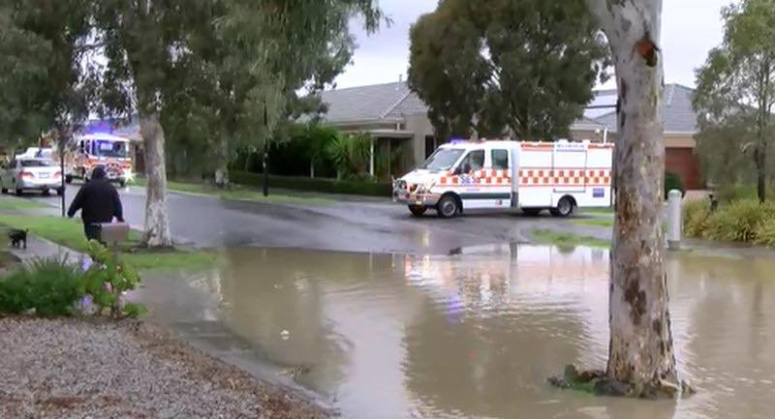Central Park Av, Craigieburn 17/06/2018
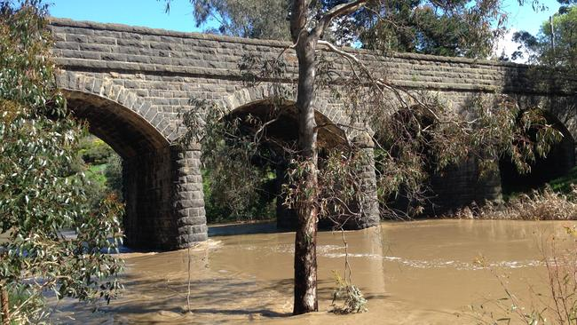Deep Creek at Bulla Bridge

Staying Informed and Further Information
- Current warnings (VicEmergency) | emergency.vic.gov.au | 1800 226 226
- Bureau of Meteorology (BoM) | bom.gov.au/vic/warnings | 1300 659 217
- VicRoads Traffic | traffic.vicroads.vic.gov.au
- Emergency Broadcasters | ABC 774 AM  SKY NEWS Television  Sunbury Local Radio 99.3 FM  North West 98.9 FM | Life-threatening Emergency  000
- VICSES Social Media | facebook.com/broadmeadowsses  facebook.com/CraigieburnSES  facebook.com/sessunbury  twitter.com/vicsesnews
- Preparing for Flood Emergencies | ses.vic.gov.au/get-ready
- Creating an Emergency Plan | redcross.org.au/prepare
- Melbourne Water | melbournewater.com.au | 131 722
- Hume City Council | hume.vic.gov.au | 9205 2200


Flood warnings and
emergency checklist

Bureau of Meteorology Warnings
Warnings are issued by the Bureau of Meteorology (BoM) to tell people about possible flooding.

A Flood Watch means there is a developing weather pattern that might cause floods in one or two days. This service covers the whole state.
A Flood Warning means flooding is about to happen or is already happening. There are minor, moderate and major flood warnings. This service is only available where flood warning systems are in place.
  A Minor Flood Warning means floodwater can: |   A Moderate Flood Warning means floodwater can: |   A Major Flood Warning means floodwater can:
Spill over river banks and cover nearby low lying areas. | Spill over river banks and cover larger areas of land. | Cause widespread flooding.
Come up through drains in nearby streets. | Reach above floor levels in some houses and buildings. | Many houses and businesses are inundated above floor level.
Require the removal of stock in some cases. | Require evacuation in some areas. | Cause properties and whole areas to be isolated by water.
Cover riverside camping areas and affect some low-lying caravan parks. | Affect traffic routes. | Closes major roads and rail routes.
Cover minor roads paths, tracks and low level bridges. | Require the removal of stock in rural areas. | Require many evacuations.
Affect backyards and buildings below floor level. |  | Affect utility services (power, water, sewage etc).

Severe Thunderstorm Warnings
Thunderstorms are classified as severe when there is potential to cause significant localised damage through wind gusts, large hail, tornadoes or flash flooding. Severe Thunderstorm Warnings are issued to the community by BoM.

Severe Weather Warnings
These warnings are issued to the community by BoM when severe weather is expected that is not directly related to severe thunderstorms or bushfires. Examples of severe weather include damaging winds and flash flooding.

Flash Flooding
- Flash Flooding can occur quickly due to heavy rainfall. You may not receive an official warning.
- Stay informed- monitor weather warnings, forecasts and river levels at the BoM website and warnings through VicEmergency.

VICSES Warnings
VICSES utilises the VicEmergency app, website and hotline to distribute flood warnings and emergency information in Victoria. Communities can also access this information through VICSES social media channels and emergency broadcasters.
VICSES warnings aim to provide you with information to help you make good decisions to protect yourself and your family
The warning level is based on severity, conditions and the likelihood that the emergency could impact on the community.
WARNING LEVELS
 | EMERGENCY WARNING  You are in imminent danger and need to take action immediately. You will be impacted. A Major flood warning usually fits into this category
 | WARNING (WATCH AND ACT)  An emergency is developing nearby. You need to take action now to protect yourself and others. A Moderate flood warning usually fits into this category.
 | ADVICE  An incident is occurring or has occurred in the area. Access information and monitor conditions.  Can also be used as a notification that activity in the area has subsided and is no longer a danger to you. A Minor flood warning or Flood Watch usually fits into this category.

ADDITIONAL MESSAGES
 | PREPARE TO EVACUATE/ EVACUATE NOW  An evacuation is recommended or procedures are in place to evacuate.
 | COMMUNITY INFORMATION  A newsletter containing updates for communities affected by an emergency.  Can also be used as a notification that an incident has occurred but there is no threat to community.
 | EMERGENCY ALERT  During some emergencies, we may alert communities by sounding a local siren, or by sending an SMS to mobile phones or a voice message to landlines.

Your emergency plan
Emergencies can happen at any time and with little warning. People who plan and prepare for emergencies can reduce the impact and recover faster.

Taking the time to think about emergencies and make your own plan helps you think clearly, have more control and make better decisions when an emergency occurs.
Visit redcross.org.au/prepare start creating your plan.
- Remember, you may not receive any official warning.
- Emergency assistance may not be immediately available.
Be aware of what is happening around you to stay safe.
- Never wait for a warning to act.

Emergency Kit
Visit Emergency Toolkit for more information
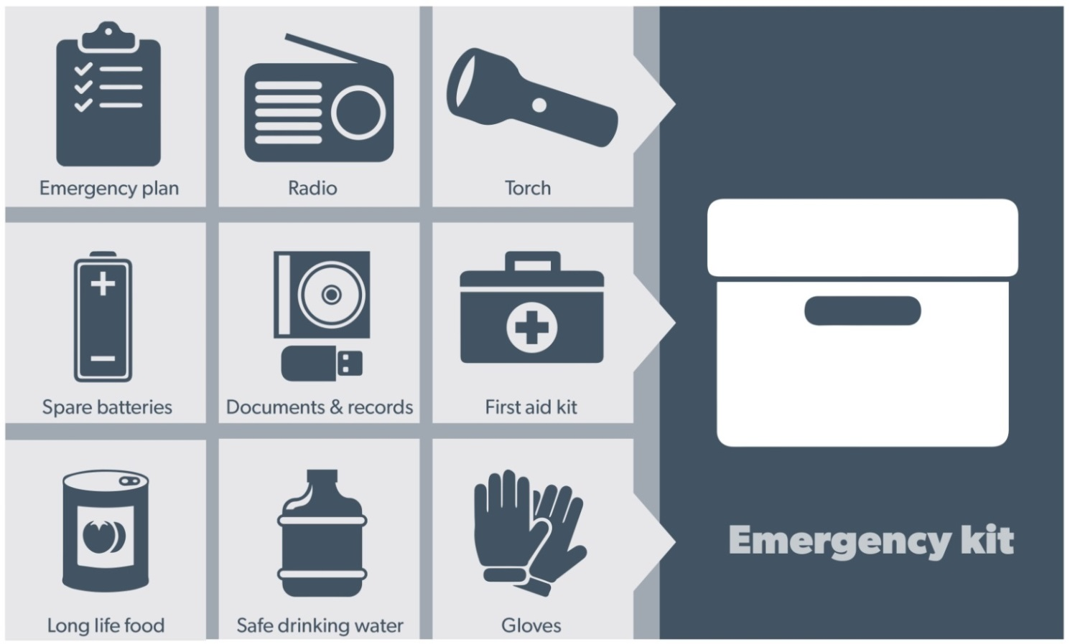
Every home and business should have a basic emergency kit with supplies for 3 days:
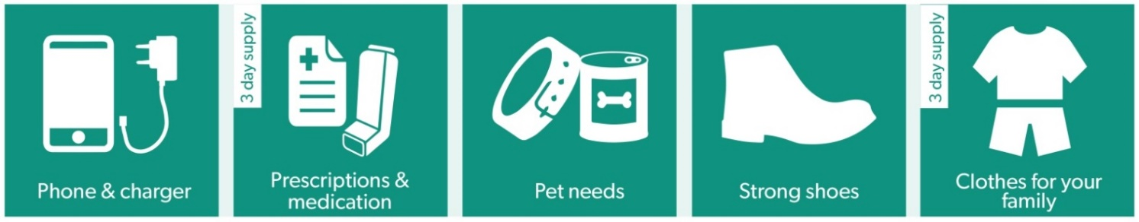
Check your kit often. Make sure things work. Replace out of date items.

When a warning is issued, have ready for use or pack into your kit:
I need to add:
Write your list here. Tick items as you pack them into your kit.
Special needs (eg, babies, elderly and people with a disability)
Photos
Family keepsakes
Valuables
Other

Emergency Checklist
    - Check if your insurance policy covers flooding.
    - Keep this list of emergency numbers in your mobile phone.
    - Download the Vic Emergency app on your mobile phone.
    - Put together an emergency kit and prepare a home or business.
    - Emergency plan, see https://www.redcross.org.au/prepare

Before Flooding
    - Leaving early before flooding occurs is always the safest option. Evacuating through floodwater is very dangerous and you may be swept away.
    - Stay informed- monitor weather warnings, forecasts and river levels at the http://www.bom.gov.au and warnings through www.emergency.vic.gov.au
    - Secure objects likely to float and cause damage.
    - Listen to the radio and check the VICSES website for information and advice.
    - Go over your emergency plan. Pack clothing and other extra items into your emergency kit and take this with you if you evacuate.

During Flooding
    - Make sure your family members and neighbours are aware of what is happening.
    - Conditions change rapidly; roads and escape routes can be covered or blocked.
    - Put household valuables and electrical items as high as possible.
    - Turn off water, gas and electricity at the mains.
    - If you are staying in a caravan, move to higher ground before flooding begins.
    - Seek shelter indoors, away from floodwater.
    - If floodwater comes inside, move to a higher point such as a kitchen bench or second storey.
    - Stay away from trees, drains, low-lying areas, creeks, canals, culverts and floodwater.

Evacuating in Flooding
    - Flood water is dangerous. Never enter floodwater. It can take just 15cm of water to float a car.
    - Find alternative travel routes if roads or underpasses are flooded.
    - Be aware of driving hazards, such as mud, debris, damaged roads and fallen trees. If driving conditions are dangerous, safely pull over away from trees, drains and floodwater.

After Flooding
    - For recovery information, contact your local council, go to the VicEmergency Relief and Recovery- emergency.vic.gov.au/Relief page or call the VicEmergency Hotline (1800 226 226).
    - Have all electrical and gas equipment professionally tested before use.
    - Stay away from damaged and flooded buildings, fallen trees and powerlines and damaged roads until authorities advise it is safe to do so.
    - Drive slowly, obey all road signs and never drive through floodwater.
    - When cleaning, protect your health and safety. Wear strong boots, gloves and protective clothing and wash your hands and clothes regularly.
For VICSES emergency assistance,
call 132 500, or Triple Zero (000)
in life threatening emergencies.

