**Katamatite**

**Local Flood Guide**

**Flood information for the Broken and Boosey Creek at Katamatite**







**Katamatite**



**For flood emergency assistance call**

**VICSES on 132 500**



# Katamatite

Katamatite is located in the Moira Shire along the Boosey Creek and is situated in the Broken and Boosey Creek catchments. Boosey Creek is the main waterway on the south and east side of the township of Katamatite, and flows into the Broken Creek downstream of Katamatite, near Gilmours Bridge.

The following map shows the expected flooding in a 1% flood in Katamatite which also represents the March 2012 flood event. A 1% flood means there is a 1 in 100 chance (or greater) of this type of flooding happening every year, measuring 3.10 metres on the Broken Creek gauge near Gilmours Bridge.

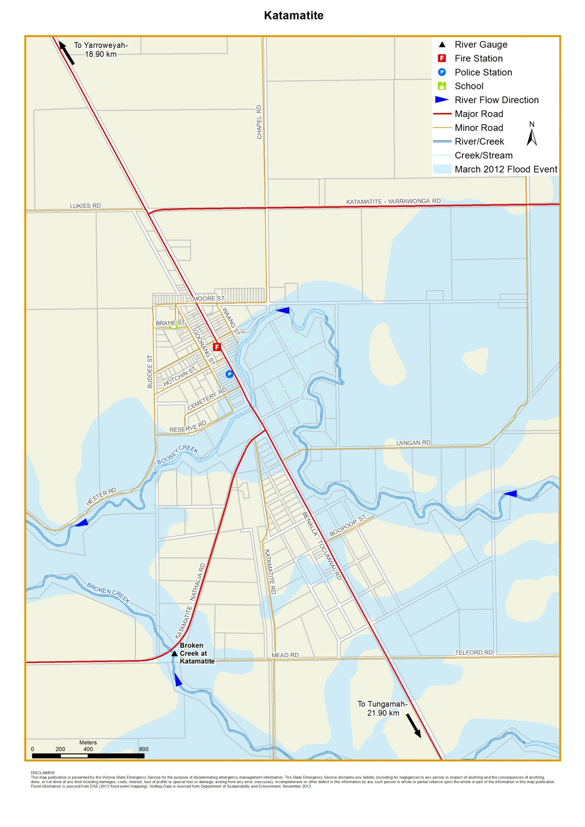

**Disclaimer**This map publication is presented by Victoria State Emergency Service for the purpose of disseminating emergency management information. The contents of the information has not been independently verified by Victoria State Emergency Service. No liability is accepted for any damage, loss or injury caused by errors or omissions in this information or for any action taken by any person in reliance upon it. Flood risk information is provided by Goulburn Broken Catchment Management Authority.

# Are you at risk of flood?

# The Katamatite area is located on a floodplain which can result in widespread flooding.

# Both the 1993 and 2012 flood events involved Riverine Flooding from the Boosey Creek System overflowing. The early stages of the 2012 flood also involved flooding caused by localised severe rainfall over a short period of time, known as Flash Flooding. Depending on the size of the flood, areas to the east and south of town are most vulnerable, including low-lying parts of Beek Street (Benalla-Tocumwal Road), Hotchin Street and Cemetery Road. The Katamatite Recreation Reserve likely to be inundated.

# During a flood, the following main roads are likely to be closed in and around Katamatite:

* Benalla – Tocumwal Road (Beek Street closed both north and south of town)
* Katamatite - Nathalia Road, also known as Shepparton - Katamatite Road
* Katamatite - Yarrawonga Road

# Did you know?

**No two floods are the same, floods like this or worse could occur again.**

**If you live in a low-lying area you may be at risk of flooding or need to detour around flooded areas.**

**Knowing what to do can save your life and help protect your property.**



Katamatite has a history of flooding, including recent large floods in May 1974, October 1993 and March 2012. The May 1974, October 1993 and March 2012 floods are the three largest floods in the Broken Creek system in recent times. In the 2012 flood, approximately 19 properties were flooded above floor level.

Floods can occur in a number of ways in Katamatite, including:

* The 1974 and 1993 events resulted from local runoff and overflows from the Broken River into the Broken Creek System
* The March 2012 event was caused by heavy rain in the nearby catchment and local runoff. Parts of Katamatite were flooded and access was cut to the township

Katamatite can have between three and five days warning for riverine flooding in the Boosey Creek after prolonged heavy rain in the Boosey Catchment.. You can monitor river and rainfall conditions within the Boosey Catchment on the Bureau of Meteorology (BOM) website at [bom.gov.au](http://www.bom.gov.au/).

The [Broken River gauge at Benalla](http://www.bom.gov.au/fwo/IDV67208/IDV67208.581006.plt.shtml) is the nearest gauge to Katamatite that the BoM will use to issue minor, moderate and major flood warnings. Checking this gauge could give you an idea of flooding in nearby areas. You can monitor rainfall and river levels on the BoM website at Benalla, Caseys Weir, and Gowangardie Weir. The [Broken River gauge at Gowangardie Weir](http://www.bom.gov.au/fwo/IDV67208/IDV67208.581019.plt.shtml) will only provide a river level height reading.

# Broken Creek flood levels at Katamatite Gauge (Gilmours Bridge) and Boosey Creek flood levels at Tungamah Station Gauge

The Bureau of Meteorology (BoM) does not use the Broken Creek at [Katamatite Gauge](http://www.bom.gov.au/fwo/IDV67208/IDV67208.580017.plt.shtml) to issue flood warnings, it can only provide creek heights. The [Tungamah Station gauge](http://www.bom.gov.au/fwo/IDV67208/IDV67208.581023.plt.shtml) could provide early indication of Boosey Creek flooding. While no two floods are the same, the following table can give you an idea of what you could expect at certain heights, including when your access may be cut off and when your property may be affected.

|  |  |  |  |
| --- | --- | --- | --- |
| **Katamatite Gauge Height (metres)** | | **Tungamah Gauge Height (metres)** | **Impact/level** |
| 3.10 m | 2.88 m | | **March 2012 flood level.** 1% flood level. Height shown on map on page 2. |
| 2.81 m | 2.80 m | | **May 1974 flood level.** |
| 2.74 m | 2.73 m | | **October 1993 flood level.** |
| 2.36 m | 2.46 m | | **October 1975 flood level.** |
| 2.40 m |  | | **September 1973 flood level.** |
|  | 2.43 m | | **August 1973 flood level.** |
|  | 2.35 m | | **July 1981 flood level.** |
| 2.36 m | 2.31 m | | **July 1995 flood level.** |
| 2.06 m |  | | **September 1989 flood level.** |

# 2012 flood observations

The following table provides observations from the 2012 flood event. These observations provide information on the expected impacts for Katamatite when certain triggers occur.

|  |  |
| --- | --- |
| **Flood behaviour (2012)** | **Expected impacts** |
| Boosey Creek overflowed its banks flooding to the south of town, Mead/Telford Road was  significantly impacted. | Possible road closures to the south and east of Katamatite |
| Floodwater crossed Chapel  Road behind the Recreation Reserve and the corner of  Chapel Road and Moore  Street. | If floodwater reaches this point, this will have a major impact on the township and surrounding farms. Low-lying parts of Beek/Hotchin Street, and Cemetery Road and the recreation reserve are likely to be affected by floodwater  including being flooded, isolated and or cut off. Most roads entering the town  will be cut off by floodwater. |

**Staying Informed and Further Information**

* Current warnings (VicEmergency) [emergency.vic.gov.au](http://emergency.vic.gov.au/respond/) 1800 226 226
* Bureau of Meteorology (BoM) [bom.gov.au/vic/warnings](http://www.bom.gov.au/vic/warnings/) 1300 659 217
* VicRoads Traffic [traffic.vicroads.vic.gov.au](https://traffic.vicroads.vic.gov.au/)
* Emergency Broadcasters ABC 97.7 FM

HIT 96.9 FM

TRIPLE M 95.3 FM

SKY NEWS Television

* VICSES Social Media [facebook.com/vicses](https://www.facebook.com/vicses)

[twitter.com/vicsesnews](https://twitter.com/vicsesnews)

* Preparing for Flood Emergencies [ses.vic.gov.au/get-ready](https://www.ses.vic.gov.au/get-ready)
* Creating an Emergency Plan [redcross.org.au/prepare](https://www.redcross.org.au/prepare)
* Catchment Management Authority [gbcma.vic.gov.au](https://www.gbcma.vic.gov.au/) (03) 5822 7700
* Moira Shire Council [moira.vic.gov.au](https://www.moira.vic.gov.au/Home) (03) 5871 9222
* National Relay Service (NRS) [relayservice.gov.au](https://relayservice.gov.au/)

**Life-threatening Emergency**

**000**



**Flood warnings and emergency checklist**

# Bureau of Meteorology Warnings

# Warnings are issued by the Bureau of Meteorology (BoM) to tell people about possible flooding.

# A Flood Watch means there is a developing weather pattern that might cause floods in one or two days. This service covers the whole state.

# A Flood Warning means flooding is about to happen or is already happening. There are minor, moderate and major flood warnings. This service is only available where flood warning systems are in place.

|  |  |  |
| --- | --- | --- |
| **A Minor Flood Warning means floodwater can:** | **A Moderate Flood Warning means floodwater can:** | **A Major Flood Warning means floodwater can:** |
| Spill over river banks and cover nearby low lying areas. | Spill over river banks and cover larger areas of land. | Cause widespread flooding. |
| Come up through drains in nearby streets. | Reach above floor levels in some houses and buildings. | Many houses and businesses are inundated above floor level. |
| Require the removal of stock in some cases. | Require evacuation in some areas. | Cause properties and whole areas to be isolated by water. |
| Cover riverside camping areas and affect some low-lying caravan parks. | Affect traffic routes. | Closes major roads and rail routes. |
| Cover minor roads paths, tracks and low level bridges. | Require the removal of stock in rural areas. | Require many evacuations. |
| Affect backyards and buildings below floor level. |  | Affect utility services (power, water, sewage etc). |

**Severe Thunderstorm Warnings**

Thunderstorms are classified as severe when there is potential to cause significant localised damage through wind gusts, large hail, tornadoes or flash flooding. Severe Thunderstorm Warnings are issued to the community by BoM.

**Severe Weather Warnings**

These warnings are issued to the community by BoM when severe weather is expected that is not directly related to severe thunderstorms or bushfires. Examples of severe weather include damaging winds and flash flooding.

**Flash Flooding**

* Flash Flooding can occur quickly due to heavy rainfall. You may not receive an official warning.
* Stay informed- monitor weather warnings, forecasts and river levels at the [BoM website](http://www.bom.gov.au/vic/warnings/) and warnings through

[VicEmergency](http://emergency.vic.gov.au/respond/).

**VICSES Warnings**

VICSES utilises the VicEmergency app, website and hotline to distribute flood warnings and emergency information in Victoria. You can also access this information through our social media channels and emergency broadcasters.

VICSES warnings aim to provide you with information to help you make good decisions to protect yourself and your family.

The warning level is based on severity, conditions and the likelihood of community impact.

|  |  |
| --- | --- |
| **WARNING LEVELS** | |
|  | **EMERGENCY WARNING**  You are in imminent danger and need to take action immediately. You will be impacted. A Major flood warning usually fits into this category. |
|  | **WARNING (WATCH AND ACT)**  An emergency is developing nearby. You need to take action now to protect yourself and others. A Moderate flood warning usually fits into this category. |
|  | **ADVICE**  An incident is occurring or has occurred in the area. Access information and monitor conditions. Can also be used as a notification that activity in the area has subsided and is no longer a danger to you. A Minor flood warning or Flood Watch usually fits into this category. |
| **ADDITIONAL MESSAGES** | |
|  | **PREPARE TO EVACUATE/ EVACUATE NOW**  An evacuation is recommended or procedures are in place to evacuate. |
|  | **COMMUNITY INFORMATION**  Updates for communities affected by an emergency.  Can also be used as a notification that an incident has occurred but there is no threat to community. |
|  | **EMERGENCY ALERT**  During some emergencies, communities may be alerted by the sounding of a local siren, or by sending an SMS to mobile phones or a voice message to landlines. |

# Your emergency plan

Emergencies can happen at any time, with little warning. People who plan and prepare for emergencies reduce the impact and recover faster.

Taking the time to think about emergencies and make your own plan helps you think clearly and have more control to make better decisions when an emergency occurs.

Visitredcross.org.au/prepare start creating your plan.

* **Remember, you may not receive any official warning.**
* **Emergency assistance may not be immediately available. Be aware of what is happening around you to stay safe.**
* **Never wait for a warning to act.**

# Emergency Kit

*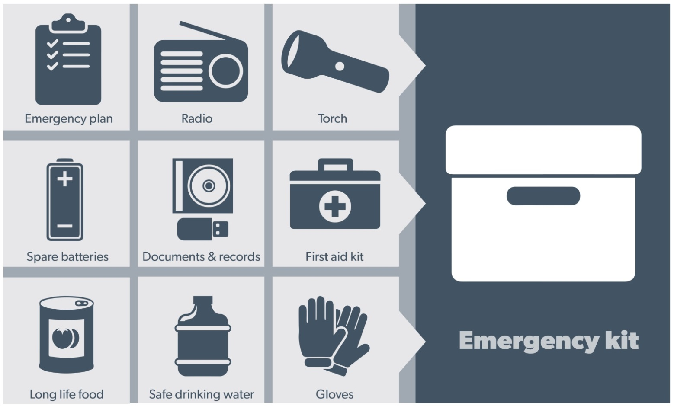***Visit** [**Emergency Toolkit**](https://www.ses.vic.gov.au/documents/112015/135368/Emergency+Toolkit-pdf/4f569017-36e6-4cb1-982a-67003016699b) **for more information**

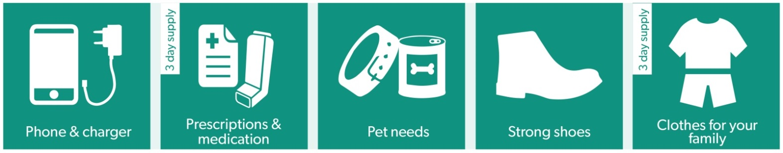*Every home and business should have a basic emergency kit with a supply of 3 days:*

*Check your kit often. Make sure things work. Replace out of date items.*

## When a warning is issued, have ready for use or pack into your kit:

## I need to add:

|  |  |
| --- | --- |
| * Special needs *(eg, babies,* * *Elderly)* |  |
| * Photos |  |
| * Family keepsakes |  |
| * Valuables |  |
| * Other |  |

## Write your list here. Tick items as you pack them into your kit

**Emergency Checklist**

* Check if your insurance policy covers flooding.
* Keep this list of emergency numbers in your mobile phone
* Download the Vic Emergency app on your mobile phone.
* Put together an emergency kit and prepare a home or business emergency plan, see [**redcross.org.au/prepare**](https://www.redcross.org.au/prepare)

## Before Flooding

* **Leaving early before flooding occurs is always the safest option. Evacuating through floodwater is very dangerous and you may be swept away.**
* Stay informed- monitor weather warnings, forecasts and river levels at [**bom.vic.gov.au**](http://bom.vic.gov.au) and warnings through [**emergency.vic.gov.au**](http://www.emergency.vic.gov.au)**.**
* Secure objects likely to float and cause damage.
* Listen to the radio and check the VICSES website for information and advice.
* Go over your emergency plan. Pack clothing and other extra items into your emergency kit and take this with you if you evacuate.
* If you are staying in a caravan, move to higher ground before flooding begins.

## During Flooding

* Make sure your family members and neighbours are aware of what is happening.
* Conditions change rapidly; roads and escape routes can be covered or blocked.
* Put household valuables and electrical items as high as possible.
* Turn off water, gas and electricity at the mains.
* Seek shelter indoors, away from floodwater.
* If floodwater comes inside, move to a higher point such as a kitchen bench or second storey.
* Stay away from trees, drains, low-lying areas, creeks, canals, culverts and floodwater.

## Evacuating in Flooding

* **Flood water is dangerous. Stay safe by never entering flood water. It can take just 15cm of water to float a car.**
* Find alternative travel routes if roads or underpasses are flooded.
* Be aware of driving hazards, such as mud, debris, damaged roads and fallen trees. If driving conditions are dangerous, safely pull over away from trees, drains and floodwater.

## After Flooding

* For recovery information, contact your local council, go to the [VicEmergency Relief and Recovery](https://emergency.vic.gov.au/relief/)- **emergency.vic.gov.au/Relief** page or call the VicEmergency Hotline (1800 226 226).
* Have all electrical and gas equipment professionally tested before use.
* Stay away from damaged and flooded buildings, fallen trees and powerlines, and damaged roads. Drive slowly, obey all road signs and never drive through floodwater.
* When cleaning, protect your health and safety. Wear strong boots, gloves and protective clothing.

**For VICSES emergency assistance, call 132 500, or Triple Zero (000) in life threatening emergencies.**