Nathalia
Local Flood Guide
Flood information for the Broken Creek at Nathalia





2012 flood, Nathalia
Nathalia
For flood emergency assistance call
VICSES on 132 500

Nathalia

Nathalia is located in northern Victoria along the banks of the Broken Creek on the Murray Valley Highway, in the Moira Shire. The Broken Creek catchment that flows from the east towards Nathalia includes: Broken, Boosey, Pine Lodge, Nine Mile and Congupna Creek, Muckatah Depression and Drains 11 and 13. The Muckatah Depression is a natural drainage basin that extends from west of Bundalong and drains into the Broken Creek east of Numurkah.

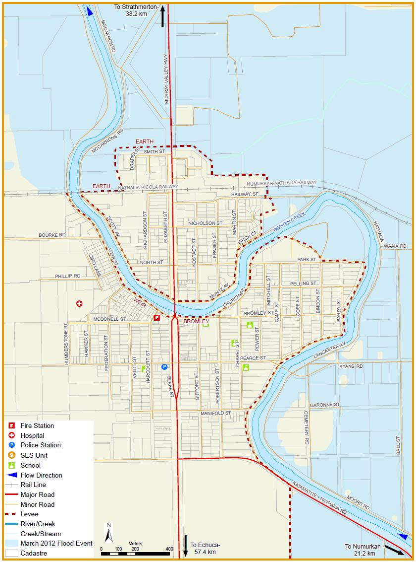
The following map shows the flooding that occurring in March 2012 in Nathalia. This flood measured 3.26 metres on the Nathalia Town Gauge.

Include a map as a high resolution JPEG to be inserted here.

Disclaimer
This map publication is presented by Victoria State Emergency Service for the purpose of disseminating emergency management information. The contents of the information has not been independently verified by Victoria State Emergency Service. No liability is accepted for any damage, loss or injury caused by errors or omissions in this information or for any action taken by any person in reliance upon it. Flood risk information is provided by Goulburn Broken Catchment Management Authority.

Are you at risk of flood?

Flooding in the Nathalia area can happen when:
- Floodwater overflows the banks of the Broken Creek.
- Heavy local rainfall overwhelms local creeks and drains, especially from the Tungamah, Katamatite, Numurkah and Wunghnu area.
- Floodwater from the Benalla area breaks out from the Broken River at Casey’s Weir and/or Gowangardie Weir, flowing overland toward the Broken Creek near Walsh’s Bridge.

During major level floods, the flat nature of the area usually results in slow-moving floods that last around ten days, with low-lying areas outside the levee taking longer to clear. Important roads are likely to be closed including the Murray Valley Highway and roads to Shepparton, Katamatite, Waaia and Echuca. Isolation is likely for parts of the town and most surrounding rural properties. Properties outside the town levee are at high risk of overfloor flooding and/ or isolation, including (but not limited to) low areas of Lancaster Avenue, McCarrons Road, Ryan’s Road and Cemetery Road.

Did you know?
No two floods are the same, floods like this or worse could occur again.
If you live in a low-lying area you may be at risk of flooding or need to detour around flooded areas.
Knowing what to do can save your life and help protect your property.

Nathalia has a long history of large floods occurring roughly every 18 years including in 1916, 1939, 1956, 1974, 1993 and 2012.
Facts about flooding in Nathalia:
- Floodwater at Nathalia town gauge usually peaks 48 hours after flood levels peak at the (Katie) Walsh’s Bridge gauge. Keeping close watch on this gauge can be a guide for what might happen in Nathalia.
- After the 1974 flood, earthen (soil) levees were built around the town between 1982 and 1988.
- After the 1993 floods, the height of the town levee was increased by 30cm. Removable metal flood barriers were built to complete the town’s flood levee system.
- The 2012 flood measured 3.26 metres on the Nathalia Town Gauge, causing 17 properties outside of the town levee to be flooded.
Flood Levees
A levee is an embankment usually along-side a river or creek designed to protect property from floodwater.
Levees can reduce the frequency of flooding but no levee is guaranteed to be flood proof. A levee is designed to control a certain amount of floodwater. If larger floods occur, water will flow over the levee into low-lying areas. Floodwater may also damage the levee, allowing floodwater to flow through an opening or break.
Flood levees are to protect property, not people. If the levee is in danger of failing, you will be advised to evacuate flood prone areas. It is important that you follow this advice.
The levee at Nathalia provides protection from the 1% flood. The levee is mostly earthen (soil) although road openings and the foreshore area need to be completed ahead of an approaching flood using a system of demountable aluminium panels.
More information about levees is available on the SES website.

Broken Creek flood levels at Nathalia Town Gauge and Walsh’s Bridge Gauge

When the Bureau of Meteorology (BoM) issues Flood Warnings they include a prediction of the flood height. The Nathalia Town Gauge will be used to provide warnings for Nathalia, and (KD) Walsh’s Bridge Gauge near Waaia is used to provide information to estimate how high the flood might get or how fast the flood is moving. While no two floods are the same, the following table can give you an indication of what you could expect at certain heights, including when your access may be cut off and when your property may be affected.

Nathalia Town Gauge Height (metres) | Walsh’s Bridge Gauge Height (metres) | Impact/level
3.65 m | 3.96 m | Water likely to overtop most of the town levees resulting in most of the town flooding to depth over 1.2 m. Levees can fail before this level
3.49 m | 3.82 m | Water likely to overtop Nathalia-Katamatite Road town levee near town weir. Levees can fail before this level
3.29 m | 3.66 m | 1% flood level. A 1% flood means there is a 1% chance of this type of flooding happening every year
3.26 m | 3.57 m | March 2012 flood level Height shown on map on page 2. 17 houses were damaged during this flood
3.09 m | 3.50 m | October 1993 flood level
2.92 m | 3.41 m | Demountable flood barriers installed along Bromley Street between the Murray Valley Highway bridge and levee end wall
2.90 m | 3.40 m | Demountable flood barriers installed across Murray Valley Highway north of town. Road access is closed
2.90 m | 3.40 m | Major flood level.
2.89 m | 3.25 m | 1974 flood level without levees, impacts wouldn’t be the same today
2.82 m | 3.35 m | Demountable flood barriers installed across Railway Street closing road access
2.80 m | 3.30 m | Demountable flood barriers installed along Weir Street, west of Murray Valley Highway Bridge near fire station to the public toilets
2.63 m | 3.13 m | 1995 flood level
2.60 m |  | Drain 13 channel spillway will begin operating around this level with flow path to the north west
2.52 m | 3.10 m | Flooding two-four kilometres north of town likely to close Murray Valley Highway
2.50 m | 3.00 m | Moderate flood level
2.20 m | 2.95 m | Flooding to the lowest part of Weir Street likely
1.72 m | 2.55 m | December 2010 flood level. Low-lying road and land beside Creek flooded
1.30 m | 2.00 m | Minor flood level
Staying Informed and Further Information

- Current warnings (VicEmergency) emergency.vic.gov.au 1800 226 226
- Bureau of Meteorology (BoM) bom.gov.au/vic/warnings 1300 659 217
- VicRoads Traffic traffic.vicroads.vic.gov.au
- Emergency Broadcasters ABC 97.7 FM
HIT 96.9 FM
TRIPLE M 95.3 FM
SKY NEWS Television
- VICSES Social Media facebook.com/vicses
twitter.com/vicsesnews
- Preparing for Flood Emergencies ses.vic.gov.au/get-ready
- Creating an Emergency Plan redcross.org.au/prepare
- Catchment Management Authority gbcma.vic.gov.au (03) 5822 7700
- Moira Shire Council moira.vic.gov.au (03) 5871 9222
- National Relay Service (NRS) relayservice.gov.au

Life-threatening Emergency
000
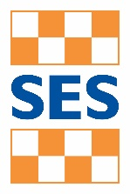
Flood warnings and emergency checklist

Bureau of Meteorology Warnings

Warnings are issued by the Bureau of Meteorology (BoM) to tell people about possible flooding.

A Flood Watch means there is a developing weather pattern that might cause floods in one or two days. This service covers the whole state.

A Flood Warning means flooding is about to happen or is already happening. There are minor, moderate and major flood warnings. This service is only available where flood warning systems are in place.
  A Minor Flood Warning means floodwater can: |   A Moderate Flood Warning means floodwater can: |   A Major Flood Warning means floodwater can:
Spill over river banks and cover nearby low lying areas. | Spill over river banks and cover larger areas of land. | Cause widespread flooding.
Come up through drains in nearby streets. | Reach above floor levels in some houses and buildings. | Many houses and businesses are inundated above floor level.
Require the removal of stock in some cases. | Require evacuation in some areas. | Cause properties and whole areas to be isolated by water.
Cover riverside camping areas and affect some low-lying caravan parks. | Affect traffic routes. | Closes major roads and rail routes.
Cover minor roads paths, tracks and low level bridges. | Require the removal of stock in rural areas. | Require many evacuations.
Affect backyards and buildings below floor level. |  | Affect utility services (power, water, sewage etc).
Severe Thunderstorm Warnings
Thunderstorms are classified as severe when there is potential to cause significant localised damage through wind gusts, large hail, tornadoes or flash flooding. Severe Thunderstorm Warnings are issued to the community by BoM.
Severe Weather Warnings
These warnings are issued to the community by BoM when severe weather is expected that is not directly related to severe thunderstorms or bushfires. Examples of severe weather include damaging winds and flash flooding.
Flash Flooding
- Flash Flooding can occur quickly due to heavy rainfall. You may not receive an official warning.
- Stay informed- monitor weather warnings, forecasts and river levels at the BoM website and warnings through
VicEmergency.

VICSES Warnings
VICSES utilises the VicEmergency app, website and hotline to distribute flood warnings and emergency information in Victoria. You can also access this information through our social media channels and emergency broadcasters.
VICSES warnings aim to provide you with information to help you make good decisions to protect yourself and your family.
The warning level is based on severity, conditions and the likelihood of community impact.
WARNING LEVELS
 | EMERGENCY WARNING  You are in imminent danger and need to take action immediately. You will be impacted. A Major flood warning usually fits into this category.
 | WARNING (WATCH AND ACT)  An emergency is developing nearby. You need to take action now to protect yourself and others. A Moderate flood warning usually fits into this category.
 | ADVICE  An incident is occurring or has occurred in the area. Access information and monitor conditions. Can also be used as a notification that activity in the area has subsided and is no longer a danger to you. A Minor flood warning or Flood Watch usually fits into this category.
ADDITIONAL MESSAGES
 | PREPARE TO EVACUATE/ EVACUATE NOW  An evacuation is recommended or procedures are in place to evacuate.
 | COMMUNITY INFORMATION  Updates for communities affected by an emergency.  Can also be used as a notification that an incident has occurred but there is no threat to community.
 | EMERGENCY ALERT  During some emergencies, communities may be alerted by the sounding of a local siren, or by sending an SMS to mobile phones or a voice message to landlines.

Your emergency plan
Emergencies can happen at any time, with little warning. People who plan and prepare for emergencies reduce the impact and recover faster.

Taking the time to think about emergencies and make your own plan helps you think clearly and have more control to make better decisions when an emergency occurs.
Visit redcross.org.au/prepare start creating your plan.
- Remember, you may not receive any official warning.
- Emergency assistance may not be immediately available. Be aware of what is happening around you to stay safe.
- Never wait for a warning to act.

Emergency Kit
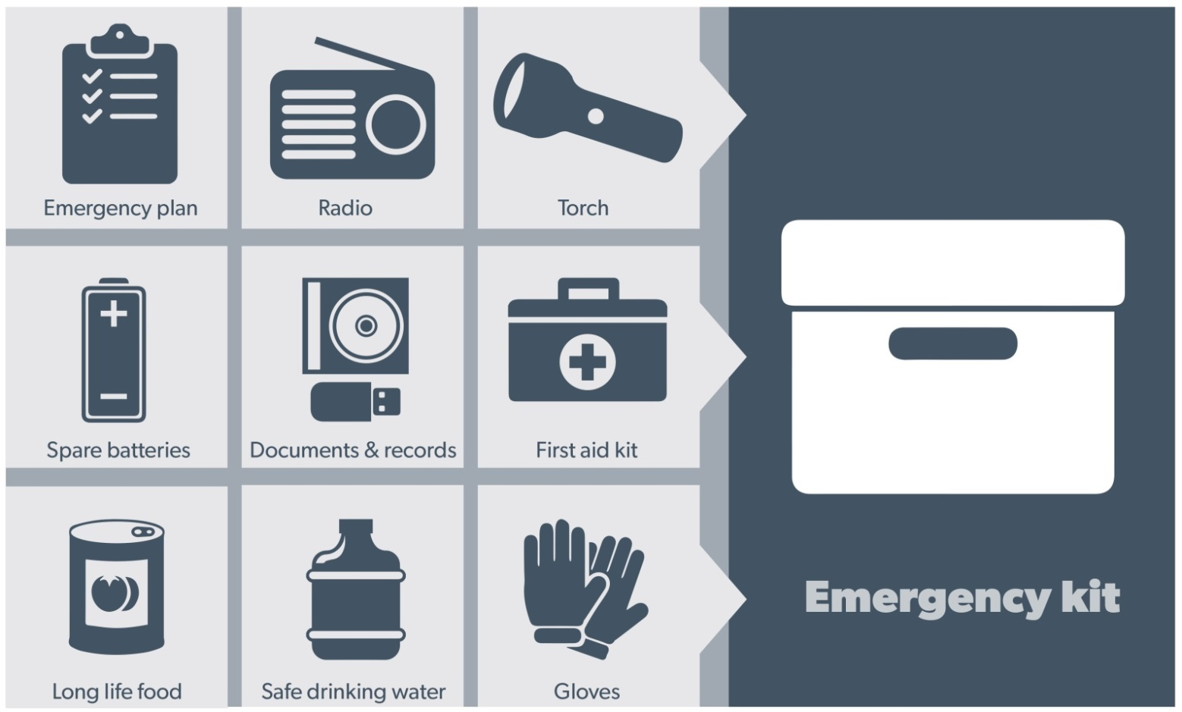
Visit Emergency Toolkit for more information
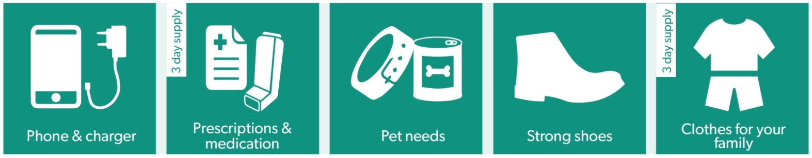
Every home and business should have a basic emergency kit with a supply of 3 days:
Check your kit often. Make sure things work. Replace out of date items.

When a warning is issued, have ready for use or pack into your kit:

I need to add:
- Special needs (eg, babies,
- Elderly)
- Photos
- Family keepsakes
- Valuables
- Other

Write your list here. Tick items as you pack them into your kit

Emergency Checklist

- Check if your insurance policy covers flooding.
- Keep this list of emergency numbers in your mobile phone
- Download the Vic Emergency app on your mobile phone.
- Put together an emergency kit and prepare a home or business emergency plan, see redcross.org.au/prepare

Before Flooding
- Leaving early before flooding occurs is always the safest option. Evacuating through floodwater is very dangerous and you may be swept away.
- Stay informed- monitor weather warnings, forecasts and river levels at bom.vic.gov.au and warnings through emergency.vic.gov.au.
- Secure objects likely to float and cause damage.
- Listen to the radio and check the VICSES website for information and advice.
- Go over your emergency plan. Pack clothing and other extra items into your emergency kit and take this with you if you evacuate.
- If you are staying in a caravan, move to higher ground before flooding begins.

During Flooding
- Make sure your family members and neighbours are aware of what is happening.
- Conditions change rapidly; roads and escape routes can be covered or blocked.
- Put household valuables and electrical items as high as possible.
- Turn off water, gas and electricity at the mains.
- Seek shelter indoors, away from floodwater.
- If floodwater comes inside, move to a higher point such as a kitchen bench or second storey.
- Stay away from trees, drains, low-lying areas, creeks, canals, culverts and floodwater.

Evacuating in Flooding
- Flood water is dangerous. Stay safe by never entering flood water. It can take just 15cm of water to float a car.
- Find alternative travel routes if roads or underpasses are flooded.
- Be aware of driving hazards, such as mud, debris, damaged roads and fallen trees. If driving conditions are dangerous, safely pull over away from trees, drains and floodwater.

After Flooding
- For recovery information, contact your local council, go to the VicEmergency Relief and Recovery- emergency.vic.gov.au/Relief page or call the VicEmergency Hotline (1800 226 226).
- Have all electrical and gas equipment professionally tested before use.
- Stay away from damaged and flooded buildings, fallen trees and powerlines, and damaged roads. Drive slowly, obey all road signs and never drive through floodwater.
- When cleaning, protect your health and safety. Wear strong boots, gloves and protective clothing.

For VICSES emergency assistance, call 132 500, or Triple Zero (000) in life threatening emergencies.

