
Rural City of Wangaratta
FLOOD & STORM EMERGENCY PLAN

A Sub-Plan of the Municipal Emergency Management Plan

For Rural City of Wangaratta

and

VICSES Wangaratta Unit

Version 1.3, January 2022





This page is left Intentionally Blank

Table of Contents
A Sub-Plan of the Municipal Emergency Management Plan 1
For Rural City of Wangaratta 1
and 1
VICSES Wangaratta Unit 1
DRAFT Version 1.3, 2021 1
This page is left Intentionally Blank ii
Distribution of MFSEP vi
Document Transmittal Form / Amendment Certificate vi
List of Abbreviations & Acronyms vii
Part 1. Introduction 8
1.1 Approval and Endorsement 8
1.2 Purpose and Scope of this Flood & Storm Emergency Plan 2
1.3 Municipal Flood & Storm Planning Committee (MFSPC) 2
1.4 Responsibility for Planning, Review & Maintenance of this Plan 2
Part 2. BEFORE: Prevention / preparedness arrangements 3
2.1 Community Engagement and Awareness 3
2.2 Structural Flood Mitigation Measures 3
2.3 Non-structural Flood Mitigation Measures 6
2.3.1 Exercising the Plan 6
2.3.2 Flood & Storm Warnings 6
2.3.3 Local Knowledge 6
2.3.4 Snap Send Solve – Flood Observations 6
Part 3. DURING: Response arrangements 7
3.1 Introduction 7
3.1.1 Activation of Response 7
3.1.2 Responsibilities 7
3.1.3 Emergency Coordination Centre or equivalent 7
3.1.4 Escalation 7
3.2 The six C’s 8
3.2.1 Control 8
3.2.2 Incident Controller (IC) 8
3.2.3 Incident Control Centre (ICC) 8
3.2.4 Divisions and Sectors 9
3.2.5 Incident Management Team (IMT) 9
3.2.6 Emergency Management Team (IEMT) 9
3.2.7 On Receipt of a Flood Watch / Severe Weather Warning 9
3.2.8 On Receipt of the First and Subsequent Flood Warnings 10
3.3 Initial Impact assessment 11
3.4 Preliminary Deployments 11
3.5 Response to Flash Flooding 11
3.6 Evacuation 12
3.7 Flood Rescue 12
3.8 Aircraft Management 12
3.9 Resupply 13
3.10 Essential Community Infrastructure and Property Protection 13
3.11 Disruption to Services 14
3.12 Road Closures 14
3.13 Dam Spilling/ Failure 14
3.14 Waste Water related Public Health Issues and Critical Sewerage Assets 14
3.14.1 Public Health Issues and Critical Sewerage Assets 15
3.14.2 Preventing Illness from Contaminated Water 15
3.15 Access to Technical Specialists 15
3.16 After Action Review 15
Part 4. AFTER: Emergency relief and recovery arrangements 16
4.1 General 16
4.2 Emergency Relief 16
4.3 Animal Welfare 16
4.4 Transition from Response to Recovery 16
Appendix A: Flood threats for Rural City of Wangaratta 17
Historic Floods 18
Dam Spilling/ Failure 21
Overview of Flooding Consequences 22
Flood Mitigation 24
Appendix A1: Storm threats for Rural City of Wangaratta 28
Overview 28
Appendix B: Typical flood peak travel times 33
Appendix C1: River Systems Overview & Schematics (Ovens, King Rivers & 15 Mile Creek) 34
Appendix C2: Flood Intelligence Card – Ovens River at Rocky Point - Use for Whorouly 37
Gauge Location: Ovens River at Rocky Point 37
Appendix C3: Flood Intelligence Card – King River at Cheshunt, Docker Rd & Hurdle Creek 39
Gauge Location: King River – various gauges 39
Appendix C4: Flood Intelligence Card – Ovens River at Wangaratta 47
Gauge Location: Ovens River at Wangaratta 47
Appendix C5: Flood Intelligence Card – Fifteen Mile Creek (Including One & Three Mile Creeks) 61
Gauge Location: Fifteen Mile Creek at Greta South 61
Appendix D - Flood evacuation arrangements & triggers 68
Phase 1 - Decision to Evacuate 68
Phase 2 – Warning 70
Phase 3 – Withdrawal 70
Phase 4 – Shelter 71
Phase 5 – Return 72
Disruption to Services 73
Essential Community Infrastructure and Property Protection 73
Appendix E: Public Information and Warnings 74
Appendix F: Maps 76
Appendix G: Local knowledge arrangements 87
Snap Send Solve 87
Appendix H: Local flood & Storm information 88
Local Flood Guides 88
How to use Sandbags to protect your home 88
Appendix I: Victoria State Emergency Service Statewide Guideline – Sandbags 89

Distribution of MFSEP

Once endorsed and signed the, MFSEP should be distributed to all MFSEP committee members, MEMPC Chair, council, MEMO, Deputy MEMO, Representatives from; BoM, CMA, DELWP, Parks Victoria, Ambulance Victoria, VicRoads, DFFH, relevant utilities, FRV, MERC, RERC, Police station, VICSES Units, VICSES Regional office, CFA Brigades, CFA Regional office,

Document Transmittal Form / Amendment Certificate
This Municipal Flood & Storm Emergency Plan (MFSEP) will be amended, maintained, and distributed as required or every 3 years facilitated by VICSES in consultation with the Municipal Emergency Management Planning Committee (MEMPC)
Suggestions for amendments to this Plan should be forwarded to VICSES Regional Office via

Regional Manager
North East Region
Victoria State Emergency Service
64 Sydney Road, Benalla,
Victoria 3672

Phone: (03) 9256 9650
Fax: (03) 9256 9671
Email: northeast@ses.vic.gov.au

Amendments listed below have been included in this Plan and updated as a new version.
Amendment  Number | Date of  Amendment | Amendment  Entered By | Summary of Amendment
V1.1 | Oct 2018 | Charlie Sexton | Update the 2014 MFEP and Incorporate storm hazard into the plan. Update with the 2018 Wangaratta Urban Flood Study data and update into the new VICSES template.
V1.2 | Oct 2020 | Toby Richards | Update of actions in the intel flood cards and ensure data from flood study is correct
V1.3 | Jan 2022 | Charlie Sexton | Update intel card actions and input Flood Study data  Update changes to the EMLA Act 2018 and references to the new SEMP  Approval by the RCOW MEMPC
This Plan will be maintained on the VICSES website at www.ses.vic.gov.au/get-ready/your-local-flood-information and https://www.wangaratta.vic.gov.au/

List of Abbreviations & Acronyms
The following abbreviations and acronyms are used in the Plan
AAR | After Action Review | IEMT | Incident Emergency Management Team
AEP | Annual Exceedance Probability (%) | IMT | Incident Management Team
AHD | Australian Height Datum (the height of a location above mean sea level in metres) | IMS | Incident Management System
AIDR | Australian Institute of Disaster Resilience | IWO | Information & Warnings Officer
ARI | Average Recurrence Interval (years) | JSOP | Joint Standard Operations Procedure
AV | Ambulance Victoria | LSIO | Land Subject to Inundation Overlay
BoM | Bureau of Meteorology | MEMO | Municipal Emergency Management Officer
CALD | Culturally and Linguistically Diverse | MEMP | Municipal Emergency Management Plan
CERA | Community Emergency Risk Assessment | MEMPC | Municipal Emergency Management Planning Committee
CFA | Country Fire Authority | MERC | Municipal Emergency Response Coordinator
CMA | Catchment Management Authority | MFSEP | Municipal Flood & Storm Emergency Plan
RERC | Regional Emergency Response Coordinator | MFSEPC | Municipal Flood & Storm Emergency Planning Committee
DFFH | Department of Families, Fairness and Housing | MRM | Municipal Recovery Manager
DJPR | Department of Jobs Precincts and Regions (Ag Vic) | PIO | Public Information Officer
DELWP | Department of Environment, Land, Water and Planning | PMF | Probable Maximum Flood
DRA | Dynamic Risk Assessment | PV | Parks Victoria
EA | Emergency Alert | RAC | Regional Agency Commander
EMCOP | Emergency Management Common Operating Picture | RCC | Regional Control Centre
EMLO | Emergency Management Liaison Officer | RCOW | Rural City of Wangaratta
EMT | Emergency Management Team | RDO | Regional Duty Officer
EMV | Emergency Management Victoria | RFEP | Regional Flood Emergency Plan
ERC | Emergency Relief Centre | RRV | Regional Roads Victoria
FO | Floodway Overlay | SAC | State Agency Commander
FRV | Fire Rescue Victoria | SBO | Special Building Overlay
GAR | Great Alpine Road | SCC | State Control Centre
IC | Incident Controller | SDO | State Duty Officer
IIA | Initial Impact Assessment | SEMP | State Emergency Management Plan
SEWS | Standard Emergency Warning Signal | VICSES | Victoria State Emergency Service
VICPOL | Victoria Police

- Introduction

Approval and Endorsement
This Municipal Flood & Strom Emergency Plan (MFSEP) has been prepared by the (Municipal Flood & Storm Planning Committee) and with the authority of the Rural City of Wangaratta MEMPC) –pursuant to Section 20 of the Emergency Management Act 1986 (as amended).
The Wangaratta MFSPC have undertaken the following consultations with the community about the arrangements contained within this plan:
- RCOW MEMPC community representative
This MFSEP is a sub plan to the Rural City of Wangaratta Emergency Management Plan (MEMP), is consistent with the Emergency Management Legislation Amendment Act 2018 (EMLA Act) and the Victorian Floodplain Management Strategy (2016), and takes into account the outcomes of the Community Emergency Risk Assessment (CERA) process undertaken by the Municipal Emergency Management Planning Committee (MEMPC).
The MFSEP is consistent with the Regional Flood Emergency Plan (RFEP) and the State Emergency Management Plan (SEMP) – Flood sub-plan.
This MFSEP is a result of the cooperative efforts of the MFSPC and its member agencies.
This Plan is approved by the VICSES Regional Manager.
This Plan is endorsed by the Rural City of Wangaratta MEMPC as a sub-plan to the MEMP.

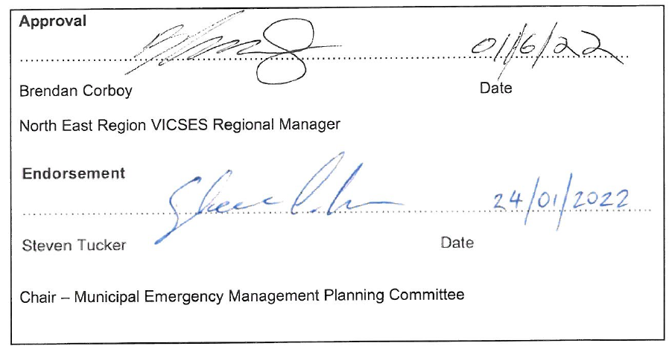
Purpose and Scope of this Flood & Storm Emergency Plan
The purpose of this MFSEP is to detail arrangements agreed for managing a flood emergency before, during and after it occurs or potentially occurs within the Rural City of Wangaratta.
As such, the scope of the Plan is to:
- Identify the local flood risk;
- Support the implementation of mitigation and planning measures to minimise the causes and impacts of flooding;
- Detail emergency management arrangements;
- Identify linkages with Local, Regional and State emergency and wider planning arrangements with a specific emphasis on those relevant to flood.

Municipal Flood & Storm Planning Committee (MFSPC)
Membership of the Rural City of Wangaratta Flood & Storm Planning Committee (MFSPC) comprises of the following representatives from the following agencies and organisations:
- VICSES (i.e. Unit Controller & Regional Officer – Emergency Management, CRC as required) (Chair),
- Council (i.e. Municipal Emergency Resource Officer)
- Victoria Police (i.e. Municipal Emergency Response Co-ordinator) (MERC),
- North East Catchment Management Authority (NECMA),
- Department of Families, Fairness and Housing (DFFH) as required,
- Department of Environment, Land, Water and Planning (DELWP) as required,
- Water Authorities as required,
- Bureau of Meteorology as required,
- Local community representatives

Responsibility for Planning, Review & Maintenance of this Plan
This MFSEP must be maintained to remain effective.
VICSES through the MFSPC has responsibility for facilitating the preparation, review, maintenance and distribution of this plan.
The MFSPC will meet at least once per year. The plan should be reviewed following:
- A new flood study;
- A significant change in flood mitigation measures;
- After the occurrence of a significant flood event within the Municipality;
- Or if none of the above occur, every 3 years.

- BEFORE: Prevention / preparedness arrangements

Community Engagement and Awareness
Details of this MFSEP will be released to the community through; local media, any Flood and Storm engagement initiatives and websites (VICSES and the Municipality) upon formal adoption of this plan by VICSES and the Rural City of Wangaratta MEMPC.
VICSES with the support of Rural City of Wangaratta and North East CMA will coordinate and deliver targeted community flood and storm engagement programs within the council area, including Local Flood Guides.
Refer to appendix H - LFG Storm and Flood Information.

Structural Flood Mitigation Measures
The following summary of structural flood mitigation measures exist within the Council area:
Refer to Appendix C for detailed information of structural flood mitigation measures.
It should be noted that additional discussion and consensus is required between RCoW and DELWP on the ownership and maintenance responsibilities for structures listed in the above table under “Public Levees”
Note: Contact details of private property’s included in this section are available at request from RCoW and are included as a Library within Crisisworks.
Flood Mitigation Type | Description | Owner* | Maintenance Responsibility | Protection Level
PUBLIC LEVEES
Wilson Road Levee | 2.17km Earth Levee | DEWLP | RCoW | The entirety of the Wilson Rd levee provides protection to the 1% AEP event however, no sections achieve 600mm freeboard. Freeboard ranges from 50mm to 500mm.
Parfitt Road Levee | 3.46km Combination of Earthen, Road and Concrete Wall | DEWLP | RCoW | The Parfitt road levee consists of two separate levees to The entirety of the Parfitt 1 (west) levee provides 1% AEP event flood protection with the wall section between chainages 80 to 400 having greater than 600 freeboard and a large section between chainage 580 to 1177 (end of levee – Banks Road) having 600mm or greater freeboard. The remaining chainages largely fall within the 300mm-600mm freeboard range. The Parfitt 2 (east) levee also provides 1% AEP event flood protection along the entire length, although none has 600mm or more freeboard from the 1% AEP flood profile. Approximately half of the levee has less than 300mm freeboard (150mm-300mm) with the other half between 300mm and 600mm freeboard
Flood Mitigation Type | Description | Owner* | Maintenance Responsibility | Protection Level
Sunset Drive Levee | Combined Earthen and Concrete Wall | DEWLP | RCoW | The entirety of the Sunset Drive levee provides protection to the 1% AEP event however, no sections achieve 600mm freeboard. Freeboard ranges from 250mm to 450mm.  There is a gate valve installed on the stormwater outlet of the Levee, the gate valve can be actuated to stop flow and allow a pump to discharge the area, such that rising levels in the creek don’t backflow and inundate adjacent homes.
Merriwa Park Levee | Earth Levee | DEWLP | RCoW | The Merriwa Park levee is 300mm to 450mm below the 1% AEP Event flood level, hence to achieve 600mm freedboard it requires 900mm to 1050mm height increase.
Diversion Channel | Diversion Channel 2.8km from the One Mile Creek to the Ovens Rivers alongside the south-eastern side of the Hume Freeway |  | RCoW
Markwood Levee | Older earthen levee over various sections along Ovens River from Henley Ridge to Pioneer Bridge. Tea Garden Creek off take in here somewhere. |  | Query - NECMA | Concern about impact of diverting river flow near Pioneer Bridge.
Fishers Levee | Old unmaintained levee on Ovens River at end of Fisher Lane, East Wangaratta.
PRIVATE LEVEES FOR PROPERTY PROTECTION
- 113 Wilson Road | Concrete/earthen wall with drop-in boards at driveways | Property Owner | Property owner | Sandbags, drop boards and plastic sheeting is place at the property. Being prepared for sale Aug 2021
- “Glenloth” – 171 Oxley Flats Road | Concrete barrier with earthen ramp as driveway | Property owner | Property owner | Owner has 25 years on the property with good situational awareness. 12.8m (on the Ovens River gauge at Wangaratta) is the approximate limit of their levee. 1993 flood did not enter the residence.
- 170 Wilson Road, Wangaratta | Portable inflatable levee provided by Flood mitigation scheme. Levee stored at property in trailer | Property owner | Property owner | Four (4) bladders form the basis of the levee system. Requires 4 people to move the units around. Requires pump to transfer water from billabong (at rear of house) to inflate the bladders. Bulk water supply can also be brought in to inflate bladders.
- 22 Taylors Lane, Wangaratta | Drop in boards at edge of house. Done under Flood Mitigation Scheme. | Property owner | Property owner | Informed by the owner that the residence does not flood
Flood Mitigation Type | Description | Owner* | Maintenance Responsibility | Protection Level
- 132 Stamps Lane, North Wangaratta | Concrete block wall. Drop in gates. Done under Flood Mitigation scheme. | Property owner | Property owner | 6 inch freeboard around private levee during 1993 flood event.
- Ambrosio house – 65 Burrows Street, North Wangaratta | Brick wall at front, earthen levee at sides and rear of residence. Drop-in gates for driveway | Property Owner | Property Owner | First flood event (assuming 1993?) water rose 18 inches from (bottom) of this levee. No breaches detected through timber boards and sandbags that were utilised.
- 57 Bowser Road, North Wangaratta | Earthen wall, access over wall. Done under Flood Mitigation Scheme. | Property Owner | Property Owner | No evidence of water ever been through this house. Pers comm New Owner.
- Alan Gibb House – 1100 Carboor Everton Road, Bobinawarrah. | Privately constructed earthen levee to protect house which was inundated in 1993 from Hurdle Creek. | Property Owner | Property Owner
Private levees for grazing protection
1. Frank Griffiths – Griffiths Lane, Laceby | Privately constructed earthen levee in excess of 20 years old. Diverts 15 Mile Creek water. May affect adjoining property | Property Owner | Property Owner
2. Geoff Cheshire – O’Keefe Road, Boorhaman | Privately constructed earthen levee on Ovens River. | Property Owner | Property Owner
Wangaratta Township Retardation Basins
• Various Township Retarding Basins | Retention / Bioretention basins deigned for the collection of surface waters | RCOW | RCOW | Basins deigned for the collection of surface waters off specific residential and industrial estates are located at: Thurles Avenue, Cormorant Way, Bowerbird Way, Liddell Drive, Macquarie Court, Weir Street, Fairway Drive, Wonga Park Drive, Morgan Road, Woodland Grove, Silver Wattle Drive, Pauline Terrace, Salisbury Street, Willow Drive, Trotman Drive / Maple Circuit, and, Murrell Street
Wangaratta Township Flood Pumps
Various Township Flood pumps | Flood pumps that service flood and/or retention/retardation basin requirements across Wangaratta | RCOW | RCOW | There are 22 pumps across Wangaratta township. These are set to Automatic, with the level at which they commence dictated by the area / location they need to pump.  All pumps are tested on a weekly basis.
NOTE: The Victorian Levee Guidelines have a requirement of 600mm freeboard from the 1% AEP. RCOW has received funding, 1/3 Federal, 1/3 State and 1/3 Local Governments to construct the Wilson Road, Parfitt Road, Sunset Drive and Merriwa Park Levee to this protection level. This construction will be stage starting in 22/23 Financial year. The below table lists in detail their current protection status.

Non-structural Flood Mitigation Measures

Exercising the Plan
Arrangements for exercising this Plan will be at the discretion of the MEMPC. It is recommended that the MFSEP is exercised on annual basis and reviewed in line with Section 1.4.

Flood & Storm Warnings
Arrangements for Bureau issued Flood Watch, Flood Warning and Storm Warnings products are contained within the SEMP Sub Plan – Flood (www.ses.vic.gov.au/em-sector/vicses-emergency-plans) and on the Bureau of Meteorology (BoM) website www.bom.gov.au.
Details on Warnings issued by VICSES through VicEmergency and VICSES channels are outlined in Appendix E.

Local Knowledge
Community Observers provide local knowledge to VICSES and the Incident Control Centre regarding local insights and the potential impacts and consequences of an incident and may assist with the dissemination of information to community members.
Specific details of arrangements to capture local knowledge are provided in Appendix G.

Snap Send Solve – Flood Observations
Snap Send Solve is an existing app currently used by the community to notify local councils and other authorities of issues that need addressing such as cracked pavements, parking problems, dumped rubbish, graffiti etc.
The existing functionality of the smartphone app has been adapted for VICSES in a well presented and user friendly way. The app is used to capture flood observations by filling in a simple form on your smartphone and using the camera to upload photos, this information is then displayed through an administration portal in EMCOP to collate and view the flood data.
The app component has been made available to flood observers in VICSES Units with plans for other emergency services and trusted members of the community. Their observations will be visible in EMCOP where Intelligence personnel in IMT’s can access them during flood events.
The intent is that better access to local knowledge and near real time impacts will add to information sources in order to maximise public information communications and flood response efforts.
- DURING: Response arrangements

Introduction

Activation of Response
Flood & Storm response arrangements may be activated by the Regional Duty Officer (RDO) VICSES North East Region or Regional Agency Commander (RAC).
The VICSES Incident Controller (IC)/RDO will activate agencies as required as documented in the State Emergency Management Plan – Flood/Storm.

Responsibilities
There are a number of agencies with specific roles that will act in support of VICSES and provide support to the community in the event of a serious flood or storm within the Rural City of Wangaratta. These agencies will be engaged through the EMT.
The roles and responsibilities of supporting agencies are as agreed within the SEMP, Table 10 – Response support agencies and SEMP Sub Plan – Flood/storm and Regional Flood/storm Emergency Plan.

Emergency Coordination Centre or equivalent
If established, liaison with the emergency coordination centre will be through the established Division/Sector Command and through Municipal involvement in the IEMT, in particular the Municipal Emergency Response Coordinator (MERC). The VICSES RDO / ICC will liaise with the centre directly if no Division/Sector Command is established.
The function, location, establishment and operation of an emergency coordination centre if relevant will be as detailed in the MEMP.

Escalation
Many flood incidents are of local concern and an appropriate response can usually be coordinated using local resources. However, when these resources are exhausted, the State’s arrangements provide for further resources to be made available, firstly from neighbouring Municipalities (on a regional basis) and then on a State-wide basis.
Resourcing and event escalation arrangements are described in the SEMP.

The six C’s
Arrangements in this MFSEP must be consistent with the 6 C’s detailed in State and Regional Flood & Storm Emergency Plans and the MEMP. For further information, refer to the SEMP.
- Command: Overall direction of response activity in an emergency.
- Control: Internal direction of personnel and resources within an agency.
- Coordination: Bringing together agencies and resources to ensure effective preparation for response and recovery.
- Consequence: Management of the effect of emergencies on individuals, communities, infrastructure and the environment.
- Communication: Engagement and provision of information across agencies and proactively with the community around preparation, response and recovery in emergencies.
- Community Connection: Understanding and connecting with trusted networks, leaders and communities around resilience and decision making.
Specific details of arrangements for this plan are to be provided in Appendix C.

Control
Functions 5(a) and 5(c) at Part 2 of the Victoria State Emergency Service Act 1986 (as amended) detail the authority for VICSES to plan for and respond to flood.
Table 9 – Roles and Responsibilities in the SEMP prepared under the ELMA Act 2018, identifies VICSES as the Control Agency for Flood and Storm. It also identifies a number of support agencies in Table 10. A more detailed explanation of roles and responsibilities can be found in the tables on the EMV website.
The SEMP identifies DELWP as the Control Agency responsible for “dam safety, water and sewerage asset related incidents” and other emergencies. A more detailed explanation of roles and responsibilities is available on the EMV website
All flood response activities within the Rural City of Wangaratta including those arising from a dam failure or retarding basin / levee bank failure incident will therefore be under the control of the appointed IC, or delegated representative.

Incident Controller (IC)
An Incident Controller (IC) will be appointed by the VICSES (as the Control Agency) to command and control available resources in response to a flood or storm event on the advice of the Bureau of Meteorology (or other reliable source) that a flood or storm event will occur or is occurring. The IC responsibilities are as defined in the SEMP.

Incident Control Centre (ICC)
As required, the IC will establish an Incident Control Centre (ICC) from which to initiate incident response command and control functions. The decision as to if and when the ICC should be activated, rests with the Control Agency (i.e. VICSES).
Pre-determined ICC locations are available in the RCOW MEMP

Incident Level | Location | ICC Location | Facility owner | Key contact
2 | VICSES Hume Regional Office | 64 Sydney Road, Benalla | VICSES | Benalla SES ICC  (03) 9256 7799 or RAC
3 | CFA District 23 Headquarters | 1 Ely Street, Wangaratta | CFA | Wangaratta ICC  (03) 5720 2300 or CFA duty officer

Divisions and Sectors
To ensure that effective Command and Control arrangements are in place, the IC may establish Divisions and sectors depending upon the complexity of the event and resource capacities.
The following Divisions and Sectors may be established to where applicable to assist with the management of flooding or storm response within the Municipality:
Division | Sector
Wangaratta DCP – SES Wangaratta LHQ, 36 Handley Street, Wangaratta VIC 3676  03 5722 1900 | Wangaratta DCP – SES Wangaratta LHQ, 36 Handley Street, Wangaratta VIC 3676  03 5722 1900

VICSES Field Operations Vehicles (FOVs) are also available for deployment where appropriate through the VICSES North East RDO.

Incident Management Team (IMT)
The IC will form an Incident Management Team (IMT).
Refer to the SEMP for guidance on IMTs and Incident Management Systems (IMSs).

Emergency Management Team (IEMT)
The IC will establish a multi-agency Incident Emergency Management Team (IEMT) to assist the flood or storm response. The IEMT consists of key personnel (with appropriate authority) from stakeholder agencies and relevant organisations who need to be informed of strategic issues related to incident control. They are able to provide high level strategic guidance and policy advice to the IC for consideration in developing incident management strategies.
Organisations, including Rural City of Wangaratta required within the IEMT will provide an Emergency Management Liaison Officer (EMLO) to the ICC if and as required as well as other staff and / or resources identified as being necessary, within the capacity of the organisation.
Refer to the SEMP for guidance on IEMTs.

On Receipt of a Flood Watch / Severe Weather Warning
VICSES SOP008 and SOP009 outline in detail the actions to be undertaken upon receipt of a Flood Watch/Flood Warning or Severe Weather Warning. VICSES RDO (until an Incident Controller is appointed) or IC will undertake actions as defined within the flood intelligence cards (Appendix C). General considerations by the IC/VICSES RDO will be as follows:
- Ensure flood warnings and community information is prepared and issued to the community where required
  - Flood (Riverine and flash) Warnings are managed by the RDO/RAC
  - Severe Weather/ Thunderstorm warnings are managed by SDO/SAC
- Review flood intelligence to assess likely flood consequences and add to flood warning
- Monitor weather and flood information – www.bom.gov.au and BOM Flood Desk
- Assess Command and Control requirements.
- Review local resources and consider needs for further resources regarding personnel, property protection, flood/swift water rescue and air support
- Notify and brief appropriate officers. This includes Regional Control Centre (RCC) (if established), State Control Centre (SCC) (if established), Council, other emergency services through the EMT.
- Assess ICC readiness (including staffing of IMT and IEMT) and open if required
- Develop media and public information management strategy
- Monitor watercourses and undertake reconnaissance of low-lying areas, initiating Flood Observers
- Ensure flood mitigation works are being checked by owners
- Develop and issue incident action plan, if required
- Develop and issue situation report, if required

On Receipt of the First and Subsequent Flood Warnings
VICSES RDO (until an Incident Controller is appointed) or IC will undertake actions as defined within the flood intelligence cards (Appendix C). General considerations by the IC/VICSES RDO will be as follows:
- Develop an appreciation of current flood levels and predicted levels. Are floodwaters, rising, peaking or falling?
- Review flood intelligence to assess likely flood consequences.
- Consider:
- What areas may be at risk of inundation?
- What areas may be at risk of isolation?
- What areas may be at risk of indirect affects as a consequence of power, gas, water, telephone, sewerage, health, transport or emergency service infrastructure interruption?
- The characteristics of the populations at risk
- Determine what the at-risk community need to know and do as the flood develops.
- Warn the at-risk community including ensuring that an appropriate warning and community information strategy is implemented including details of:
- The current flood situation
- Flood predictions
- What the consequences of predicted levels may be
- Public safety advice
- Who to contact for further information
- Who to contact for emergency assistance
- Liaise with relevant asset owners as appropriate (i.e. water and power utilities)
- Implement response strategies as required based upon flood consequence assessment.
- Continue to monitor the flood situation – www.bom.gov.au/vic/flood/
- Continue to conduct reconnaissance of low-lying areas

Initial Impact assessment
Initial impact assessments will be conducted in accordance with the SEMP & Victorian Preparedness Framework to assess and record the extent and nature of damage caused by flooding. This information may then be used to provide the basis for further needs assessment and recovery planning by DFFH and recovery agencies.

Preliminary Deployments
When flooding or storms are expected to be severe enough to cut access to towns, suburbs and/or communities the IC will consult with relevant agencies to ensure that resources are in place if required to provide emergency response. These resources might include emergency service personnel, specialist equipment (e.g Sandbagging machine) food items and non-food items such as medical supplies, shelter, assembly areas, relief centres etc.

Response to Flash Flooding
Emergency management response to flash flooding should be consistent with the guideline for the emergency management of flash flooding contained within the State Emergency Management Plan (SEMP) - Flood.
When conducting pre-event planning for flash floods the following steps should be followed, and in the order as given:
- Determine if there are barriers to evacuation by considering warning time, safe routes, resources available and etc;
- If evacuation is possible, then evacuation should be the adopted strategy and it must be supported by a public information capability and a rescue contingency plan;
- Where it is likely people will become trapped by floodwaters due to limited evacuation options safety advice needs to be provided to people at risk. Advice should be given to not attempt to flee by entering floodwater if they become isolated, it may be safer to seek the highest point within the building and to telephone 000 if they require rescue.
- For buildings known to be structurally un-suitable an earlier evacuation trigger will need to be established (return to step 1 of this cycle).
- If an earlier evacuation is not possible then specific preparations must be made to rescue occupants trapped in structurally unsuitable buildings either pre-emptively or as those people call for help.
- Contact the Rural City of Wangaratta MERC and MEMO at the earliest opportunity to allow for relief preparation to commence.
Due to the rapid development of flash flooding it will often be difficult, to establish relief centres ahead of actually triggering the evacuation. This is normal practice, but this is insufficient justification for not adopting evacuation.

Evacuation
The IC decides whether to warn people to evacuate or if it is recommended to evacuate immediately.
Once the decision is made VicPol are responsible for the management of the evacuation process where possible. VICSES and other agencies will assist where practical. VICSES is responsible for the development and communication of evacuation warnings.
VicPol and/or Australian Red Cross may take on the responsibility of registering people affected by a flood emergency including those who have been evacuated.
Refer to the Victoria Police Roles and Responsibilities - Role Statement, as part of the SEMP
Refer to Appendix C of this Plan and the MEMP for additional local evacuation considerations for the municipality.

Flood Rescue
VICSES may conduct flood rescues. Appropriately trained and equipped VICSES units or other agencies that have appropriate training, equipment and support may carry out rescues.
Rescue operations may be undertaken where voluntary evacuation is not possible, has failed or is considered too dangerous for an at-risk person or community. An assessment of available flood rescue resources (if not already done prior to the event) should be undertaken prior to the commencement of Rescue operations.
Rescue is considered a high-risk strategy to both rescuers and persons requiring rescue and should not be regarded as a preferred emergency management strategy. Rescuers should always undertake a dynamic risk assessment (DRA) before attempting to undertake a flood rescue.
Victoria Police Rescue Coordination Centre should be notified of any rescues that occur: (03) 9399 7500
The following resources are available within Rural City of Wangaratta to assist with rescue operations:
Boat | Location
Boat 574 – Achilles SG-140 | VICSES Wangaratta Unit
Other vessels available from neighbouring Units at request of VICSES RDO
Known high-risk areas/communities (i.e. low-lying islands) where rescues might be required include:
- Painters Island Caravan Park, Pinkerton Cres, Wangaratta. (03) 5721 3380
  - Painters Island caravan park has an Emergency Plan with trigger points for closure and evacuation during floods. Initial Triggers for moving to higher ground occurs at the Minor Flood Level, 11.9m with a secondary trigger to close the park at 12.2m

Aircraft Management
Aircraft can be used for a variety of purposes during flood operations including evacuation, resupply, reconnaissance, intelligence gathering and emergency travel.
Air support operations will be conducted under the control of the IC
The IC may request aircraft support through the State Air Desk located at the SCC will establish priorities.
- Wangaratta Aerodrome is located 7km directly south of the city, close to the Hume Highway and is owned and operated by the Rural City of Wangaratta.
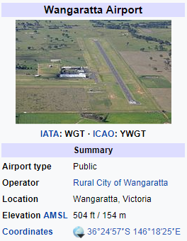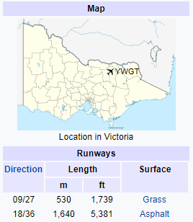

Resupply
Communities, neighbourhoods or households can become isolated during floods as a consequence of road closures or damage to roads, bridges and causeways. Under such circumstances, the need may arise to resupply isolated communities/properties with essential items.
When predictions/intelligence indicates that communities, neighbourhoods and/or households may become isolated, VICSES will advise businesses and/or households that they should stock up on essential items.
After the impact, VICSES can support isolated communities through assisting with the transport of essential items to isolated communities and assisting with logistics functions.
Resupply operations are to be included as part of the emergency relief arrangements with VICSES working with the relief agencies to service communities that are isolated.

Essential Community Infrastructure and Property Protection
Essential Community Infrastructure and Property (e.g. residences, businesses, roads, power supply etc.) may be affected in the event of a flood.
The Rural City of Wangaratta maintains a small stock of sandbags 3,000 and back-up supplies are available through the VICSES Regional Headquarters. The IC will determine the priorities related the use of sandbags, which will be consistent with the strategic priorities.
If VICSES sandbags are becoming limited in supply, then priority will be given to protection of Essential Community Infrastructure. Other high priorities may include for example the protection of historical buildings.
Property may be protected by:
- Sandbagging to minimise entry of water into buildings
- Encouraging businesses and households to lift or move contents
- Construction of temporary levees in consultation with the CMA, LGA and VICPOL and within appropriate approval frameworks.
The IC will ensure that owners of Essential Community Infrastructure are kept advised of the flood situation. Essential Community Infrastructure providers must keep the IC informed of their status and ongoing ability to provide services.
Contact your local VICSES representative for the most current Sandbag Guidelines or download it from IMT Toolbox in EMCOP- Operations.
Refer to Appendix C for further specific details of essential infrastructure requiring protection and location of sandbag collection point(s).

Disruption to Services
Disruption to services other than essential community infrastructure and property can occur in flood events. Refer to Appendix C for specific details of likely disruption to services and proposed arrangements to respond to service disruptions in Rural City of Wangaratta.

Road Closures
The Rural City of Wangaratta and Regional Roads Victoria (RRV) will carry out their formal functions of road closures including observation and placement of warning signs, road blocks etc. to its designated local and regional roads, bridges, walking and bike trails. The Rural City of Wangaratta staff should also liaise with and advise RRV as to the need or advisability of erecting warning signs and / or of closing roads and bridges under its jurisdiction. RRV is responsible for designated main roads and highways and councils are responsible for the designated local and regional road network.
RRV and Rural City of Wangaratta will communicate community information regarding road closures. Information will be updated on the VIC Traffic website: https://traffic.vicroads.vic.gov.au/
Refer to Appendix C for specific details of potential road closures.

Dam Spilling/ Failure
DELWP is the Control Agency for dam safety incidents (e.g. breach, failure or potential breach / failure of a dam), however VICSES is the Control Agency for any flooding that may result. VICSES has EMCOP warning templates for Dam failure scenarios. Emergency Alert (EA), does NOT have dam failure warning templates. Use Flood (Prepare to Evac or Evac Immediately template) Modify content to suit scenario.
DELWP have developed Dam Safety Emergency Plans for municipalities where it is applicable.
Major dams with potential to cause structural and community damage within the Municipality are contained in Appendix A.

Waste Water related Public Health Issues and Critical Sewerage Assets
Inundation of critical sewerage assets including septic tanks and sewerage pump stations may result in water quality problems within the Municipality. Where this is likely to occur or has occurred the responsibility agency for the critical sewerage asset should undertake the following:
- Advise VICSES of the security of critical sewerage assets to assist preparedness and response activities in the event of flood;
- Maintain or improve the security of critical sewerage assets;
- Check and correct where possible the operation of critical sewerage assets in times of flood;
- Advise the ICC in the event of inundation of critical sewerage assets.

It is the responsibility of the Rural City of Wangaratta Environmental Health Officer to inspect and report to the MEMO and the ICC on any water quality issues relating to flooding.

Public Health Issues and Critical Sewerage Assets
Inundation of sewerage assets including sewerage pump stations during surface flooding may result in water quality problems within the municipality. Where this is likely to or has occurred, the relevant Water Corporation will be responsible for:
- Identification and monitoring critical assets to assist preparedness and response activities in the event of flooding
- Advising VICSES/ICC of any potential or current service delivery continuity threats to critical sewerage infrastructure
- Developing action plan(s) in consultation with the Incident Controller to protect critical sewerage infrastructure assets
Inundation of septic tank systems may also result in similar water quality problems. In the event of flood waters contaminated by septic tank systems, the Rural City of Wangaratta Environmental Health Officer is to advise the ICC and relevant Water Corporation. Assessment and actions are detailed above.
North East Water on-call Duty Officer or Duty Manager support can be made via the MEMP contact list

Preventing Illness from Contaminated Water
Drinking water (potable reticulated water supply systems) have the capacity to deal with flood situations due to protective barriers such as positive pressure and chlorine unless there is damage to key infrastructure, or the system experiences a mains failure during the flood event. The relevant Water Corporation will be responsible for:
- Monitoring the performance and capacity of their respective potable water supply system
- Providing advice to the Incident Controller (IC) of any potential threat to supply or critical infrastructure
- Advising the IC whether town water (potable) supply is at risk, in consultation with the Incident Controller and Department of Health and Human Services will notify consumers and the community if the water is not safe to drink, including issuing the necessary advice (e.g. Boil Water Advisory Notice)
- Developing an action plan in consultation with the IC to protect critical water supply assets

The Municipal Environmental Health Officer will provide oversight and assistance for private domestic systems and support the relevant Water Corporation as needed.
The Incident Controller will develop drinking water warnings in consultation with the relevant Water Corporation(s) (e.g. North East Water for urban supplies and Goulburn-Murray Water for non-town water users for stock and domestic), Municipal Environmental Health Officer and Health Commander

Access to Technical Specialists
VICSES Manages contracts with private technical specialists who can provide technical assistance in the event of flood operations or geotechnical expertise. Refer to VICSES SOP061 for the procedure to engage these specialists.

After Action Review
VICSES will coordinate the after action review arrangements of flood operations as soon as practical following an event.
All agencies involved in the flood incident should be represented at the after action review.
- AFTER: Emergency relief and recovery arrangements

General
Arrangements for recovery from a flood incident within the Rural City of Wangaratta is detailed in the Rural City of Wangaratta MEMP Part 6.

Emergency Relief
The decision to recommend the opening of an emergency relief centre sits with the IC. The IC is responsible for ensuring that relief arrangements have been considered and implemented where required under the SEMP.
The range and type of emergency relief services to be provided in response to a flood event will be dependent upon the size, impact, and scale of the flood. Refer to the SEMP for details of the range of emergency relief services that may be provided.
Suitable relief facilities identified for use during floods are detailed in Appendix C and in the Rural City of Wangaratta MEMP.
Details of the relief arrangements are available in the MEMP.

Animal Welfare
Matters relating to the welfare of livestock and companion animals (including feeding and rescue) are to be referred to DJPR/Agriculture Victoria.
Requests for emergency supply and/or delivery of fodder to stranded livestock or for livestock rescue are passed to DJPR/Agriculture Victoria.
Matters relating to the welfare of wildlife are to be referred to DELWP.
Refer to Appendix C for animal shelter compound locations.

Transition from Response to Recovery
VICSES as the Control Agency is responsible for ensuring effective transition from response to recovery. This transition will be conducted in accordance with existing arrangements as detailed in the SEMP or the Rural City of Wangaratta MEMP.

Appendix A: Flood threats for Rural City of Wangaratta

This Appendix is to provide a broad overview of flood risk within the Municipality. Detailed Flood Risk Information for Individual Communities is be detailed in Appendix C.
- C1 – River Systems Overview (Ovens, King Rivers & 15 Mile Creek)
- C2 – Flood Intelligence Card – Ovens River at Rocky Point - Use for Whorouly
- C3 – Flood Intelligence Card – King River at Cheshunt, Docker Rd & Hurdle Creek
- C4 – Flood intelligence Card – Ovens River at Wangaratta
- C5 – Flood intelligence Card – Fifteen Mile Creek (Including One & Three Mile Creeks)

General

RIVERINE FLOODING
Flooding in the Fifteen Mile, One Mile and/or Three Mile Creeks can happen separately to flood in the Ovens and/or King Rivers. This means different parts of Wangaratta can be at risk depending on where floodwater is coming from.
The Wangaratta rural and urban environments are a complex flood plain with the Ovens, King and 15 Mile Creek systems flowing through the Municipality joining in the Wangaratta urban area and continuing on as the Ovens River to join the Murray River at Bundalong.
FLASH FLOODING
The upper catchment of the King River and 15 Mile Creek is prone to flash flooding events with rapid stream rises closing roads, damaging/washing away bridges and isolating communities.
Include dot point list of other flash flood prone areas not part of river systems.

OVENS RIVER, KING RIVER & FIFTEEN MILE CREEK
The Ovens River is one of the few remaining Victorian rivers that is not regulated by a dam. This means unregulated, uncontrolled flows from the upper catchments to the Murray River. The main storages in the basin are Lake Buffalo on the Buffalo River and Lake William Hovell on the King River.
The Ovens River Basin covers an area of 7,985 km² (Source. G-MW). The area extends from the Great Dividing Range in the south to the Murray River in the north and is bordered by the Broken River Basin in the west and the Kiewa River Basin in the east. The topography of the Basin is diverse ranging from rugged alpine peaks and plateaux around the Great Dividing Range, broad alluvial valleys around Myrtleford-Whorouly, to wide riverine plains near the Murray River.
The Ovens River flows in a north-westerly direction from the high country near Mt Feathertop and Mt Hotham. The Ovens River and its upstream tributaries - the Buckland, Catherine, Dandongadale, Buffalo and Rose rivers - have their headwaters in the Great Dividing Range, in the section extending between Mt Cobbler and Mt Hotham. In the south-west corner of the Basin, the Ovens River passes through the townships of Harrietville, Bright, Porepunkah and Myrtleford to Wangaratta, then north-west to the Murray River near Bundalong.
The largest tributary, the King River, is situated south-west of the Ovens River and has its headwaters on the Great Divide near Mt Howitt. The Ovens and the King Rivers meet on the riverine plain at Wangaratta just east of the Bridge near APEX Park.
In the central portion of the Basin, wide valleys have developed along the Ovens and King Rivers, downstream of Wangaratta. The Ovens River takes in the water of Reedy Creek and Fifteen Mile Creeks (which includes One and Three Mile Creeks, that pass through the Urban centre of Wangaratta) and meanders northward across the riverine flood plain to flow into Lake Mulwala on the Murray River.

Historic Floods
Year | Waterway or Drain | Description
1917 | Ovens & King Rivers | Significant Ovens & King River flood with 6 lives lost
1974 | One & 3 Mile Creek’s (Wangaratta Urban waterway) | The May 1974 flood caused above floor flooding of houses along the One Mile Creek between Cribbes Road and Yarrawonga Road, houses were flooded along Three Mile Creek. The town levees and diversion channel were constructed after this flood.
1993 | King & Ovens River, 15 Mile Creek and all other waterways | Wangaratta became an island as roads were closed in all directions.  Extensive flooding across many areas of Wangaratta damaging houses, businesses, caravan parks, farms, roads, bridges, water and sewage systems, equipment, fences and livestock.  Over 180 homes, businesses and public buildings were flooded or cut off by floodwater.  The Wilson Road levee was overtopped and some houses within the levee were flooded.  Record flows and severe damage along the mid and lower catchments of the King River. Gentle Annie Bridge washed away, significant erosion along the river.  Roads, bridges, water treatment and sewage plants, crops, pumps and 800 kilometres of fencing were damaged or destroyed.  Houses were flooded above floor level on the One Mile Creek and houses similarly affected on the Three Mile Creek.  53 homes flooded along One Mile Creek
1998 | King River | In September, intense rainfall was experienced with record flows being measured in the upper catchment. In Cheshunt, flood levels were 300 mm above the October 1993 levels
Sept & Dec 2010 | Ovens River | After over 300 mm of rain added to by a significant (2m depth) of snow melt, flooding during September 2010 in Apex Park was over the iconic ‘Yogi Bear’ where the Ovens River reached 12.77m. The 2010 flood caused significant riverbank erosion with several areas advised to evacuate  The December even reached 12.76m at Wangaratta.  On 15 Mile creek the Sept 2010 level peaked at 6.08m, above the major level. Dec 2010 peaked at 5.96m Just below the Major level.
March 2012 | RCOW Municipality | Ovens River at Wangaratta Peak level 12.48m. Over 300 millimetres of rain caused flash flooding across the Warby Ranges, Peechelba, Springhurst and Boorhaman damaging many roads and bridges.
Oct 2016 | Ovens, King & 15 Mile Creek | Ovens River peaked at 12.78m.  15 Mile Creek at Greta South - Flood Peaked at 3.98m
Dec 2018 | Flash Flooding in North Wangaratta, Eldorado, Londrigan | Heavy Rainfall of 268mm in approx. 6 hours was recorded in Eldorado which created a flash flood event and subsequent over land flood to the Hume Freeway North of Wangaratta. Several rescues from vehicles were conducted and some over floor flooding of approx. 40 properties and damage to 4 bridges occurred. Areas in Byawatha, Londrigan, Eldorado and Tarrawingee experienced significant overland flooding with agricultural losses to 440km of fences, 5000 tonnes of hay lost and 37,000ha of grazing land impacted. Hodgsons Creek at Tarrawingee flooded impacting access and egress and the closure of the Great Alpine Road at the Tarrawingee bridge. Estimated to be a 1/2000year rainfall event.

Description of Major Waterways and Drains

OVENS RIVER
The Ovens River catchment is steep topography down to Rocky Point at Whorouly East. The two main tributaries are the Buckland River and the Buffalo River. Both tributaries have steep topography to their confluence with the Ovens. This all occurs in the Alpine Shire and explains the often rapid and severe flooding that occurs in that municipality in a major event, compared to the slower but more widespread flooding that affects the gradually flatter and wider floodplain between Rocky Point and Wangaratta. The steep topography in the Alpine Shire causes a rapid stream flow that challenges the ability to provide early flood warnings for that municipality based on stream flows.
From Rocky Point to Wangaratta the Ovens floodplain follows a historically defined course several kilometres wide taking in the Whorouly, Markwood, Tarrawingee and Oxley Flats areas. This is contained initially within high country at Henley Ridge and the Everton/Murmungee divide and further west between high ground around Milawa and high ground north of the Great Alpine Road. The Tea Garden Creek defines the southern boundary of much of this flood plain from Everton to Oxley Flats and smaller catchments such as Horseshoe Creek cut through the high ground south and west of Milawa. Hodgsons Creek rises in the gold bearing country south west of Beechworth and runs westerly through Black Springs and Everton Upper to Tarrawingee where it joins the Ovens River. Reedy Creek rises in the high country around Woorragee and runs westerly through Woolshed and Eldorado and crosses the Hume Freeway north of Wangaratta from where it defines the northern edge of the Ovens River floodplain down to Boorhaman.
The combination of King River and Ovens River waters during flood times has a profound effect on properties east and north of Wangaratta on the floodplain near the confluence of the two rivers (east of the Bridge near APEX Park). This resulted in the construction of two major flood levees, the Parfitt Road Levee and the Wilson Road Levee in the early 1980's as part of the Wangaratta Flood Mitigation Scheme. The Wilson Road Levee was overtopped during the record October 1993 flood and has since been raised to provide increased protection (1% AEP) for the properties within. The Parfitt Road Levee also received substantial modification along the concrete wall section behind the Wangaratta Caravan and Tourist Park, along with raising protection (levees) for several isolated dwellings outside the two levees.
KING RIVER
The King River rises near Mt Howitt on the Great Divide and flows north through the dam at Lake William Hovell and the townships of Cheshunt, Whitfield, Moyhu and Oxley to form a confluence with the Ovens River at Wangaratta. The Upper King River catchment is steep topography down to Moyhu and has a very rapid stream flow that reduces the ability to provide an early flood warning for those areas based on stream flows alone.
Historically, severe flooding has occurred in 1851, 1870, 1917, 1974, 1981, 1993, 1998, 2010 and 2016. The 1917 event became a tragedy when six people lost their lives on 8th June after a dray overturned near the junction with the Ovens River in Wangaratta. The October 1993 flood caused record flows and severe damage along the mid and lower catchments of the King River and its main tributaries including the Black Range, Meadow, Hurdle and Boggy Creeks.
In September 1998, intense rainfall was experienced in the upper catchments of the Ovens, King and Kiewa Rivers. The King River catchment responded with record flows being measured in the upper catchment. In Cheshunt, flood levels were 300 mm above the October 1993 levels, however north of Docker Road flood levels for this event were below the levels experienced in October 1993. It is believed the relatively dry catchment prior to the 1998 event contributed to this anomaly. Around Cheshunt, Whitfield and Moyhu extensive rural inundation and damage occurred. Residents of the Gentle Annie Caravan Park near Whitfield were relocated. Severe damage occurred through gravel deposits on adjoining floodplains, particularly in the upper reaches, that required removal to ensure minimal damage to the farmland abutting the river network. Major breakaways in the river channel required emergency works at several locations and where necessary, bridge repair works, and road reinstatement works were undertaken to ensure the road network continued to function.
The 1998 flood event has been recognised as having an equivalent average return interval (ARI) of approximately 35 years while the 1993 and 1974 events were equivalent to an ARI of 120 years and ARI of 70 years respectively (Source: NECMA). Since then floods have occurred in September and December of 2010 and as recently as March 2012. The major flood of early September 2010 again caused considerable rural damage with severe bank erosion and the need to undertake costly modifications to the approach abutments at the Gentle Annie bridge near Whitfield. A comprehensive flood mapping study of the King River tributaries was undertaken by the North East Catchment Management Authority and Rural City of Wangaratta with the final report released in December 2004 - (Reference: 25.7 King River Tributaries Flood Mapping Study.pdf)
FIFTEEN MILE CREEK (ONE MILE CREEK AND THREE MILE CREEK)
The Fifteen Mile Creek rises near Wattle Range Road a few kilometers east of Tolmie and flows north through Greta South to Wangaratta. The upper Fifteen Mile Creek catchment is steep topography down to Greta South and has a very rapid stream flow that once again reduces the ability to provide early flood warning based on stream flows in this area. Near Greta West the Fifteen Mile Creek divides into the One Mile Creek system and the Three Mile Creek system.
The One Mile Creek is further divided into two components, the main one being a theoretically throttled flow into the Wangaratta urban area with excess being conveyed by the diversion channel beside the Hume Freeway and into the King River. The Three Mile Creek is an uncontrolled stream that skirts the west side of Wangaratta where it rejoins with One Mile Creek near Yarrawonga Road, and then flows into the Ovens River several kilometers downstream of the city. Most of the urban area flooding that occurs in Wangaratta is along these two streams including the parks and walking tracks that flank both of these waterways.
The May 1974 flood caused above floor flooding of houses along the One Mile Creek between Cribbes Road and Yarrawonga Road, houses were flooded along Three Mile Creek. It should be noted that flooding of this magnitude is unlikely in the future due to structural mitigation works undertaken since this event. In the period between then and the October 1993 flood, substantial residential development had occurred along the Three Mile Creek and this, combined with completed construction of the Freeway Diversion Channel just prior to the 1993 event, resulted in a reduction of houses flooded along the One Mile Creek compared to the Three Mile Creek. The Diversion Channel was estimated to have diverted some 60% of the water that would normally have flowed down the One Mile Creek, into the King River. This resulted in lower levels in the One Mile Creek down to about Rowan Street where the backup effect of water in the Three Mile Creek started to increase flood levels. In 1993 houses were flooded above floor level on the One Mile Creek and houses similarly affected on the Three Mile Creek. Lowering of the sill into the Diversion channel has been undertaken to allow floodwater to divert much earlier in an event and now provides further protection for residential properties along the One Mile Creek. A comprehensive study of flooding in the Fifteen Mile Creek catchment was undertaken by the North East Catchment Management Authority with the final report released in July 2006 - (Reference: 14.51 Fifteen Mile Creek Floodplain Management Plan.pdf)
NON RIVERINE FLOODING (Overland)
Localised flooding does occur on a frequent basis, and appears to be an increasing phenomenon, such as experienced in the 2010 and 2018 flood event, north of Wangaratta in an area roughly bounded by Boralma, Bowser and Boorhaman. The catchment for this area is in the Springhurst hills east of the Hume Freeway and whilst there is no major stream in the area the innumerable smaller valleys and relatively cleared country generate considerable runoff. Once west of the Melbourne - Sydney Railway track the extremely flat riverine plains slow the progression of runoff causing a number of small drains and depressions to rapidly fill causing overland floodwater to encroach onto properties and houses that very rarely see flooding.
Heavy Rainfall of 268mm in approx. 6 hours was recorded in Eldorado which created a flash flood event and subsequent over land flood to the Hume Freeway North of Wangaratta. Several rescues from vehicles were conducted and some over floor flooding of approx. 40 properties and damage to 4 bridges occurred. Areas in Byawatha, Londrigan, Eldorado and Tarrawingee experienced significant overland flooding with agricultural losses to 440km of fences, 5000 tonnes of hay lost and 37,000ha of grazing land impacted. Hodgsons Creek at Tarrawingee flooded impacting access and egress and the closure of the Great Alpine Road at the Tarrawingee bridge. Estimated to be a 1/2000year rainfall event.
The 2010 and 2012 events saw similar localised flooding from the eastern face of the Warby Ranges, which impacted on the rapidly developing semi-rural properties as far south as Hamilton Park near Glenrowan, to the more intensely developed areas near Waldara. It is only since this development has occurred and storm-water runoff has been concentrated into defined drainage systems that the potential for flooding of adjacent properties has become apparent.
Although Flood Mitigation schemes have been developed, it is acknowledged works in place prior to 1993 were not entirely adequate. Further measures have been taken but cannot be assumed to be a complete answer.

Dam Spilling/ Failure
Flooding resulting from spilling or failure of the following dams is likely to cause significant structural and community damage
The following supporting documentation is available through Goulburn Murray Water Dam Safety Manager:
- Lake Buffalo Dam Safety Emergency Plan Document DM3374318 – April 2012*
- Lake William Hovell Dam Safety Emergency Plan Document DM3304269 – May 2012*
Emergency contact details are available in the RCOW MEMP.
*these documents are only released by Goulburn Murray Water in hard copy and are tightly controlled. A hard copy of each plan is available at the VICSES Hume Regional Office in Benalla

Location | Owner | Dam Height | Dam Capacity | Comments
Lake Buffalo | Goulburn-Murray Water | 33 metres (Embankment) | 24,000ML | Lake Buffalo is located on the Buffalo River, 24 km south of Myrtleford in north-eastern Victoria. It lies at the foot of the western slope of Mount Buffalo National Park.  Construction was completed in 1965 with a 600m long earth and rockfill embankment, with a gated primary spillway.  The water stored in Lake Buffalo is used to supplement flows in the Ovens River for irrigation and urban water supply. The dam initially supplied a thriving tobacco industry in the valley, however this has now changed to numerous vineyards.
Lake William Hovell | Goulburn-Murray Water | 35 metres (Embankment) | 13,690ML | Lake William Hovell is located on the King River 18km south of Cheshunt in north-eastern Victoria.  Construction of the reservoir was completed in 1973.  Lake William Hovell supplies water for irrigated crops, vineyards and grazing properties along the King River from Cheshunt to Wangaratta. It also generates a small amount of hydroelectricity.  The ‘flip bucket' spillway is a special feature of the storage. When the storage has filled and during floods, overflow water is directed into the King River as a spectacular spray

Overview of Flooding Consequences
The urban area of Wangaratta lies at the confluence of the Ovens and King River’s and the 15 Mile Creek Catchments (which Include the One and Three Mile Creeks).
Wangaratta’s predominant flood risk comes from the One and Three Mile creek systems. Protection measures on this system are a levee at Sunset Drive.
Many of the properties in the Ovens and King Floodway confluence in Wangaratta are encircled by two levee systems being the Parfitt and Wilson Rd Levees. Some properties to the east of the Wilson Rd Levee along the Oxley Flats Road are protected by private levees. Properties to north of Wangaratta in the Stamps Lane and Burrows Lane area are also protected by private levees.
Painters Island Caravan Park is impacted from the Ovens River System from 11.9m and is situated between the Ovens River and the Parfitt Rd Levee System.
Wangaratta Caravan and Tourist Park on Parfitt Road is protected by the Parfitt Rd Levee System.
There are many properties at risk predominately on the One and Three Mile Creek systems during significant flooding
A flood damages assessment was undertaken for the Wangaratta Urban Waterways Flood study (2017) area under existing conditions. The flood damage assessment determined impacts across the range of design floods (20%, 10%, 5%, 2%, 1% and 0.5% AEP flood events). Floor level survey was obtained for 160 properties in the study area and combined with existing floor level datasets provided by the North East CMA. The combined floor level dataset was one of the principal inputs for the damage assessment.
The stage-damage curves developed by the New South Wales Office of Water have been recommended by Aither and were used for this study.
The model results for all mapped flood events were processed to calculate the number and location of properties affected. This included properties with buildings inundated above floor, properties with buildings inundated below floor and properties where the building was not impacted but the grounds of the property were inundated. In addition to the flood affected properties, lengths of flood affected roads for each event were also calculated. Damage to agricultural parcels was also included in the assessment.
The 1% AEP flood damage estimate for existing conditions was calculated to be just over $6 million. A total of 307 properties are predicted to be flooded affected in a 1% AEP flood event, with 55 of those properties flooded above floor level.

Parameter | Annual Exceedance Probability (%AEP)
Parameter | 0.5% | 1% | 2% | 5% | 10% | 20%
Residential Buildings Flooded Above Floor | 81 | 53 | 28 | 7 | 2 | 1
Commercial Buildings Flooded Above Floor | 3 | 2 | 2 | 0 | 0 | 0
Properties Flooded Below Floor | 308 | 252 | 234 | 188 | 166 | 126
Total Properties Flooded | 392 | 307 | 264 | 195 | 168 | 126

Parameter | Flood Class Level
Parameter | Minor | Moderate | Major | Total
Roads Impacted by water | 9 | 25 | 51 | 85
Caravan Parks Impacted by floodwater | 1 | 0 | 1 | 2
Car Parks impacted by flood water | 4 | 0 | 0 | 4

Flood Mitigation
Note: Contact details of private property’s included in this section are available at request from RCoW and are included as a Library within Crisisworks.
The Rural City of Wangaratta Flood Mitigation scheme comprises of the following;
Mitigation | Description | Protection | Comments
Ovens & King River systems
Wilson Road Levee System | 2.17km Earth Levee | - 42 Residential Properties | Upgrade of the Northern Wilson Road Levee to 600mm freeboard from the 1% AEP was completed June 2021, this extended from Wilson Road right through to Chandler Street. This section was completed as a priority in relation to its high risk due to weakness and instability. Sufficient 1% AEP freeboard of 300mm is available along the northern portion of the levee from Chandler Street (western end) to Wilson Road (eastern end).  Along the south-eastern section of the levee (Chainage 900 to 1700 m) there is generally adequate freeboard of 300-400 mm aside from a 100 metre section (Chainage 1050 to 1150m) where freeboard drops to 240 – 270 mm.  Along the south-western section (Chainage 1700 to 2050 m) the freeboard is generally adequate however there is a 100 metre section (Chainage 1750 to 1850 m) where the freeboard drops to 250-280 mm.  Overall, the assessment has identified that the Wilson Road Levee system currently does not provide adequate 1% AEP protection with two main sections of the levee having less than the preferred 300mm freeboard.  In 2010, the levee south of Wilson Road reached stage 3 of 4 failure criteria, primarily due to long water exposure, and tree damage. Community advised to evacuate based on this assessment.
Parfitt Road Levee System | 3.46km Combination of Earthen, Road and Concrete Wall | - 77 Residential Properties  - 28 Commercial Properties  - 1 Church  - 2 Hotel  - 1 Caravan Park | The Parfitt Road Levee was in generally fair condition, with some rutting and minor erosion, particularly at road and stock crossings, and some cracks in the crest. The levee batters were generally uniform at approximately 3H:1V, 1 to 3m in height, and well grassed, although the batters are locally steeper at approximately 2.5H:1V in the south-eastern corner. The eastern half of the levee (Parfitt 2) has a sealed track on the crest, used by pedestrians and cyclists.  The western half (Parfitt 1) was unpaved along the crest. An occasional established tree was observed at the toe of the batters. Longitudinal cracking was observed at CH1125 W, which should be repaired imminently to limit the potential for piping from infiltrating water  Sufficient 1% AEP freeboard is available along the western portion of the levee from Pinkerton Crescent to Bowser Road (Chainage 50 m to 1250 m) with there generally being a minimum of 500-600 mm freeboard through this section.  A shallow overtop (less than 30 mm) occurs at the northern boundary of the levee system across Bowser Road (Chainage 1300 m). Sandbagging is required in this location and this has occurred in recent major flood events.  Along the eastern section of the levee (Chainage 1300 to 3100 m) approximately 50% of the reach does not have the minimum 300 mm freeboard. There is a particularly low section from Chainage 1650 to 2150 m where the freeboard is as low as 140 mm.  There is reduced freeboard in the south-western corner of the levee system along Pinkerton Crescent (Chainage 3350 to 0 m) with the lowest freeboard of 50-60 mm occurring at Chainage 0, near the entrance road to Painters Island Caravan Park.  Overall, the assessment has identified that the Parfitt Road Levee system currently does not provide  adequate 1% AEP protection with Bowser Road overtopping and extensive sections of the levee having less than the preferred 300 mm freeboard, particularly along the eastern and south-western sections of the levee system.  In 2016 this levee began leaking between the bridge and hire company, near the pump station. Significant emergency sandbagging required by multiple agencies to stabilise the bank.
Merriwa Park Levee | Earth Levee | Christopher Robin Kindergarten  Tennis Club | The Merriwa park levee was generally in poor condition. The upstream bank was over-steepened at batters of typically 2H:1V with localised areas of up to 1.5H:1V and had significant amounts of established trees growing into the bank.  Evidence of slumping and creep was observed, and the path along the crest had cracks along the length which has been repaired. The cracking in inferred to be a result of stress relief. The trees in the embankment were warped. The slumping, cracking and warped trees are likely a result of localised small slope instabilities., rather than a global failure.  The downstream embankment was grassed with gentle batters. In general, The Merriwa Park levee is 300mm to 450mm below the 1% AEP Event flood level, hence, to achieve 600mm freeboard it requires 900mm to 1050mm height increase  Tennis courts, playground and sound shell pavilion flood, clubhouse usually floods to well above clubhouse floor level. 1993 nearly to roof level
Fishers Levee | Old unmaintained levee on Ovens River at end of Fisher Lane, East Wangaratta. | Fishers Levee | Old unmaintained levee on Ovens River at end of Fisher Lane, East Wangaratta.
170 Wilson Road, Wangaratta | Portable inflatable levee |  | Levee stored at property in trailer. Four (4) bladders form the basis of the levee system. Requires 4 people to move the units around. Requires pump to pump to transfer water from billabong (at rear of house) to inflate the bladders. Bulk water supply can also be brought in to inflate bladders.
“Glenloth” – Oxley Flats Road | Check Council files |  | Owner has 25 years on the property with good situational awareness. 12.8m (on the Ovens River gauge at Wangaratta) is the approximate limit of their levee. 1993 flood did not enter the residence.
22 Taylors Lane, Wangaratta | Check Council files. |  | Informed by the owner that the residence does not flood. Is able to isolate septic and other drainage lines.
132 Stamps Lane | Concrete block wall. |  | 6 inch freeboard around private levee during 1993 flood event.
Ambrosio House 65 Burrows Street, North Wangaratta | Query earthen wall and drop in gates. |  | First flood event (assuming 1993?) water rose 18 inches from (bottom) of this levee. No breaches detected through timber boards and sandbags that were utilised.
57 Bowser Road, North Wangaratta | Earthen wall, access over wall. |  | No evidence of water ever been through this house
Geoff Cheshire – O’Keefe Road, Boorhaman | Privately constructed earthen levee on Ovens River.
Markwood Levee | Older earthen levee |  | over various sections along Ovens River from Henley Ridge to Pioneer Bridge. Tea Garden Creek off. Query - NECMA  Concern about impact of diverting river flow near Pioneer Bridge.
• Various Township Retarding Basins | Retention / Bioretention basins | Deigned for the collection of surface waters | Basins deigned for the collection of surface waters off specific residential and industrial estates are located at: Thurles Avenue, Cormorant Way, Bowerbird Way, Liddell Drive, Macquarie Court, Weir Street, Fairway Drive, Wonga Park Drive, Morgan Road, Woodland Grove, Silver Wattle Drive, Pauline Terrace, Salisbury Street, Willow Drive, Trotman Drive / Maple Circuit, and Murrell Street
Various Township Flood pumps | Flood pumps | Pumps service flood and/or retention/ retardation basin requirements across Wangaratta | There are 22 pumps across Wangaratta township. These are set to Automatic, with the level at which they commence dictated by the area / location they need to pump.  All pumps are tested on a weekly basis.
Sunset Drive Levee | Combined Earthen and Concrete Wall | 8 Residential Properties  (Sunset Dr, Walter St & Hilandra Ave) | The Sunset Drive Levee was in generally good condition. The earthen levee embankment was low in height with gentle batters, well vegetated with grass and no evidence of erosion was observed. Part of the levee was a concrete and brick retaining wall. Access to part of this wall was restricted by fences. The raising of the wall is considered a structural issue. It is also noted that the residences adjacent to the retaining wall had established trees growing very close to the toe. It is recommended that no trees or large vegetation should be permitted near the toe of the retaining wall, and that a setback distance is established.  There is a gate valve installed on the stormwater outlet, which was installed to counter previous issues with a flap gate installed on the end of the pipe. This was placed such that if the flap gate is stuck open then the gate valve can be actuated to stop flow and allow a pump to discharge the area, such that rising levels in the creek don’t backflow and inundate adjacent homes.
Frank Griffiths – Griffiths Lane, Laceby | Privately constructed earthen levee in excess of 20 years old. |  | Privately constructed earthen levee. Diverts 15 Mile Creek water. May affect adjoining property.
Retarding Basins
Hurdle Creek
Alan Gibb House – 1100 Carboor Everton Road, Bobinawarrah. | Privately constructed earthen levee

There are a number of rural properties to the north and east of Wangaratta with levee systems or raised floor levels provided as a part of the Wangaratta Flood Mitigation scheme and maintained by the individual land owners.

Appendix A1: Storm threats for Rural City of Wangaratta

Overview
The Rural City of Wangaratta has experienced and is susceptible to severe weather events all year around. A combination of topography throughout the municipality, the public and private land interface, rural and agricultural settings with townships and the City of Wangaratta itself nestled amongst mature native vegetation and bushland means tree damage during wind events is a significant risk.
BoM’s storm archive (www.bom.gov.au/australia/stormarchive/ ) and VICSES’ records of recent events show the North East (Hume) Region to be very susceptible to severe storms, including tornadoes, large hail, flash flooding, severe winds and lightning. Though there are few dust storm events that have specifically impacted this region. There have also been isolated occurrences of atmospheric downbursts/microburst in adjacent municipalities that have been very damaging.
People in the open, under trees or camping, are statistically the most vulnerable to death due to storm.
Older homes may be more susceptible to damage, as can properties undergoing development and renovation. Construction works can interfere, and excavations can interfere with natural drainage or stability of existing trees. Blocked drains and pits, or drainage systems that may be insufficiently sized also contribute to the effects of storm activity. Severe storm activity could result in injuries and an increase in road accidents. Damaging wind events can lead to trees down, with damage to the built and natural environment.
Obstructions across roads could disrupt services, affect community functioning and have great potential for road traffic delays for access and egress of the community and emergency services. Infrastructure near waterways, such as pedestrian bridges or their approaches may become damaged either directly or from debris that has been washed into the current.
The VICSES North East (Hume) Region (see map below) includes four Bureau of Meteorology (BOM) weather districts (parts or all of): Northern Country, North East, North Central, and the Alpine area. RCoW sits within the North East District.
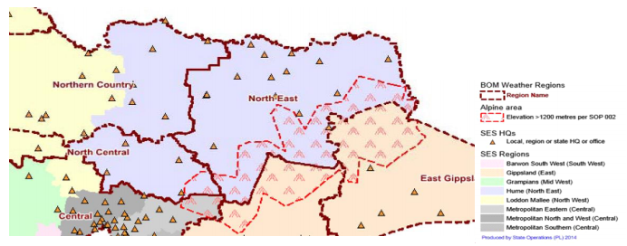

Historic Storm Events
Year | Location | Details
Feb 2022 | Markwood | A storm cell impacted the Rural city of Wangaratta around the Milawa, Markwood, Great Alpine Road are cutting off King Valley area. Many kilometres of trees down and power outages were experienced. Although the event was short lived the financial expenses to council for tree clearing contractors and machinery was such it qualified for disaster funding.
Dec 2018 | Flash Flooding in North Wangaratta, Eldorado, Londrigan, Tarrawingee, Boorhaman, Byawatha | Heavy Rainfall of 268mm in approx. 6 hours was recorded in Eldorado which created a flash flood event and subsequent over land flood to the Hume Freeway North of Wangaratta. Several rescues from vehicles were conducted and some over floor flooding of approx. 40 properties and damage to 4 bridges occurred. Areas in Byawatha, Londrigan, Eldorado and Tarrawingee experienced significant overland flooding with agricultural losses to 440km of fences, 5000 tonnes of hay lost and 37,000ha of grazing land impacted. Hodgsons Creek at Tarrawingee flooded impacting access and egress and the closure of the Great Alpine Road at the Tarrawingee bridge. Estimated to be a 1/2000year rainfall event.
Mar 2018 | Tolmie | Tornado - 8 homes damaged.
Dec 2017 | Wangaratta & King Valley | Severe wind event occurred. Homes and businesses without power, telecoms, road and property access for several hours (to days/weeks)  Building Damage in Wangaratta & King Valley
2016 | Most of RCOW | Over 300 mm across the Warby Ranges. That scenario in the flood info above.
2010 | Wangandary/Wangaratta | Microburst.
Jan – March 2003 | King Valley | Multiple lightning strikes resulted in 1.3 million hectare Alpine Fires
2001 | Eldorado | 71.1mm in 30 minutes anecdotally

VICSES Requests for Assistance – Severe Weather - RCOW
This data uses Request for Assistance information from the Victoria State Emergency Service (VICSES) to display areas at risk from severe weather events. VICSES Severe Weather Requests for Assistance. The Victoria State Emergency Service records requests for assistance made by the public during severe weather events. Additional calls may have been made directly to Council during these events.
The Table below is a breakdown of requests for assistance (RFA) by type during the period Jan 2011 and June 2021 in relation to severe weather and storm events.
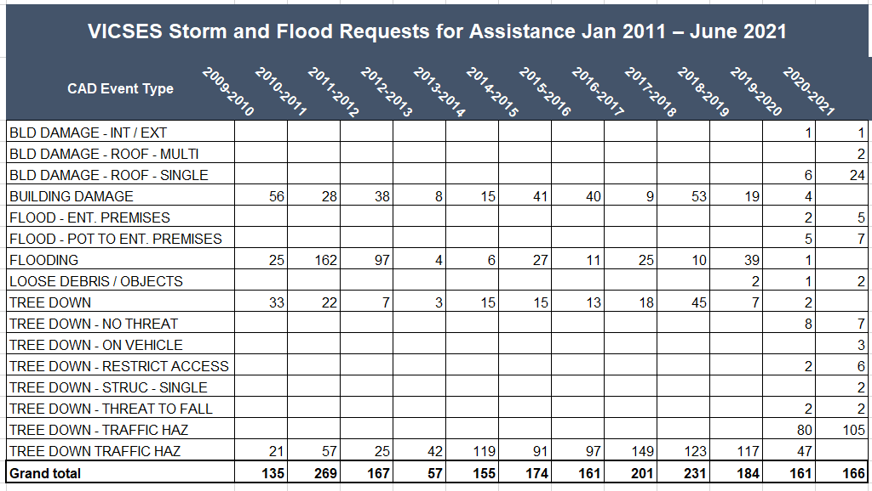
VICSES Severe Weather Requests for Assistance Mapping – Wangaratta Township – Jan 2011- Jun 2021
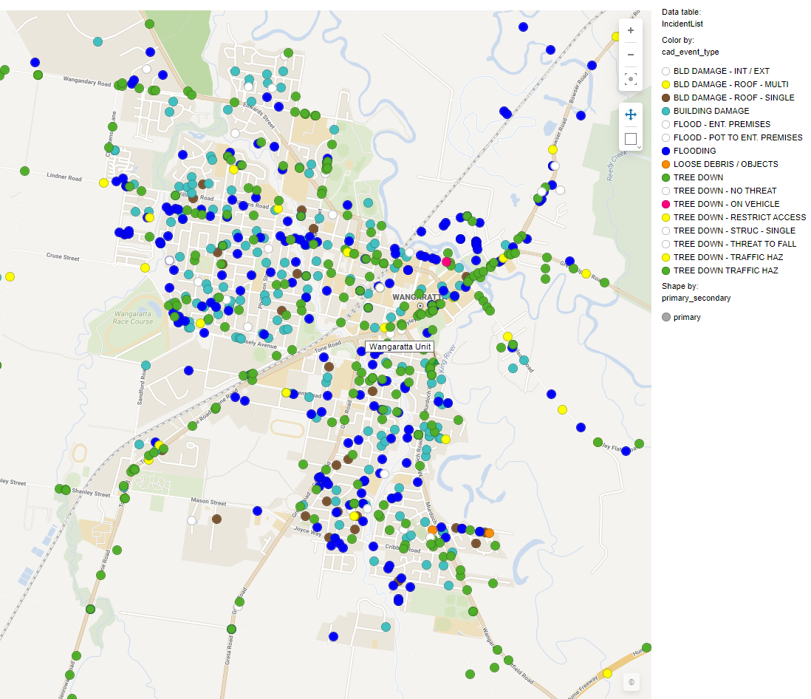

VICSES Severe Weather Requests for Assistance Mapping – Rural City of Wangaratta - Jan 2011- Jun 2021
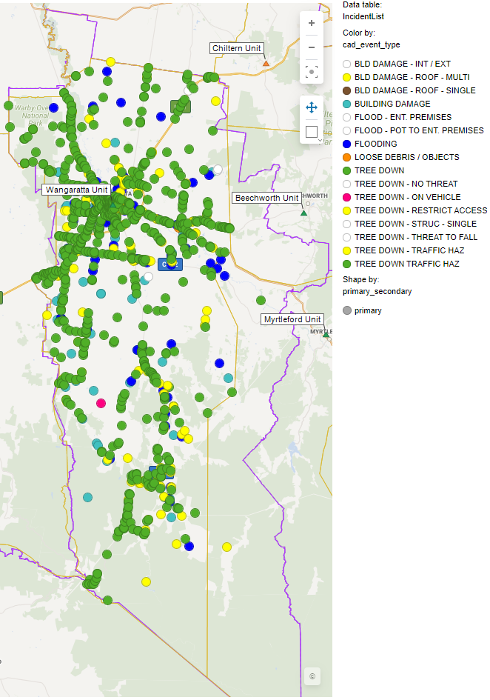

Appendix B: Typical flood peak travel times
Ovens River Catchment
Location From | Location To | Distance | Typical Travel Time | Comments
Alpine Shire Council
Bright | Myrtleford | 31km | Around 8:15 hours | Major flooding(Ovens River Catchment Floods October 1993 vol 3)
Bright | Eurobin |  | 7.5 – 12.5 Hours  Oct 2000 (7.5 Hrs)  Sept 2010 (12.5 Hrs) | Ovens River Intelligence Report 2012
Harris Lane (Buckland River) | Myrtleford | 29km | Around 8:15 hours | Major flooding (Ovens River Catchment Floods October 1993 vol 3)
Myrtleford | Rocky Point | 6km | Around 1:13 hours | Major flooding (Ovens River Catchment Floods October 1993 vol 3)
Lake Buffalo | Rocky Point | 25km | Around 6:30 hours | Major flooding (Ovens River Catchment Floods October 1993 vol 3)
Rural City of Wangaratta
Rocky Point | Wangaratta | 42km | Around 12:45 hours | Major flooding (Ovens River Catchment Floods October 1993 vol 3)
Wangaratta | Peechelba E | 33km | Around 12:30 hours | Major flooding (Ovens River Catchment Floods October 1993 vol 3)
Moira Shire Council
Peechelba E | Yarrawonga | 42km | Around 15:00 hours | Major flooding (Ovens River Catchment Floods October 1993 vol 3)
Wangaratta | Yarrawonga | 75km | Around 27:30 hours | Major flooding (Ovens River Catchment Floods October 1993 vol 3)
Bright | Yarrawonga | 155km | Around 50:00 hours | Major flooding (Ovens River Catchment Floods October 1993 vol 3)

King River Catchment
Location From | Location To | Distance | Typical Travel Time | Comments
Lake William Hovell | Cheshunt |  | Around 1-3 hours | Major flooding  Ovens River Intelligence Report 2012
Cheshunt | Edi |  | Dec 2010 (2 hours) | Major flooding  Ovens River Intelligence Report 2012
Edi | Docker Rd Bridge | 17km | Around 4-7 hours  Dec 2010 & Sept 1998 (7 hours) | Major flooding (Ovens River Catchment Floods October 1993 vol 3)  Ovens River Intelligence Report 2012
Docker Rd Bridge | Wangaratta | 22km | Around 9 hours | Major flooding (Ovens River Catchment Floods October 1993 vol 3)

15 Mile Creek Catchment (One and Three Mile Creeks at Wangaratta)
Location From | Location To | Distance | Typical Travel Time | Comments
Greta South | Glenrowan |  | 4.5 – 11.5 Hours  Feb 2005 (4.5 Hrs)  Sept 2000 (5 Hrs)  Dec 2010 (11.5 Hrs) | Ovens River Intelligence Report 2012
Greta South | Cribbes Rd | 30km | Around 20:15 hours | Major flooding (Ovens River Catchment Floods October 1993 vol 3) Note: the speed calculated for the 15 Mile Creek between Greta South and Cribbes Road is inconsistent with other speed in the catchment, and if correct would imply a very substantial storage effect in the flood plain downstream of Greta South

Appendix C1: River Systems Overview & Schematics (Ovens, King Rivers & 15 Mile Creek)
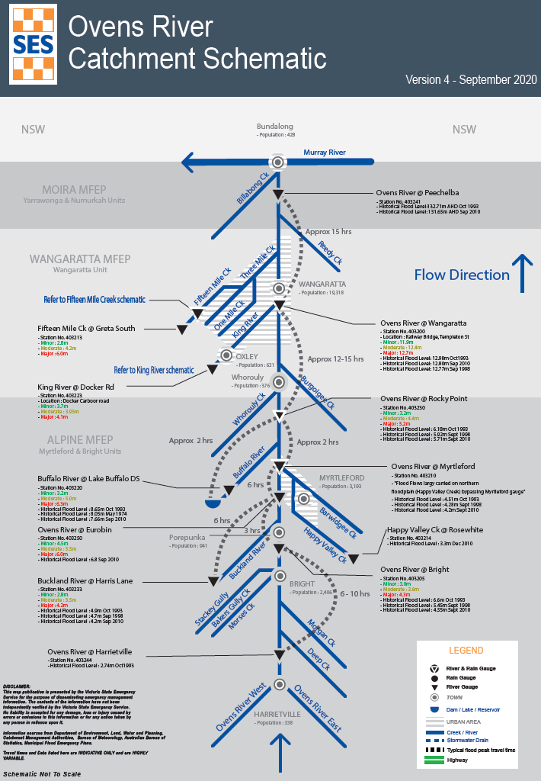
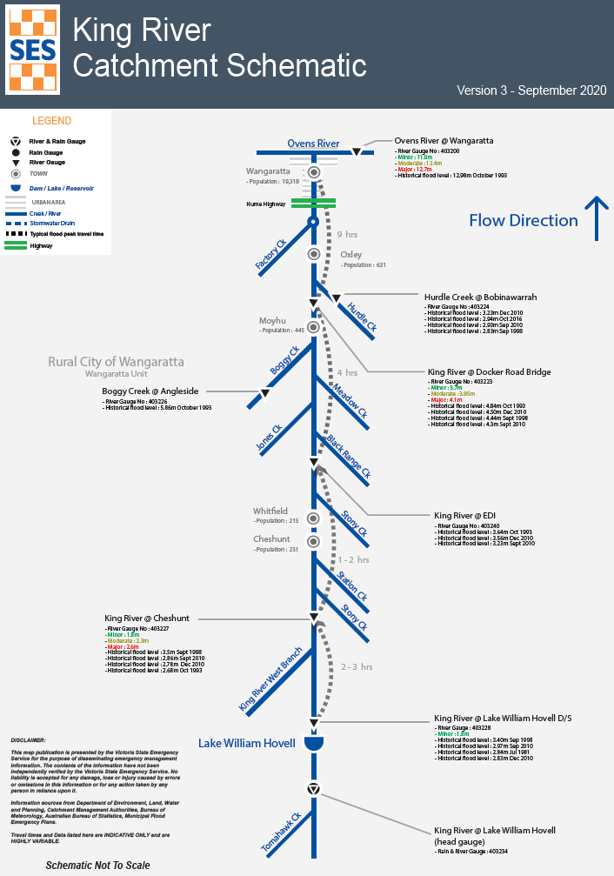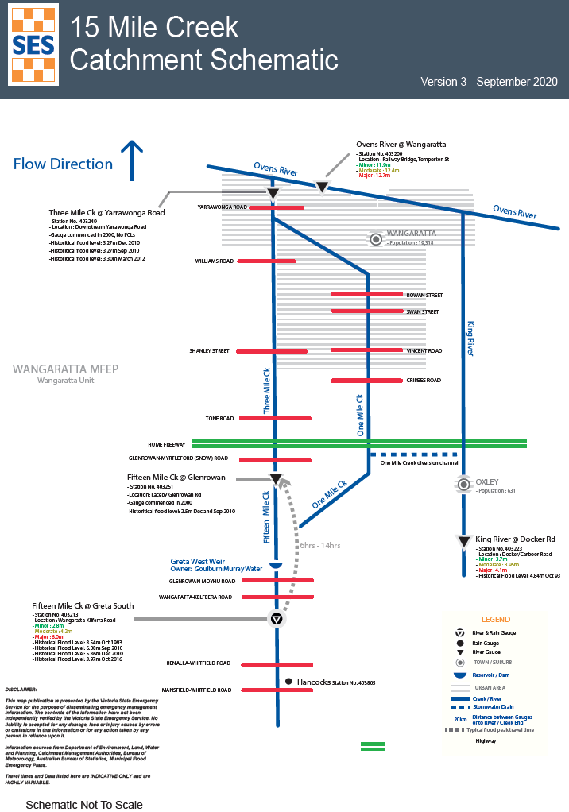

Appendix C2: Flood Intelligence Card – Ovens River at Rocky Point - Use for Whorouly

Gauge Location: Ovens River at Rocky Point
Gauge | River Height (m) | River Flow (ML/d) | Flood Class Level & Annual Exceedance Probability (%AEP) | Consequence/ Impact | Action  Actions may include: Evacuation, closure of road, sandbagging, issue warning and who is responsible etc. | Reference
Ovens. R at Rocky Point (use for Whorouly area) NOTE: no info on Whorouly Creek  Ovens. R at Rocky Point (use for Whorouly area) NOTE: no info on Whorouly Creek | 3.2 |  | Minor Flood Level  x% AEP (xx-year ARI) | 1981 Flooding through depression. All houses above floor level | BOM will issue and VICSES to publish Minor flood warning to community  RCOW/ RRV to monitor roads to determine road closures necessary  VICSES units to respond on a request by request basis.  The VICSES NE Duty Officer in conjunction with the RAC will maintain operational awareness and form an appropriate response to suit the level of the incident. | FIC Ovens catchment / BOM Dec 2012
 | 4.4 |  | Moderate Flood Level  x% AEP (xx-year ARI) |  | BOM will issue and VICSES to publish Moderate flood warning to community  RCOW/ RRV to monitor roads to determine road closures necessary | FIC Ovens catchment / BOM Dec 2012
 | 4.77 |  |  | 2010 Dec flood peak
Gauge | River Height (m) | River Flow (ML/d) | Flood Class Level & Annual Exceedance Probability (%AEP) | Consequence/ Impact | Action  Actions may include: Evacuation, closure of road, sandbagging, issue warning and who is responsible etc. | Gauge
Ovens. R at Rocky Point (use for Whorouly area) NOTE: no info on Whorouly Creek | 5.2 |  | Major Flood Level  x% AEP (xx-year ARI) |  | BOM will issue and VICSES to publish Major flood warning to community  RCOW/RRV to monitor and inspect roads to determine road closures  IMT to consider the use of Snap, Send, Solve Flood observers | FIC Ovens catchment / BOM Dec 2012
 | 5.72 | 99,290 |  | - Sept 2010 Flood peak. - upstream at Myrtleford created pockets of isolation  - No above floor flooding upstream in Myrtleford.  - Water over Road at sewerage treatment plant but road remains open. (Sewerage farm is NOT affected by even extreme flood levels, rail trail acts as support levee unless Lake Buffalo breeches)
 | 5.92 | 110,725 |  | - 1998 Sept flood peak.  - GAR at sewerage farm near Myrtleford will be blocked. Alternative access via the Rail Trail for emergency Service vehicles only.  - Large flows from the Buffalo River in addition to Ovens River can impact this area downstream of Rocky Point further | IMT to monitor Flows into the Ovens from the Buffalo and Buckland sub catchments to determine in downstream impacts and timing.
 | 6.18 | 99,248 |  | - October 1993 Flood Peak  NECMA – Any Additional info for use in Whorouly area? |  | Ovens River Intelligence Report 2012  NECMA Limited mapping Whorouly to Wang Flood Study 2003
Note: flood intelligence records are approximations. This is because no two floods at a location, even if they peak at the same height, will have identical impacts. Flood intelligence cards detail the relationship between flood magnitude and flood consequences. More details about flood intelligence and its use can be found in the Australian Institute of Disaster Resilience (AIDR) Handbook series on managing the Floodplain.

Appendix C3: Flood Intelligence Card – King River at Cheshunt, Docker Rd & Hurdle Creek

Gauge Location: King River – various gauges
Gauge | River Height (m) | River Flow (ML/d) | Flood Class Level & Annual Exceedance Probability (%AEP) | Consequence/ Impact | Action  Actions may include: Evacuation, closure of road, sandbagging, issue warning and who is responsible etc. | Reference
King River at Lake William Hovell  (800 metres downstream of Lake William Hovel) |  |  | Minor Flood Level  x% AEP  (<2-year ARI) |  | BOM will issue and VICSES to publish Minor flood warning to community  RCOW/ RRV to monitor roads to determine road closures necessary  VICSES units to respond on a request by request basis.  The VICSES NE Duty Officer in conjunction with the RAC will maintain operational awareness and form an appropriate response to suit the level of the incident. | Refer Lake William Hovell Dam safety Plan. Ungated spillway.
 | 1.8 | 4000
 | 2.42 | 12300 | 18%
 | 2.48 | 15000 |  | Oct 1993 flood level
 | 2.69 | 18900 | 10%
 | 2.91 | 25900 |  | May 1974 flood level
 | 3.04 | 30400 | 4%
 | 3.32 | 41900 | 2%
 | 3.38 | 46000 |  | Sept 1998 flood level
 | 3.65 | 56300 | 1%

Gauge | River Height (m) | River Flow (ML/d) | Flood Class Level & Annual Exceedance Probability (%AEP) | Consequence/ Impact | Action  Actions may include: Evacuation, closure of road, sandbagging, issue warning and who is responsible etc. | Reference
King River at Cheshunt  (4 km upstream Cheshunt) | 1.8 |  | Minor Flood Level  50% AEP |  | BOM will issue and VICSES to publish Minor flood warning to community  RCOW/ RRV to monitor roads to determine road closures necessary  VICSES units to respond on a request by request basis.  The VICSES NE Duty Officer in conjunction with the RAC will maintain operational awareness and form an appropriate response to suit the level of the incident. | BOM Dec 2012
King River at Cheshunt  (4 km upstream Cheshunt) | 1.8 |  |  | - Dry Creek commences to flow over farmland from Queens Creek to King River.  - At Gentle Annie Caravan Park, King river approaching top of bank.  Water over road  - Whitfield-Wangaratta Rd. at Edi commences flooding | Gentle Annie Caravan Park on alert – WHO& HOW?  VICSES NEDO/IWO to add to Minor Flood warning impacts at this level  RCOW/ RRV to monitor and inspect roads to determine road closures | FIC King Catchment
King River at Cheshunt  (4 km upstream Cheshunt) | 2.0 |  |  | - At Cheshunt, King River at top of bank.  - King Valley roadside flooding commences at Cheshunt.  - Low lying farmland (Cheshunt-Edi) commences flooding.  - Local roadside flooding along King Valley Rd. | VICSES NEDO/IWO to add to Minor Flood warning impacts at this level  RCOW/ RRV to monitor and inspect roads to determine road closures | FIC King Catchment
Gauge | River Height (m) | River Flow (ML/d) | Flood Class Level & Annual Exceedance Probability (%AEP) | Consequence/ Impact | Action  Actions may include: Evacuation, closure of road, sandbagging, issue warning and who is responsible etc. | Reference
King River at Cheshunt  (4 km upstream Cheshunt) | 2.3 |  | Moderate Flood Level  20% AEP |  | BOM will issue and VICSES to publish Moderate flood warning to community  VICSES to Consider the use of Snap, Send, Solve Flood observers for Intelligence gathering
King River at Cheshunt  (4 km upstream Cheshunt) |  |  |  | - Large areas of farmland flooding along the King River.  - Johnsons Bridge on Lake Buffalo-Whitfield Road (Black Range Creek) close to inundation.  - Land inundated at confluence of Black Range Creek & King River | VICSES NEDO/IWO to add to Moderate Flood warning impacts at this level  Local SES units to engage landholders of potential isolation – Are there any upstream of here  RRV/ RCOW to place road closure signs along Lake Buffalo-Whitfield Road. Alpine Shire to close road from the other end? | FIC King Catchment
King River at Cheshunt  (4 km upstream Cheshunt) | 2.6 |  | Major Flood Level  10% AEP |  | BOM will issue and VICSES to publish Major flood warning to community  VICPOL Evacuation Manager required and to consider Evacuations from this level  VICSES to consider the use of Snap, Send, Solve Flood observers for Intelligence gathering and Flood Gauge Reading patrols
Gauge | River Height (m) | River Flow (ML/d) | Flood Class Level & Annual Exceedance Probability (%AEP) | Consequence/ Impact | Action  Actions may include: Evacuation, closure of road, sandbagging, issue warning and who is responsible etc. | Reference
King River at Cheshunt  (4 km upstream Cheshunt) | 2.6 | 23,600 |  | - Large areas of farmland flooding along the King River.  - King River causeway at Cheshunt commences flooding.  - Edi Cutting camping ground inundated.  - Fosangs Lane residential land flooding.  - King River over bank at Gentle Annie Caravan Park.  - At Cheshunt Causeway, abutting farmland commences flooding either side.  Water over road  - Upper King River Road between Cheshunt & Lake William Hovell inundated (south of Hamiltons Bridge).  - King Valley Road closed between Whitfield and Cheshunt.  - Edi-Cheshunt Road inundated. | VICSES NEDO/IWO to add to Major Flood warning impacts at this level  Gentle Annie Caravan Park to commences evacuation  IMT to consider Evacuations and relief centre of affected Cheshunt properties for 2.7m flood height  Parks Vic to close Edi Cutting  VICSES Unit to doorknock King Valley Residents due to be impacted  RRV/ RCOW to place road closure signs along Upper King River Road, King Valley Road, Edi-Cheshunt Road | King Rural Floodplain Study
King River at Cheshunt  (4 km upstream Cheshunt) | 2.7 |  |  | Property Inundation  - 2 Properties at 430 King Valley Rd in Cheshunt commence flooding.  - Residential properties in Cheshunt Township evacuated.  Water over road  - Wangaratta-Whitfield Road closed at several locations e.g. at Edi Cutting. | VICSES with partner agencies to determine if response to 430 King Valley Rd. Cheshunt required  Considerations for the Evacuation of Cheshunt residents required  VICSES to respond on a request by request basis  RRV/ RCOW to place road closure signs along Wangaratta –Whitfield Road and at Edi Cutting | King Rural Floodplain Study
King River at Cheshunt  (4 km upstream Cheshunt) | 2.9 |  |  | - May 1974 Peak height (2.91)  - Jessie’s Creek commences flooding near Mountain Hotel, Whitfield.  Water over road  - Upper King Road closed between Lake William Hovell and Cheshunt (South of Hamilton’s bridge)  - Gentle Annie Lane inundated.  - Satori road inundated.  - King Valley Road requires closing at Cheshunt Causeway between Whitfield and Cheshunt.  - Edi-Cheshunt Road inundated | RCOW/RRV(as appropriate) to provide road closure signage at these location  VICSES to doorknock/ provide information tro the King Valley Residents due to be impacted at 1% level (above 3.54m)
Gauge | River Height (m) | River Flow (ML/d) | Flood Class Level & Annual Exceedance Probability (%AEP) | Consequence/ Impact | Action  Actions may include: Evacuation, closure of road, sandbagging, issue warning and who is responsible etc. | Reference
King River at Cheshunt  (4 km upstream Cheshunt) | 3.32 | 41,900 | 2% |  |  | Ovens River Intelligence Report 2012
King River at Cheshunt  (4 km upstream Cheshunt) | 3.38 | 46,000 |  | - September 1998 Peak height |  | Ovens River Intelligence Report 2012
King River at Cheshunt  (4 km upstream Cheshunt) | 3.54 |  |  | - 1998 Flood Peak (Sept) Large areas of farm land along King River flooded | Incident Management Team to consider evacuations and opening Relief centre
King River at Cheshunt  (4 km upstream Cheshunt) | 3.55 | 67,000 | 1% | - in a 1% flood Upper Ovens Study indicates 50 + properties affected by flooding in King Valley |  | King Rural Floodplain Study
King River at Cheshunt  (4 km upstream Cheshunt) |  |  | 14% | 1993 flood level ????
Gauge | River Height (m) | River Flow (ML/d) | Flood Class Level & Annual Exceedance Probability (%AEP) | Consequence/ Impact | Action | Reference
King River at Docker Road  (at the Bridge) | 3.7 | 5,200 | Minor Flood Level  ~63% AEP | - No Impacts at this level | BOM will issue and VICSES to publish Minor flood warning to community  VICSES units to respond on a request by request basis. | Ovens River Intelligence Report 2012
King River at Docker Road  (at the Bridge) | 3.95 | 10,800 | Moderate Flood Level  ~40% AEP | - Low lying agricultural areas see water  Water over road  - Docker-Carbour Road is Closed Between Wangaratta-Whitfield Road & Oxley-Meadow Creek Road | BOM will issue and VICSES to publish Moderate flood warning to community  RCOW to place road closure signs at Docker Road | Ovens River Intelligence Report 2012
King River at Docker Road  (at the Bridge) | 4.1 | 53,000 | Major Flood Level  ~10% AEP | - Agricultural land flooding | BOM will issue and VICSES to publish Major flood warning to community  VICSES to consider the use of Snap, Send, Solve Flood observers for Intelligence gathering and Flood Gauge Reading patrols | Ovens River Intelligence Report 2012
King River at Docker Road  (at the Bridge) | 4.3 |  |  | - September 2010 Peak Flood height
King River at Docker Road  (at the Bridge) | 4.44 | 74,000 |  | - September 1998 flood peak | VICSES NEDO/IWO to add to Major Flood warning impacts at this level  IMT to consider if property isolations begin and to gather intel/local knowledge | Ovens River Intelligence Report 2012
King River at Docker Road  (at the Bridge) | 4.5 |  |  | - December 2010 Peak Flood height
King River at Docker Road  (at the Bridge) | 4.65 | 98,700 | 2% |  |  | Ovens River Intelligence Report 2012
King River at Docker Road  (at the Bridge) | 4.76/4.84 | 112,000 |  | - October 1993 flood peak |  | Ovens River Intelligence Report 2012
King River at Docker Road  (at the Bridge) | 4.86 | 123,000 | 1% |  |  | Ovens River Intelligence Report 2012
Note: flood intelligence records are approximations. This is because no two floods at a location, even if they peak at the same height, will have identical impacts. Flood intelligence cards detail the relationship between flood magnitude and flood consequences. More details about flood intelligence and its use can be found in the Australian Institute of Disaster Resilience (AIDR) Handbook series on managing the Floodplain.

Ungauged Flood Location Warnings
Where there are no set Flood Class Levels for a gauge, VICSES NEDO/IWO will need to consider issuing “Ungauged Flood warnings” (Minor to Major) with confirmed impact examples at each level.
Impact Guide below:
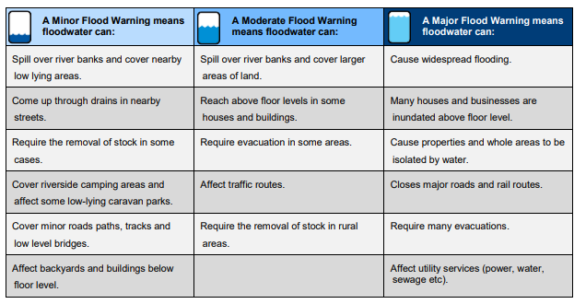

This table provides guidance on the BoM definitions of each warning category

Gauge Location: Hurdle Creek at Bobinawarrah

Gauge | River Height (m) | River Flow (ML/d) | Flood Class Level & Annual Exceedance Probability (%AEP) | Consequence/ Impact |  | Action  Actions may include: Evacuation, closure of road, sandbagging, issue warning and who is responsible etc. | Reference
Hurdle Creek at Bobinawarrah | 3.23 | 7,737 |  | - December 2010 flood peak |  |  | Ovens River Intelligence Report 2012
Hurdle Creek at Bobinawarrah | 3.54 | 12800 | 1% | - Oct 1993 Flood Level, 6 properties flooded above floor level.  - Carboor-Everton Rd Hurdle Creek, Black Range Creek area impacted in 1993, between Mahers Lane and Murphys Lane.  Residents names were:  - Jennings  - Ludeman  - Mitchell  - Hedderman  - 2 X properties on Carboor-Everton Rd most vulnerable:  Gibb Family(at Bridge and Box)  NEED TO DETERMINE IF THIS IS STILL THE CASE OR HAVE WORKS BEEN UNDERTAKEN…SAME FAMILIES? | VICSES to consider publishing ungauged Major flood warning to community  VICPOL Evacuation Manager required and to consider Evacuations from this level  Considerations is a relief centre is required  VICSES to consider the use of Snap, Send, Solve Flood observers for Intelligence gathering  VICSES to respond on a request by request basis  VICSES unit to engage residents in areas or properties listed about access issues and flooding predictions and speak to at risk residents |  | Whorouly-Wangaratta Flood Study 2003
Note: flood intelligence records are approximations. This is because no two floods at a location, even if they peak at the same height, will have identical impacts. Flood intelligence cards detail the relationship between flood magnitude and flood consequences. More details about flood intelligence and its use can be found in the Australian Institute of Disaster Resilience (AIDR) Handbook series on managing the Floodplain.

Appendix C4: Flood Intelligence Card – Ovens River at Wangaratta

Gauge Location: Ovens River at Wangaratta
NOTE: Wangaratta Ovens River Flood Gauge 0 = 130.426 AHD
The flood intelligence cards in Appendix C4 - Ovens River at Wangaratta, are based largely on outputs from the Wangaratta Urban Waterways Flood Investigation (2017). This provides the most consistent and up to date flood mapping for the Wangaratta region and is well calibrated to large historic events. While the mapping is considered to be of a high standard, observations in recent flood events (2012 onwards) suggest that the flood impacts for the Wangaratta gauge between 12.5m and 12.8m are likely marginally overstated by the flood study mapping. The intelligence products could be considered a conservative upper limit representation of likely impact at the stated gauge level. Recent Observations have been included in the below flood intelligence cards to accurately reflect impacts observed in live events. However, no two floods are the same.
Gauge | River Height (m) | River Flow (ML/d) | Flood Class Level & Annual Exceedance Probability (%AEP) | Consequence/ Impact | Action  Actions may include: Evacuation, closure of road, sandbagging, issue warning and who is responsible etc. | Reference
Ovens River at Wangaratta  Gauge  Ovens River at Wangaratta Cont.  Ovens River at Wangaratta Cont. | 10.0 |  | Below Minor Flood Class Level | - Flooding of low lying crossing on tracks within the Lower Ovens park commence.
Ovens River at Wangaratta  (Railway Bridge Templeton St) | 11.1 |  |  | - Low level track on Ovens River west bank between Parfitt Road and Stock Bridge closed (onset below this level) | Rural City of Wangaratta to enact - Flood Ready Operations Procedures document | 25/06/2016?
Ovens River at Wangaratta  (Railway Bridge Templeton St) | 11.4 |  |  | - Access routes into Lower Ovens National Park cut by flows in Boundary Creek (Francis Ln, Frosts Crossing). |  | 17/07/2014
Ovens River at Wangaratta  (Railway Bridge Templeton St) | 11.5 |  |  | - Flooding of wetland area near corner of Phillipson St and Cambridge Drive |  | 17/07/2014
Ovens River at Wangaratta  (Railway Bridge Templeton St) | 11.6 |  |  | - (Reedy Creek 3.98m) Stamps Lane open to end but peripheral flooding in a number of areas to around 300mm below road.  - Highest is lagoon adjacent driveway to 150 Stamps Ln with water over around 1/3 of road width.  - Main lagoon flood runner near 132 Stamps Ln has strong flow from Reedy Creek side.  - Stamps Lane near Bowser Road is around 300 mm above Reedy Creek level.  - Wills Street, Burrows Street, Dale Street remain dry but minimal freeboard on Burrows Street near Dale Street intersection | RCOW to commence closure of bike paths along Ovens River
Gauge | River Height (m) | River Flow (ML/d) | Flood Class Level & Annual Exceedance Probability (%AEP) | Consequence/ Impact | Action  Actions may include: Evacuation, closure of road, sandbagging, issue warning and who is responsible etc | Reference
Ovens River at Wangaratta  (Railway Bridge Templeton St) | 11.6 |  |  | - Ambrosio Road north of Burrows Street starts to flood but no houses in this area  - Commencement of flooding over loop track (nearest to water treatment plant) in Frank Garth reserve.  - At this stage water ponds under second span of Parfitt Road Bridge upstream of Apex Park due to culvert connection but there are no through flows to Apex Park  - Hoban Street under rail bridge around 300mm above water level – house downstream is well elevated and likely that residents will remain in situ.  - Bike / walking paths on Ovens River west bank between Parfitt Road and showgrounds closed (likely closed at around 11m upstream of stock bridge).  - East bank tracks from Parfitt Road to footbridge near railway line remains dry  - Flooding into Sydney Beach carpark commences due to water backing up through stormwater drains - results in shallow flooding over access road near entrance. Walking track between carpark and footbridge flooded  - Flooding over access road into Northern Beaches (east of end of College Street)– water backing up through stormwater drains. Shallow flooding of open parkland area east of houses on Ovens View Terrace.  - Flooding over lower access tracks around Billabongs Camping Area (Oxley Flats Rd / Hume Fwy)  - Camping area remains accessible but arrangements for evacuation should begin to be established  - Great Alpine Road around Yellow Creek remains open  - Water at toe of Wilson Road levee at western end of Thomas Street but dry around remainder  - Shallow flooding over driveway to single dwelling (19 Thomas Street) outside of levee – house is well elevated and residents likely to remain in-situ (boat access) | VICSES to consider EMT meeting with RCOW and VICPOL, likely via phone. Consider ground crews to visit camp sites to understand if there are campers on site and to provide advice if further flooding imminent.  VICPOL to start reviewing Evacuation plans for camping areas and other areas along Rivers where people are known to camp/live.  Vic SES units to respond on a request by request basis  RCOW to commence closure of bike paths along Ovens River | 14/07/2016
Gauge | River Height (m) | River Flow (ML/d) | Flood Class Level & Annual Exceedance Probability (%AEP) | Consequence/ Impact | Action  Actions may include: Evacuation, closure of road, sandbagging, issue warning and who is responsible etc | Reference
Ovens River at Wangaratta (Railway Bridge Templeton St) | 11.6 |  |  | - Shallow flooding into park area around Templeton Street boat ramp - road remains above flood level but walking tracks closed  - Water against Painters Island river levee / concrete path over most of its length but freeboard remains
Ovens River at Wangaratta (Railway Bridge Templeton St) | 11.65 |  |  | - Shallow flooding (backwater flooding) into backyards around 36 and 38 Templeton St) and to rear fences of houses between 38 Templeton Street and railway bridge |  | 21/07/2013 and 2016  14/07/2016
Ovens River at Wangaratta (Railway Bridge Templeton St) | 11.7 |  |  | - Lower bench of park area between Wilson Rd bridge and WTP deeply flooded (onset threshold not known) |  | 02/03/2012
Ovens River at Wangaratta (Railway Bridge Templeton St) | 11.8 |  |  | - Likely closure of Great Alpine Road at Yellow Creek (Detour Road bypasses) | RRV to consider closure of GAR at Yellow Creek and enact detour  RCOW to monitor and inspect roads to determine road closures
Ovens River at Wangaratta (Railway Bridge Templeton St) | 11.85 |  |  | - Dowling Lane remains open and dry, no impact around dwelling  - Paths from Sydney Beaches to footbridge closed | RCOW to close paths at Sydney Baches | 01/07/2014
Gauge | River Height (m) | River Flow (ML/d) | Flood Class Level & Annual Exceedance Probability (%AEP) | Consequence/ Impact | Action  Actions may include: Evacuation, closure of road, sandbagging, issue warning and who is responsible etc | Reference
Ovens River at Wangaratta (Railway Bridge Templeton St) | 11.9 | 25,300 | Minor Flood Level |  | BOM will issue and VICSES to publish Minor flood warning to community with tailored information from this plan  The North East Duty Officer in conjunction with the Regional Agency Commander will maintain operational awareness and form an appropriate response to suit the level of the incident  Rural City of Wangaratta to enact - Flood Ready Operations Procedures document - Minor Level
Ovens River at Wangaratta (Railway Bridge Templeton St) | 11.9 |  |  | - Estimated threshold for overtopping of Hoban Street beneath rail line - cuts access to 1 house  - Advise Painters Island Caravan Park of flood risks  - Ovens River commences flooding over bank at Apex Park and Painters Island Caravan Park.  - Water up to Yogi’s Chin in APEX Park | VICSES NEDO/IWO to add to Minor Flood warning impacts at this level  VICSES RDO/RAC to advise Painters Island Caravan park to enact their Emergency Plan -phase 1 and enact their emergency plan checklist.  Painters Island caravan park to move residents in low lying areas to higher ground in park.  RCOW to commence closure of Apex Park.  RCOW to ensure Sydney Rd Carpark is closed with cars removed before 11.9m at the latest  VicPol to advise owners of cars parked on Sydney Rd car park to move cars before 11.9m Minor flood level  RCOW to commence closure of low lying car parks at:  - Sydney Beach  - Bickerton Street  - Baker Street  - Boat Ramp (off Templeton Street)  - Northern Beaches  RCOW to remove bins, close bike and shared paths listed in Flood operation procedure | 14/07/2016  FIC Ovens catchment  Wangaratta Urban Waterways Flood Study v03 2017
Gauge | River Height (m) | River Flow (ML/d) | Flood Class Level & Annual Exceedance Probability (%AEP) | Consequence/ Impact | Action  Actions may include: Evacuation, closure of road, sandbagging, issue warning and who is responsible etc | Reference
Ovens River at Wangaratta (Railway Bridge Templeton St) | 12.0 |  |  | - Consider Fishers Levee (1917 levee along Yellow Creek) likely to overtop  - East Wangaratta, GAR closed / traffic detours via Detour Rd area)  - Minor flows into Apex Park commence.  - Ovens River near bank full through length of Apex Park but only shallow breakout immediately downstream of bridge (flows return to river)  - Further flooding from Ovens River over entrance road to Sydney Beaches carpark  - Northern beaches access road deeply flooded at end of College Street (flooding commences around 11.6m)  - Shallow flooding of park areas near Ovens View Tce | VICSES to respond on a request by request basis  RRV to put Detour In place and Close GAR  VICSES to consider the use of Snap, Send, Solve Flood observers  RCOW to monitor and inspect roads to determine any further road closures | Validated July 2013 event.  19/07/2014  Wangaratta Urban Waterways Flood Study v03 2017
Ovens River at Wangaratta (Railway Bridge Templeton St) | 12.1 |  |  | - CHECK could occur at lower level TL. Water flows across Apex Park and enters lagoon behind Painters Island Caravan Park.  - Shallow flooding around eastern side of Wilson Road levee downstream of Oxley Flats Road (not overtopping Oxley Flats Rd in this area)  - Nominal level at which flooding over Stamps Lane near Bowser Road can be expected - timing depends on precedent floods filling Yellow Creek area.  - Flooding commences at Reedy Creek Wangaratta North level 4.25m  - Overtopping of Ovens River in Frank Garth Reserve upstream of floodway bridge commences.  - Water commences to pass beneath floodway span of Parfitt Road Bridge upstream of Apex Park (having spilled over the Ovens River bank in Frank Garth reserve)  - Bickerton Street carpark overtops after depressions in Apex Park fill resulting in progressive filling of lagoon around Painters Island Caravan Park | APEX Park Carpark should be closed / cars removed before 12.1m | 05/09/2015  08/08/2013  Wangaratta Urban Waterways Flood Study v03 2017
Gauge | River Height (m) | River Flow (ML/d) | Flood Class Level & Annual Exceedance Probability (%AEP) | Consequence/ Impact | Action  Actions may include: Evacuation, closure of road, sandbagging, issue warning and who is responsible etc | Reference
Ovens River at Wangaratta (Railway Bridge Templeton St) | 12.2 |  |  | - Broad flooding of Apex Park commences - extends around Pavilion and reaches Yogi and covers road.  - Level in Apex Park depends on duration of flooding (more-so than increment in gauge level)  - Further flooding of Painters Island Caravan Park can commence based of steady flow rates  - Painters Island Caravan Park access Road may be subject to shallow flooding from around 12.2  Water over road  - Peechelba Rd (east of Ovens River | VICSES RDO/RAC to advise Painters Island Caravan park to enact their Emergency Plan -phase 2 and continue with emergency plan checklist.  Painters Island Caravan Park determine to close park and ask all patrons to relocate  VICSES/RCOW/VICPOL to hold EMT regarding the closure of Painters Island Caravan park – This may result in assistance to move residents and may trigger relocation funding from DFFH  RCOW to commence closure of Peechelba Road
Ovens River at Wangaratta (Railway Bridge Templeton St) | 12.3 |  |  | - Deep flooding in Frank Garth reserve by 12.3  - Dale Street railway underpass flooded  - Deep, rapid flows through Parfitt Rd floodway bridge  - Overtopping of levee/bike path along Ovens River frontage of Painters Island - at the defined low point in the levee (dip can also operate to drain water from the park depending on level of filling from Apex Park)  - Shallow overtopping of Pinkerton Crescent (<200mm) near 35 Pinkerton (at rear of Painters Island) - timing and level depends on duration at this level.  - Overflows drain away toward Dale St and Wills St  - Low ground in Painters Island will be flooded to level controlled by Pinkerton Crescent and dip in river levee.  - Cabins and office etc remain accessible from Pinkerton Cres but road may be subject to shallow flooding from around 12.2 | VICSES to respond on a request by request basis | 02/03/2012  22/02/2013  22/07/2013  Wangaratta Urban Waterways Flood Study v03 2017
Gauge | River Height (m) | River Flow (ML/d) | Flood Class Level & Annual Exceedance Probability (%AEP) | Consequence/ Impact | Action  Actions may include: Evacuation, closure of road, sandbagging, issue warning and who is responsible etc | Reference
Ovens River at Wangaratta (Railway Bridge Templeton St) | 12.4 | 40,500 | Moderate Flood Level | - Water up to Yogi’s Mouth in APEX Park | VICSES to consider Base IMT rostered/standby or Base IMT in place depending on forecast  BOM will issue and VICSES to publish Moderate flood warning to community  VICSES to Consider the use of Snap, Send, Solve Flood observers for Intelligence gathering  IMT To consider requesting Swift water rescue team to be on standby  Rural City of Wangaratta to enact - Flood Ready Operations Procedures document - Moderate Level | BOM Dec 2012
Ovens River at Wangaratta (Railway Bridge Templeton St) | 12.4 |  |  | - Need to determine if this gauge level is the time to alert Parfitt Rd. Levee and Wilson Rd. Levee residential properties, Farms, Wang. Rural residential.  - Broad scale, deep flooding of Northern beaches area outside of levee - floods close to road closure gate at end of College St  - No impact on private properties along Ovens View Tce  - No overtopping of Oxley Flats Road between Wilson Road and Taylors Lane (but may occur early under large King flood 24/07/2016 | VICSES units to engage landholders of potential isolation/evacuations if required | FIC Ovens catchment  24/07/2016  Wangaratta Urban Waterways Flood Study v03 2017
Ovens River at Wangaratta (Railway Bridge Templeton St) | 12.45 |  |  | - Water around toe level of Wilson Road levee for most of perimeter (excluding west of Oxley Flats Rd).  - Shallow flooding over Taylors Lane (may occur early under large King flood  - Flooding along eastern perimeter of Parfitt Road levee  - Continuous overbank flooding through Apex Park  - Deep and fast flows through entire Sydney Beach carpark  - Deep flooding over culverts at lagoon at entrance to Painters Island | RCOW to conduct Inspections of the levee systems to occur in line with Asset Inspection requirements.  Includes regular inspection (two times per day), recording and images of levee system.  RCOW Flood pump systems will commence operations. ???  RCOW to inspect and determine Closure of Taylors Lane | 24/07/2016  Wangaratta Urban Waterways Flood Study v03 2017
Gauge | River Height (m) | River Flow (ML/d) | Flood Class Level & Annual Exceedance Probability (%AEP) | Consequence/ Impact | Action  Actions may include: Evacuation, closure of road, sandbagging, issue warning and who is responsible etc | Reference
Ovens River at Wangaratta (Railway Bridge Templeton St) | 12.45 |  |  | - Near overtopping high point in driveway / low level carpark at rear of 16 Templeton St  - Flooding into park area on Riverview Crescent (may flood earlier from large King River flood)  - Baker St carpark deep flooding. Flooding of back yard 34 Templeton St extends through gate in colorbond fence  - Flooding into park area on Riverview Crescent (may flood earlier from large King River flood)  - Wangaratta gauge site inaccessible (probably from at least 12.1)  - Templeton St boat ramp area flooded to around rear property boundaries  - Flooding of park near Ovens View Tce / College Street extends to around 5m outside of fence lines  - Approaching edge of road at corner of Philipson St / Cambridge Drive (Mullinmur Billabongs) but well below road level  - Billabong area at western end of Cambridge Drive not connected to floodplain flows but will fill from local runoff  Water over road  - Wilson Road (outside of the levee protected area).  - Markwood-Everton Road  - Bickerton Street, including the car parking areas.  - Milawa-Tarrawingee Road  - College Street, preventing access to the Northern Beaches carpark  - Markwood-Tarrawingee Road  - Pinkerton Crescent  - Baker Street car park  - Dowling Lane  - River Road  - GAR, between the Rail Trail and Detour Road.  - Oxley Flats Road  - Stamps Lane / Dale Street / Ambrosio Road | VICSES NEDO/IWO to add to Moderate Flood warning impacts at this level  IMT to advise Flood observers that gauge is now inaccessible  VICSES to respond on a request by request basis  RCOW/RRV to commence closure of roads identified | 24/07/2016  Wangaratta Urban Waterways Flood Study v03 2017
Gauge | River Height (m) | River Flow (ML/d) | Flood Class Level & Annual Exceedance Probability (%AEP) | Consequence/ Impact | Action  Actions may include: Evacuation, closure of road, sandbagging, issue warning and who is responsible etc | Reference
Ovens River at Wangaratta (Railway Bridge Templeton St) | 12.5 | 58,100 | 20% AEP | - Localised breakouts on the northern floodplain of the Ovens River upstream of the Hume Freeway inundating agricultural land  - AHD 142.93  - Downstream of the Hume Freeway there are widespread outbreaks from the Ovens River, King River Yellow Creek and Reedy Creek.  - Some properties on Oxley Flats Rd, Wilson Rd, River Rd, Markwood-Tarrawingee Rd, Milawa-Tarrawingee Rd, have water over driveways  - Floodwaters from the King River fill Kaluna Wetlands and  - the rest of Merriwa Park not protected by the levee.  - Some outbuildings in the Ovens River Floodplains are impacted by water  Properties at Risk  - 1 residential property at: Dowling Lane, North Wangaratta  Water over road  - Ivones Lane  - Reids Lane  - Goodwins Lane  - River Road  - Oxley Plains Road  - Williams Lane  - College Street, preventing access to the Northern Beaches carpark  - Tweed Street  - Burrows Street | VICSES NEDO/IWO to add to Moderate Flood warning impacts at this level  VICSES to respond on a request by request basis  VICSES to determine if response to Dowling Lane required  RCOW/RRV to commence closure of roads identified | Wangaratta Urban Waterways Flood Study v03 2017
Ovens River at Wangaratta (Railway Bridge Templeton St) | 12.62 | 84,200 | 10% AEP | - AHD 143.05  - Increased extent of flooding around Markwood-Tarrawingee Road with additional driveways impacted by floodwaters <100 mm deep.  Properties at Risk (above floor):  - 9 Pinkerton Crescent  Water over road  - Willis Street  - Minor inundation of Billabong Drive east of Kingfisher Drive | VICSES to respond on a request by request basis  VICSES to determine if response to Pinkerton Crescent required  RCOW/RRV to commence closure of roads identified | Wangaratta Urban Waterways Flood Study v03 2017
Gauge | River Height (m) | River Flow (ML/d) | Flood Class Level & Annual Exceedance Probability (%AEP) | Consequence/ Impact | Action  Actions may include: Evacuation, closure of road, sandbagging, issue warning and who is responsible etc | Reference
Ovens River at Wangaratta (Railway Bridge Templeton St) | 12.7 | 98,000 | Major Flood Level | - Water up to Yogi’s Nose in APEX Park  - Widespread flooding around the airport and along the Ovens River flats north of Wangaratta to Peechelba | VICSES to consider Base IMT in place or Core in place with observed activity  BOM will issue and VICSES to publish Major flood warning to community  VicPol Evacuation Manager to consider Evacuations Plan  Rural City of Wangaratta to enact - Flood Ready Operations Procedures document – Major Level | BOM Dec 2012
Ovens River at Wangaratta (Railway Bridge Templeton St) | 12.7 |  |  | - Merriwa Park levee under threat – consideration to sandbag or implementation of other protection measures  - The Christopher Robin Kindergarten will be threatened.  Water over road  - Parfitt and Bowser Roads – north of levee system  - Vernon Road  - Lucas Street  - Carboor- Everton Road (Markwood Everton Road to Snow Road)  - Fraser Lane  - Wylie Street  - Melba Street  - Sunset Drive  - Trotman Drive  - Walter Street  - Willow Drive | VICSES NEDO/IWO to add to Major Flood warning impacts at this level  VICSES/RCOW to Inspect Merriwa Park Levee and Christopher Robin Kindergarten determine protection measures  IMT will consider critical services infrastructure  VICSES to respond on a request by request basis  RCOW/RRV to commence closure of roads identified  RCOW to Close Merriwa Park | Wangaratta Urban Waterways Flood Study v03 2017
Ovens River at Wangaratta (Railway Bridge Templeton St) | 12.71 | 111,000 | 5% AEP | - AHD 143.14  - Floodwaters begin to impact low lying areas of Merriwa Park within the levee including Christopher Robin Kindergarten.  Properties at Risk (above floor): 5 additional residential properties (6 in total)  - 182 Markwood-Tarrawingee Road Markwood  - 171 Oxley Flats Road Wangaratta  - 194 Great Alpine Road  - 31-37 Weir Street Wangaratta  - 23 Peruzzo Street Wangaratta | VICSES to determine if response to Properties identified  VICSES to respond on a request by request basis  VICSES NEDO/IWO to add to Major Flood warning impacts at this level | Wangaratta Urban Waterways Flood Study v03 2017
Gauge | River Height (m) | River Flow (ML/d) | Flood Class Level & Annual Exceedance Probability (%AEP) | Consequence/ Impact | Action  Actions may include: Evacuation, closure of road, sandbagging, issue warning and who is responsible etc | Reference
Ovens River at Wangaratta (Railway Bridge Templeton St) | 12.71 | 111,000 | 5% AEP | Water over road  - Vernon Road -= Preventing access to agricultural land  - Markwood-Everton Road  - Allans Lan | RCOW/RRV to commence closure of roads identified | Wangaratta Urban Waterways Flood Study v03 2017
Ovens River at Wangaratta (Railway Bridge Templeton St) | 12.759 |  |  | - Dec 2010 flood peak
Ovens River at Wangaratta (Railway Bridge Templeton St) | 12.772 |  |  | - Sept 1998 Flood peak following 300mm of rain
Ovens River at Wangaratta (Railway Bridge Templeton St) | 12.78 |  |  | - Oct 2016 Flood Peak
Ovens River at Wangaratta (Railway Bridge Templeton St) | 12.804 |  |  | - Sept 2010 flood peak  - Old Hume Hwy Floods
Ovens River at Wangaratta (Railway Bridge Templeton St) | 12.82 | 144,000 | 2% AEP | - AHD 143.25  - Merriwa Park Inundated  - Increased access issues to driveways and home along Oxley Flats Rd  - Access issues beginning to properties Bowser Rd  - Some of North East Water’s wastewater treatment ponds are breached by floodwaters.  - Floodwaters begin to breach the Parfitt Road levee but do not impact on dwellings. This assumes no temporary measures are in place such as sandbagging.  - The levee around Merriwa Park is up to 700 mm below the floodwater resulting in the park including tennis club buildings and Christopher Robin Kindergarten being inundated with depths over 2 m in low lying areas.  Properties at Risk: 9 additional residential properties (15 in total)  - 340 Markwood-Tarrawingee Road Markwood  - 231 Ivones Lane Milawa  - 150 Stamps Lane North Wangaratta  - 49 Stamps Lane North Wangaratta  - 14 Taylors Lane Wangaratta  - 5 Milawa-Tarrawingee Road Milawa  - 240 Stamps Lane North Wangaratta  - 49 Great Alpine Road Wangaratta  - 61 Great Alpine Road Wangaratta | VICSES to determine if response to Properties identified  VICSES to respond on a request by request basis  VICSES NEDO/IWO to add to Major Flood warning impacts at this level  IMT to engage REMT (NE Water) about waste water treatment impacts  IC & VICPOL Evacuation Manager to consider Evacuation of homes within Parfitt Road Levee System and opening of a relief centre | Wangaratta Urban Waterways Flood Study v03 2017
Gauge | River Height (m) | River Flow (ML/d) | Flood Class Level & Annual Exceedance Probability (%AEP) | Consequence/ Impact | Action  Actions may include: Evacuation, closure of road, sandbagging, issue warning and who is responsible etc | Reference
Ovens River at Wangaratta (Railway Bridge Templeton St) | 12.82 | 144,000 | 2% AEP | Commercial/Municipal properties at risk:  - 66 Ryley Street Wangaratta (Wangaratta Lawn Tennis Club)  - Christopher Robin Childcare, Merriwa Park, Wangaratta  Water over road  - Carboor-Everton Road, from the Markwood-Everton Road to the Snow Road.  - Parfitt and Bowser Roads, north of the Parfitt Levee System | RCOW/RRV to close Merriwa Park and Christopher Robin Kindergarten  RCOW/RRV to commence closure of roads identified | Wangaratta Urban Waterways Flood Study v03 2017
Ovens River at Wangaratta (Railway Bridge Templeton St) | 12.92 | 180,000 | 1% | - AHD 143.35  - Residential and commercial property within the levee on Wylie St and Parfitt Road, north of Morgan Road become impacted by flood waters.  - Areas that are not protected by levees between Reedy Creek and the Ovens River, downstream of Fishers Lane are inundated by generally more than 1 m of water.  Properties at Risk (above floor): additional 15 residential properties (30 in total)  - 707 Oxley Flats Road Oxley Flats  - 87 Milawa-Tarawingee Road  - 49 Pinkerton Crescent Wangaratta  - 137 Taylors Lane Wangaratta  - 1 Bowser Road Wangaratta  - 86 Stamps Lane North Wangaratta  - 119 Stamps Lane North Wangaratta  - 22 Taylors Lane Wangaratta  - 132 Stamps Lane North Wangaratta  - 128 Wilson Road Wangaratta  - 1 Willis Street Wangaratta  - 53 Pinkerton Crescent Wangaratta  - 57 Bowser Road North Wangaratta  - 19 Thomas St Wangaratta  - 3 Willis St Wangaratta  Water over road  - No additional | VICSES to determine if response to Properties identified  VICSES to respond on a request by request basis  VICSES NEDO/IWO to add to Major Flood warning impacts at this level  RCOW/RRV to commence closure of roads identified | Wangaratta Urban Waterways Flood Study v03 2017
Gauge | River Height (m) | River Flow (ML/d) | Flood Class Level & Annual Exceedance Probability (%AEP) | Consequence/ Impact | Action  Actions may include: Evacuation, closure of road, sandbagging, issue warning and who is responsible etc | Reference
Ovens River at Wangaratta (Railway Bridge Templeton St) | 12.974 |  | 1% | - AHD RL 143.4  - Parfitt Rd levee design height. 600 mm above 1%  3 Mile Creek:  - Sunset Drive levee design height,  - Wilson Rd levee design height. 600 mm above 1%  - Oxley Flats Road refer July 2013 event photos |  | Declaration maps
Ovens River at Wangaratta (Railway Bridge Templeton St) | 12.98 | 187,000 |  | - Oct. 1993 flood peak and estimated 1917 flood peak  - Complete breakout through Whorouly and along Lower River Rd.  - Whorouly township: Above floor flooding to houses in Church St and 1 house in Lane beside Pub.  - Lower River Rd: Several Houses adjacent to Snow Rd (ex Glenrowan to Myrtleford Rd) above floor flooding.  - Relatively calm flows around town but High velocity flows near Newth's Bridge, above floor flooding likely in this local area.  - GAR at sewerage farm will be flooded.  - Alternative access via the Rail Trail for emergency Service vehicles only.  - Effects of the Ovens and Buffalo River can impact this area.  - Sonnemans, approx 25 properties above floor level.  - SEE ALSO impacts on Hurdle Creek in King Catchment. | Water authorities to consider contamination of floodwaters and safety of drinking water  VICSES units to respond on a request by request basis  IMT to consider most at risk locations to stage land-based swift water response rescue capability and flood boat response capability  Levee patrols increased | FIC Ovens catchment
Gauge | River Height (m) | River Flow (ML/d) | Flood Class Level & Annual Exceedance Probability (%AEP) | Consequence/ Impact | Action  Actions may include: Evacuation, closure of road, sandbagging, issue warning and who is responsible etc | Reference
Ovens River at Wangaratta (Railway Bridge Templeton St) | 13.03 | 201,900 | 0.5% AEP | - AHD 143.46  - The Wilson Road Levee is overtopped impacting serval houses on Wilson Road and the side roads.  - Wilson Road Levee is over topped at the northern end, impacting a number of properties and dwelling within the levee.  - The majority of residential and commercial properties within the Parfitt Road levee are impacted by flood waters.  Water over road  - Parfitt Road  - Wylie Street  - Bickerton Street  - Kett Street  - Morgan Road  - Regal Crescent  - Potter Street  - Wilson Road  - Dunphy Street  - Thomas Street  - Boyd Street  - Heach Street  - Chandler Street | VICSES units to respond on a request by request basis  VICSES NEDO/IWO to add to Major Flood warning impacts at this level  RCOW/RRV to commence closure of roads identified | Wangaratta Urban Waterways Flood Study v03 2017
Ovens River at Wangaratta (Railway Bridge Templeton St) | 13.6 est |  |  | - Local Knowledge Raised cabins at Painters Island inundate.  - Reidy Creek floodplain. Stamps Lane overtopping at Reidy Creek Gauge 4.25 m |  | FIC Ovens catchment
Note: flood intelligence records are approximations. This is because no two floods at a location, even if they peak at the same height, will have identical impacts. Flood intelligence cards detail the relationship between flood magnitude and flood consequences. More details about flood intelligence and its use can be found in the Australian Institute of Disaster Resilience (AIDR) Handbook series on managing the Floodplain.

Appendix C5: Flood Intelligence Card – Fifteen Mile Creek (Including One & Three Mile Creeks)

Gauge Location: Fifteen Mile Creek at Greta South
Gauge | River Height (m) | River Flow (ML/d) | Flood Class Level & Annual Exceedance Probability (%AEP) | Consequence/ Impact | Action  Actions may include: Evacuation, closure of road, sandbagging, issue warning and who is responsible etc | Reference
Fifteen Mile Creek at Greta South | 2.8 |  | Minor Flood Level |  | BOM will issue and VICSES to publish Minor flood warning to community with tailored information from this plan  The North East Duty Officer in conjunction with the Regional Agency Commander will maintain operational awareness and form an appropriate response to suit the level of the incident
Fifteen Mile Creek at Greta South | 3.2 |  |  | - GoTAFE paddocks (Tone Rd), CFA and SES Training Grounds (Shelley St) and low-lying farms near freeway are inundated.  - Rattray Avenue footbridge closed on One Mile Creek  - Swan and Bronmar Streets
Fifteen Mile Creek at Greta South | 3.8 | 6,200 | 20% AEP (5 year ARI) | - No above floor flooding to residential or commercial/municipal properties  - Generally shallow inundation of agriculture land between the Hume Freeway and Arundels Lane from 15 Mile Creek breakouts and culverts under the freeway.  - Flow in 1 and 3 Mile Creeks generally confined to channel or minor breakouts into the waterway corridor not impacting property  Water over road  - Snow Road, between the Hume Freeway and Laceby-Targoora Road  - Greta Road near corner of Brian Higgins Drive impacting access to the airport from both north and south  - Arundels Lane  - Tone Road, at 3 Mile Creek  - Clarkes Lane | VICSES NEDO/IWO to add to Minor Flood warning impacts at this level  RCOW/RRV to commence closure of roads identified  RCOW consider impacts of access and Egress to/from the aerodrome | Wangaratta Urban Waterways Flood Study 2017
Gauge | River Height (m) | River Flow (ML/d) | Flood Class Level & Annual Exceedance Probability (%AEP) | Consequence/ Impact | Action  Actions may include: Evacuation, closure of road, sandbagging, issue warning and who is responsible etc | Reference
Fifteen Mile Creek at Greta South | 3.9 |  |  | - Oct 2016 flood peak
Fifteen Mile Creek at Greta South | 4.2 |  | Moderate Flood Level |  | VICSES to consider Base IMT rostered/standby or Base IMT in place depending on forecast  BOM will issue and VICSES to publish Moderate flood warning to community  VICSES to Consider the use of Snap, Send, Solve Flood observers for Intelligence gathering
Fifteen Mile Creek at Greta South | 4.83 | 9,700 | 10% AEP (10year ARI) | - No above floor flooding to residential or commercial / municipal properties  - Access to airport impacted but runway and buildings not impacted.  - Low lying property at 1 Glenrowan Road, Wangaratta isolated from breakouts from 15 Mile Creek with depths of 200-300 mm across the driveway.  - Flow in 1 Mile Creek still mainly confined to waterway corridor.  - Some impact to rear of properties along Graham Avenue but homes not affected.  - Minor inundation at rear of several properties along Mannion Court and Martin Place.  - Flow in 3 Mile Creek also generally confined to waterway corridor. Some impact to rear of properties along Franklin Street but homes not affected.  - Breakouts from 3 Mile Creek leading to generally shallow inundation to the exterior of several properties on Laura Court and Scott Street.  Water over road  - Gravel Pit Rd  - Glenrowan Road | VICSES units to respond on a request by request basis  RCOW/RRV to commence closure of roads identified | Wangaratta Urban Waterways Flood Study 2017
Fifteen Mile Creek at Greta South | 5.0 |  |  | - Flooding begins along One Mile Creek near Cribbes Road and begins to impact properties in Graham Avenue.
Gauge | River Height (m) | River Flow (ML/d) | Flood Class Level & Annual Exceedance Probability (%AEP) | Consequence/ Impact | Action  Actions may include: Evacuation, closure of road, sandbagging, issue warning and who is responsible etc | Reference
Fifteen Mile Creek at Greta South | 5.96 |  |  | - December 2010 flood level.
Fifteen Mile Creek at Greta South | 6.00 |  | Major Flood Level |  | VICSES to consider Base IMT in place or Core in place with observed activity  BOM will issue and VICSES to publish Major flood warning to community  VicPol Evacuation Manager to consider Evacuations Plan
Fifteen Mile Creek at Greta South | 6.04 | 14,200 | 5% AEP  (20 year ARI) | - No above floor flooding to residential or commercial / municipal properties  - No additional key locations of interest inundated  - Increased depths around the airport but runway and buildings not impacted.  - Three Mile Creek downstream of Shanley Street remains largely within the waterway corridor.  - The One Mile Creek is largely confined to the creek corridor  Water begins to enter properties (below floor) at:  - 20 Turner Street,  - 122-128, 118 and 116 Phillipson Street,  - 109 and 100 Edward Street (below floor). | VICSES units to respond on a request by request basis  VICSES NEDO/IWO to add to Major Flood warning impacts at this level | Wangaratta Urban Waterways Flood Study 2017
Fifteen Mile Creek at Greta South | 6.8 |  |  | - September 2010 flood level.
Fifteen Mile Creek at Greta South | 7.0 |  |  | Properties at Risk (above floor):  - Properties in Rowan Street | VICSES units to respond on a request by request basis  VICSES to consider sending a crew or Flood Observers to determine Rowan Street impacts
Gauge | River Height (m) | River Flow (ML/d) | Flood Class Level & Annual Exceedance Probability (%AEP) | Consequence/ Impact | Action  Actions may include: Evacuation, closure of road, sandbagging, issue warning and who is responsible etc | Reference
Fifteen Mile Creek at Greta South | 8.1 | 22,100 | 2% AEP  (50 year ARI) | - Widespread inundation across the 15 Mile Creek floodplain between the Snow Road and Hume Freeway.  - Flood waters start to impact on the CFA training centre and the and saleyard wastewater treatment ponds.  - Flow in 1 Mile Creek still mainly confined to waterway corridor with some exceptions.  - Multiple properties that border the One and Three Mile Creeks throughout Wangaratta see water enter yards and properties.  Properties at Risk (above floor): additional 12 residential properties (12 in total)  - 37 Crisp Street Wangaratta  - 20 Graham Avenue Wangaratta  - 15 Valdoris Avenue Wangaratta  - 14 Graham Avenue Wangaratta  - 35 Crisp Street Wangaratta  - 10 Graham Avenue Wangaratta  - 18 Graham Avenue Wangaratta  - 16 Graham Avenue Wangaratta  - 13 Bronmar Street Wangaratta  - 14 Bronmar Street Wangaratta  - 112 Arundels Lane Wangaratta South  - 0 Williams Rd  Water over road  - Bronmar Street  - Trottman Drive | VICSES units to respond on a request by request basis  VICSES NEDO/IWO to add to Major Flood warning impacts at this level  IMT to engage CFA RAC regarding floodwater entering VEMTC Training Ground  IC, RCOW and evacuation manger to consider evacuations and relief arrangement for impacted residents  RCOW/RRV to commence closure of roads identified | Wangaratta Urban Waterways Flood Study 2017
Fifteen Mile Creek at Greta South | 8.54 | 24,500 |  | - October 1993 Flood Peak  - 53 Homes flooded along One Mile Creek |  | Ovens River Intelligence Report 2012
Fifteen Mile Creek at Greta South | x.xxm Beyond level of rating curve | 29,700 | 1% AEP  (100 year ARI) | - The exterior of 43 Cusack Street becomes impacted by flood water.  - Low lying paddocks at the Tafe Campus at Tone Road start to become inundated.  - Buildings and roadways at the Wangaratta Speedway become impacted by flood waters from the Three Mile Creek. | IC, RCOW and evacuation manger to consider evacuations and relief arrangement for impacted residents  VICSES units to respond on a request by request basis | Wangaratta Urban Waterways Flood Study 2017
Gauge | River Height (m) | River Flow (ML/d) | Flood Class Level & Annual Exceedance Probability (%AEP) | Consequence/ Impact | Action  Actions may include: Evacuation, closure of road, sandbagging, issue warning and who is responsible etc | Reference
Fifteen Mile Creek at Greta South | x.xxm Beyond level of rating curve | 29,700 | 1% AEP  (100 year ARI) | - Further properties that border the One and Three Mile Creeks throughout Wangaratta see water enter yards and properties  Properties at Risk (above floor): additional 11 residential properties (23 in total)  - 12 Graham Avenue Wangaratta  - 2/152 Rowan Street Wangaratta  - 1/152 Rowan Street Wangaratta  - 152a Rowan Street Wangaratta  - 15 Walter Street Wangaratta  - 22 Graham Avenue Wangaratta  - 33 Crisp Street Wangaratta  - 122-128 Phillipson Street Wangaratta  - 13 Walter Street Wangaratta  - 26 Graham Avenue Wangaratta  - Dwelling and Shedding adjacent to 101 Williams Road  Water over road  - Melba Street  - Sunset Drive  - Trotman Drive  - Walter Street  - Willow Drive  - Edwards Street  - Rattray Avenue  Panes Lane | VICSES NEDO/IWO to add to Major Flood warning impacts at this level  IMT to engage TAFE/ Dept of Education regarding water entering grounds  RCOW/RRV to commence closure of roads identified | Wangaratta Urban Waterways Flood Study 2017
Fifteen Mile Creek at Greta South | x.xxm Beyond level of rating curve | 39,000 | 0.5% AEP  (200 year ARI) | - Further properties that border the 15, One and Three Mile Creeks floodplains see water further enter properties  - Additional agricultural land in the 15 Mile Creek Floodplain inundated  - Flood Waters Approach the Northern End of The Airport Runway.  - The One Mile Creek Breaks Out of The Creek Reserve Along Rattray Avenue.  - The One Mile Creek Breaks Out of The Creek Reserve Between White Street and Vincent Road Impacting A Number of Properties, Including Dwellings on Valdoris Avenue. | VICSES NEDO/IWO to add to Major Flood warning impacts at this level  IC, RCOW and evacuation manger to consider evacuations and relief arrangement for impacted residents  VICSES units to respond on a request by request basis | Wangaratta Urban Waterways Flood Study 2017
Gauge | River Height (m) | River Flow (ML/d) | Flood Class Level & Annual Exceedance Probability (%AEP) | Consequence/ Impact | Action  Actions may include: Evacuation, closure of road, sandbagging, issue warning and who is responsible etc | Reference
Fifteen Mile Creek at Greta South | x.xxm Beyond level of rating curve | 39,000 | 0.5% AEP  (200 year ARI) | - Significant Impact to The Saleyards Wastewater Treatment Ponds.  - Floodwaters Approaching and Impacting on Stables at The Turf Club.  - The Crochet Club and Church on Ryan Avenue Are Inundated by Floodwaters.  - Breakout Across Park Adjacent to Police Station. | VICSES to consider door knock of impacted properties and streets.  RCOW to engage Turf Cub, Crotchet Club, saleyards and Church on Ryan St regarding enacting emergency plans  Determine impact on water treatment ponds at the saleyards on waterways and other business in the area and environment  RCOW/RRV to commence closure of roads identified
Fifteen Mile Creek at Greta South | x.xxm Beyond level of rating curve | 39,000 | 0.5% AEP  (200 year ARI) | Additional impacts to dwellings (not above floor) in:  - Cusack St  - 27-33 Perry Street.  - Swan Street  - Rowan Street.  - Phillipson Street  - Hulme Drive,  - Moran Court  - Dalton Court,  - O’Callaghan Drive,  - Warratah Court,  - Mannion Court  - Edward Street  - 79 Shanley Street  - 1 & 2 Hayes Court  - 1 Scott Street.  - 2-6 Sunset Drive  - 22 Willow Drive  - 42-48 & 59-61 Franklin Street  - 42-46 Trotman Drive  Properties at Risk (above floor): additional 18 residential properties (41 in total) | IC, RCOW and evacuation manger to consider evacuations and relief arrangement for impacted residents  VICSES units to respond on a request by request basis  VICSES to consider door knock of impacted properties and streets.  VICSES NEDO/IWO to add to Major Flood warning impacts at this level | Wangaratta Urban Waterways Flood Study 2017
Gauge | River Height (m) | River Flow (ML/d) | Flood Class Level & Annual Exceedance Probability (%AEP) | Consequence/ Impact | Action  Actions may include: Evacuation, closure of road, sandbagging, issue warning and who is responsible etc | Reference
Fifteen Mile Creek at Greta South | x.xxm Beyond level of rating curve | 39,000 | 0.5% AEP  (200 year ARI) | - 2 Hayes Court Wangaratta  - 22 Hulme Drive Wangaratta  - 8 Sadler Street Wangaratta  - 1/85 Swan Street Wangaratta  - 27 Perry Street Wangaratta  - 12 Bronmar Street Wangaratta  - 19 Martin Place Wangaratta  - 46 Franklin Street Wangaratta  - 4 Sunset Drive Wangaratta  - 44 Franklin Street Wangaratta  - 16 Olive Street Wangaratta  - 11 Bronmar Street Wangaratta  - 2 Sunset Drive Wangaratta  - 24 Graham Avenue Wangaratta  - 31 Perry Street Wangaratta  - 156 Rowan Street Wangaratta  - 154 Rowan Street Wangaratta  - 64 Swan Street Wangaratta  - Various Properties on Valdoris Avenue.  Water over road  - White Street  - Franklin Street  - Esmond Street | RCOW/RRV to commence closure of roads identified | Wangaratta Urban Waterways Flood Study 2017
Note: flood intelligence records are approximations. This is because no two floods at a location, even if they peak at the same height, will have identical impacts. Flood intelligence cards detail the relationship between flood magnitude and flood consequences. More details about flood intelligence and its use can be found in the Australian Emergency Management Manuals flood series.

Appendix D - Flood evacuation arrangements & triggers

Phase 1 - Decision to Evacuate
The decision to evacuate is to be made in consultation with the MEMO, MERC, DFFH, Health Commander and other key agencies and expert advice (CMA’s and Flood Intelligence specialists).
The Incident Controller may make the decision to evacuate an at-risk community under the following circumstances:
- Properties are likely to become inundated;
- Properties are likely to become isolated and occupants are not suitable for isolated conditions;
- Public health is at threat as a consequence of flooding and evacuation is considered the most effective risk treatment. This is the role of the Health Commander of the incident to assess and manage. Refer to the State Health Emergency Response Plan (SHERP) for details);
- Essential services have been damaged and are not available to a community and evacuation is considered the most effective risk treatment.
The following should be considered when planning for evacuation:
- Anticipated flood consequences and their timing and reliability of predictions;
- Size and location of the community to be evacuated;
- Likely duration of evacuation;
- Forecast weather;
- Flood Models;
- Predicted timing of flood consequences;
- Time required and available to conduct the evacuation;
- Evacuation priorities and evacuation planning arrangements;
- Access and egress routes available and their potential flood liability;
- Current and likely future status of essential infrastructure;
- Is cross border assistance required or evacuation to another municipality relief centre?;
- Resources required and available to conduct the evacuation;
- Shelter including Emergency Relief Centres, Assembly Areas etc.;
- Vulnerable people and facilities;
- Transportation;
- Registration
- People of CALD background and transient populations;
- Safety of emergency service personnel;
- Different stages of an evacuation process.
The table on the next page details triggers for evacuation, if these heights are predicted or are likely to occur evacuation should be considered

Location | Evacuation Trigger | Action
WANGARATTA  Ovens River – Wangaratta Gauge | 11.9m | Painters Island Caravan Park, Wangaratta to enact Emergency Management Plan – Phase 1 (Move low lying camping area to higher ground.  VICSES RDO/RAC to hold an EMT between SES, VICPOL and RCOW to determine actions
WANGARATTA  Ovens River – Wangaratta Gauge | 12.2m | Painters Island Caravan Park, Wangaratta to enact Emergency Management Plan – Phase 2 (Close Park – Relocate all visitors/residents to alternate location  VICSES RDO/RAC to hold an EMT between SES, VICPOL and RCOW to determine actions
WANGARATTA  Ovens River – Wangaratta Gauge | 12.5m | One property in Dowling Lane North Wangaratta may need evacuation  IMT to determine if response to Dowling Lane Required – make contact or Visit address
WANGARATTA  Ovens River – Wangaratta Gauge | 12.62m | 9 Pinkerton Crescent Wangaratta may need evacuation  IMT to determine if response to Dowling Lane Required – make contact or Visit address
WANGARATTA  Ovens River – Wangaratta Gauge | 12.82m | Evacuation of Parfitt Road Levee required due to levee over topping and possible failure  Open Relief centre
WANGARATTA  Ovens River – Wangaratta Gauge | 12.97m | Evacuation of Wilson Road Levee required due to levee over topping and possible failure  Open Relief centre
KING VALLEY  King River at Cheshunt | 2.6m | King River overtopping bank into Gentle Annie Caravan Park, Whitfield.  EDI Cutting Camp Area inundated. VICSES/VICPOL to visit and evacuate campers. RCOW/PV to close Edi Cutting  IMT to make contact or Visit addresses, consider Relief centre
KING VALLEY  King River at Cheshunt | 2.7m | Properties in Cheshunt township become inundated  IMT to make contact or Visit addresses and open relief centre
WANGARATTA  15 Mile Creek – Greta South Gauge | 6.04m | Some home in the following streets \inundated and require evacuation: Turner St, Phillipson St & Edward St (Refer Appendix C)  IMT to make contact or Visit addresses, consider Relief centre
WANGARATTA  15 Mile Creek – Greta South Gauge | 8.1m | Some home in the following streets \inundated and require evacuation: Crisp St, Graham Ave, Valdronis Ave, Bronmer St, Arundals Lne (Refer Appendix C)  IMT to make contact or Visit addresses, consider Relief centre
WANGARATTA  15 Mile Creek – Greta South Gauge | 8.54 & Above | Some home in the following streets \inundated and require evacuation: Rowan St, Walter St, Graham Ave, Crisp St, Phillipson St, Williams St (Refer Appendix C)  IMT to make contact or Visit addresses, consider Relief centre

The table below details time required to evacuate established areas.
Sector | Likely time required for evacuation (including resource assumptions)
Painters Island Caravan Park | 6 Hours – Business resources only
Christopher Robin Kindergarten, Merriwa Park | They have a plan parent and teacher response to remove all children and essential items
Wangaratta Lawn Tennis Clubroom/tennis courts

Phase 2 – Warning
Warnings may include a warning to ‘prepare to evacuate’ and a warning to ‘evacuate now’. Once the decision to evacuate has been made, the at-risk community will be warned to evacuate. Evacuation warnings should be disseminated via methods listed in section 3.3 of this plan.

Phase 3 – Withdrawal
VICPOL is the responsible agency for evacuation. VICSES will provide advice regarding most appropriate evacuation routes and locations for at-risk communities to evacuate to.
VICSES, CFA, AV and Local Government will provide resources where available to support VICPOL/VICROADS with route control and may assist VICPOL in arranging evacuation transportation.
VICPOL will control security of evacuated areas.
Evacuees will be encouraged to move using their own transport where possible. Transport for those without vehicles or other means will be arranged during an I/EMT meeting.
Possible Evacuation Routes to be used:
Sector | Evacuation Route | Evacuation route closure point and gauge height of closure

Landing zones for helicopters (if possiple) are located at:
- Wangaratta Aerodrome
- Helipad – Batchelor’s Green Victoria Police Complex
- Whitfield Recreational Reserve
Special needs groups will be/are identified in Council’s ‘residents at risk’ register. This can be done through community network organisations. Further information on Council’s ‘residents at risk’ register can be obtained at request from RCOW

Phase 4 – Shelter
Relief Centres and/or assembly areas which cater for people’s basic needs for floods may be established to meet the immediate needs of people affected by flooding. The flood relief centres and/or Assembly Areas are listed in the table below:
Shelter type (Relief Centre/ Assembly Area (include address) | Comments
Relief Centre - Wangaratta Showgrounds Complex | Refer to Appendix of the Rural City of Wangaratta MEMP
Relief Centre – Goulburn Ovens TAFE Docker St Campus | Refer to Appendix of the Rural City of Wangaratta MEMP
Relief Centre – Goulburn Ovens TAFE Tone Rd Campus | Refer to Appendix of the Rural City of Wangaratta MEMP
Relief Centre – Wangaratta Performing Arts Centre | Refer to Appendix of the Rural City of Wangaratta MEMP
Relief Centre - Eldorado Hall | Refer to Appendix of the Rural City of Wangaratta MEMP
Relief Centre - Moyhu Hall | Refer to Appendix of the Rural City of Wangaratta MEMP
Relief Centre - Greta Hall/Sports Complex | Refer to Appendix of the Rural City of Wangaratta MEMP
Relief Centre - Carboor Hall | Refer to Appendix of the Rural City of Wangaratta MEMP
Relief Centre - Whorouly Memorial Park Pavilion | Refer to Appendix of the Rural City of Wangaratta MEMP
Relief Centre - Bowmans – Murmungee Hall | Refer to Appendix of the Rural City of Wangaratta MEMP
Relief Centre – Whitfield Recreation Reserve | Refer to Appendix of the Rural City of Wangaratta MEMP

VICPOL in consultation with VICSES will liaise with Local Government and DFFH (where regional coordination is required) via the relevant control centre to plan for the opening and operation of relief centres. This can best be achieved through the Emergency Management Team (EMT).

Animal Shelter
Animal shelter compounds will be established for domestic pets and companion animals of evacuees. These facilities may be located at locations will be coordinated by the Rural City of Wangaratta.
Sector | Animal Shelter (include address) | Comments
 | Wangaratta Livestock Exchange, Shanley Street, Wangaratta | Livestock
 | Wangaratta RSPCA Shelter, 1 Connell Street, Wangaratta | Dogs, cats, small companion animals
Refer to the Rural City of Wangaratta Municipal Emergency Management Animal Welfare Plan for animal shelter details

Caravans
Caravans or caravan parks may be relocated to the following locations:
Sector | Caravan evacuation location (include address) | Comments
Painters Island Caravan Park (Ovens River)  Gentle Annie Caravan Park (King River) | BIG4 Wangaratta North Cedars Holiday Park,  170 Bowser Rd, North Wangaratta VIC 3678

Phase 5 – Return
The Incident Controller in consultation with VICPOL will determine when it is safe for evacuees to return to their properties and will arrange for the notification of the community.
VicPol will manage the return of evacuated people with the assistance of other agencies as required.
Considerations for deciding whether to evacuate include:
- Current flood situation;
- Status of flood mitigation systems;
- Size and location of the community;
- Access and egress routes available and their status;
- Resources required to coordinate the return;
- Special needs groups;
- Forecast weather;
- Transportation particularly for people without access to transport

Disruption to Services
Disruption to a range of services can occur in the event of a flood. This may include road closures affecting school bus routes, truck routes, water treatment plant affecting potable water supplies etc.

Service | Impact | Trigger Point for action | Strategy/ Temporary Measures
North East Water’s sewage pumping station at 8 Graham Avenue, Wangaratta | Inundated by Flood water | Above 8.10m on 15 Mile Creek at Greta South Gauge
Saleyards wastewater treatment ponds | Inundated by Flood water | Above 8.10m on 15 Mile Creek at Greta South Gauge

Essential Community Infrastructure and Property Protection
Essential Community Infrastructure and properties (e.g. residences, businesses, roads, power supply etc.) that require protection are:
Facility | Impact | Trigger Point for action | Strategy/ Temporary Measures
Christopher Robin Kindergarten, Merriwa Park, Access From Ely Street | Inundated | 2% AEP Ovens River at Wangaratta Gauge | Closure  Has an Emergency Plan including removal of all essential items by teachers/parents.
Wangaratta Lawn Tennis Club, Merriwa Park, Wangaratta | Inundated | 2% AEP Ovens River at Wangaratta Gauge | Closure  removal of all essential items by club members

The Rural City of Wangaratta will establish a sandbag collection point at
- front of Council Depot or another community facility determined during the event

Appendix E: Public Information and Warnings

VICSES uses VicEmergency EMCOP Public Publishing and Emergency Alert Telephone warnings to distribute riverine and flash flood (and other hazards) warnings in Victoria.
BoM Flood Warning products and Flood Class Levels can be found on the BoM website. Flood Warning Products include Severe Thunderstorm Warnings, Severe Weather Warnings, Flood Watches and Flood Warnings.
The EMCOP platform enables automatic publishing to the VicEmergency app, website, hotline (1800 226 226) and Emergency Broadcasters. Communities can also access this information through EMV and VICSES social media channels (VicEmergency, Victoria State Emergency Service on Facebook and VICSES News on Twitter etc) and emergency broadcasters, such as Sky News TV, ABC radio, 3NE/Edge FM and various other local emergency broadcaster radio stations (current list available via the EMV website).
Sky News TV (current list available via the EMV website).
VICSES Regional staff (eg RDO) (or ICCs where established) lead the issuing of warnings for riverine flood events when pre-determined triggers are met (issuing of a BOM Flood Watch or Warning), and share locally tailored information via the EMV (Vic Emergency) and standard VICSES communication channels (VICSES social media, traditional media, web and face to face). These activities are coordinated by the VICSES RDO and approved by the VICSES RAC, or the PIO and IC respectively (when an ICC is active).
If verified reports are received of flash flooding posing, or resulting in, a significant threat to life or property, VICSES Regions (or ICCs) will issue a flash flood warning product via EM-COP.
VICSES at the state tier (or SCC Public Information Section) plays an important role in sharing riverine and flash flood information via state-based standard communication channels.
During some emergencies, VICSES may alert communities by sounding a local siren (where this exists) or via media broadcasters by the use of SEWS, or by using the Emergency Alert (EA) platform to send an SMS to mobile phones or a voice message to landlines. The use of sirens for higher-end warnings has been pre-determined and mapped to relevant warning templates in EMCOP. Sirens also appear in the warning polygon when drawn over an area where official community alerting sirens exist.
EMCOP Public Publishing Business Rules for Riverine and Flash Flood are available in the Public Information tab of the IMT Toolbox, providing further guidance on specific triggers, roles and responsibilities. VICSES SOP057 and JSOP 04.01 provide further guidance

Flood Warning Example

Appendix F: Maps
Council Area Maps;
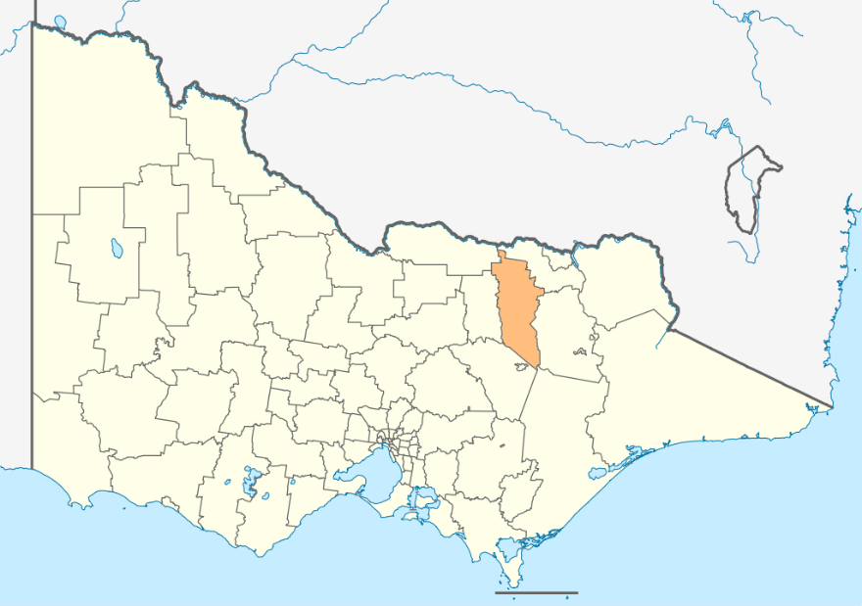

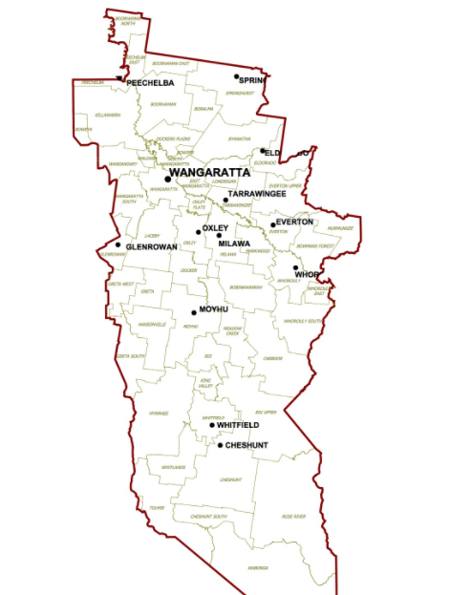

Ovens River Basin Map with River Gauges

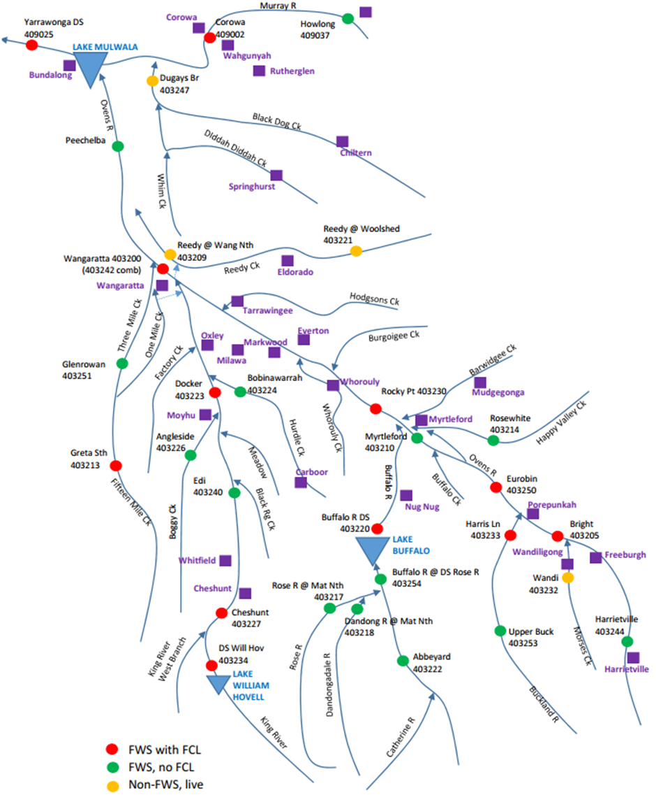
Existing 1% AEP flood extent from Victorian Flood Database for the Ovens & King Rivers & 15 Mile Creek systems

1% AEP Flood Depth Wangaratta Urban Waterways Flood
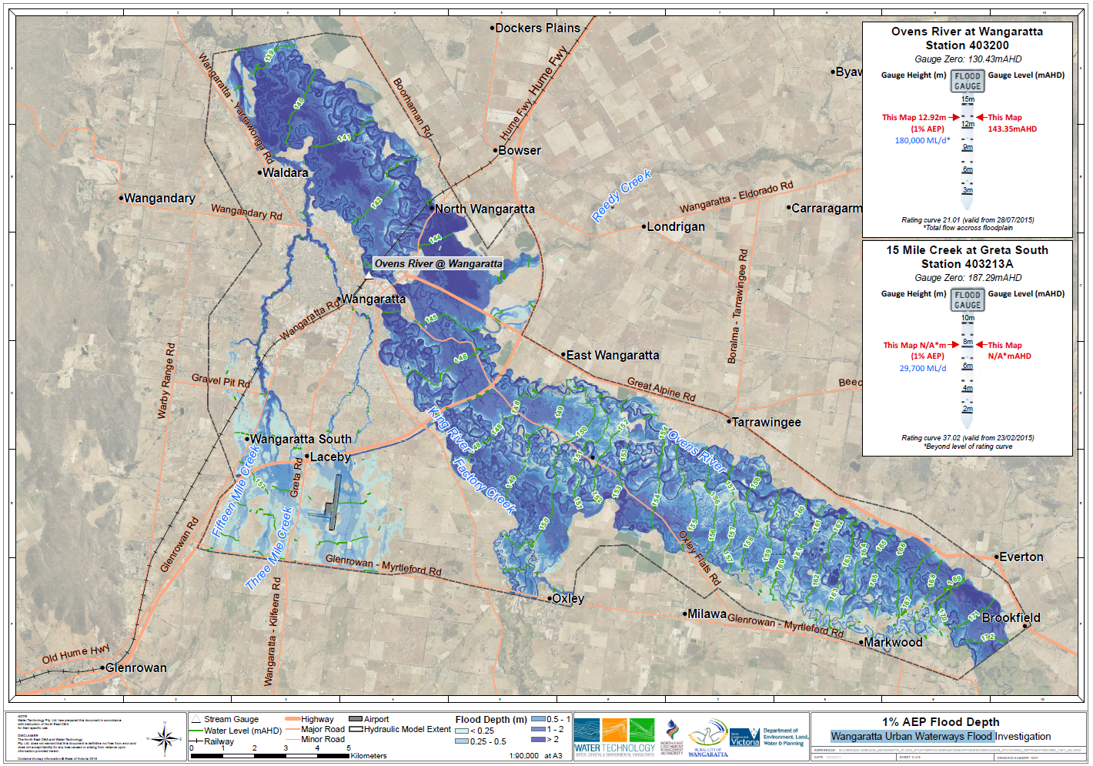

1% AEP Inundation Map – Wangaratta Township
Ovens River at Wangaratta & 15 Mile Creek at Greta South Gauges both at 1% AEP

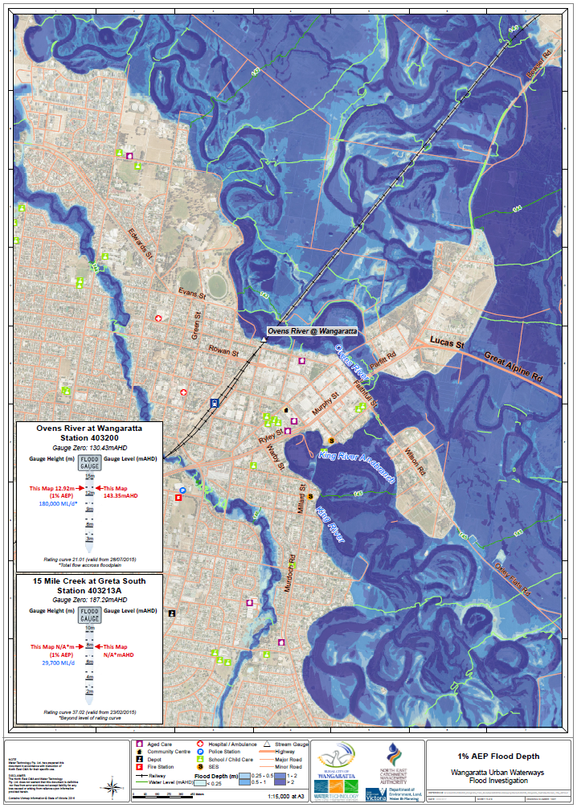
1% AEP Inundation Map – Wangaratta Township and aerodrome
Ovens River at Wangaratta & 15 Mile Creek at Greta South Gauges both at 1% AEP
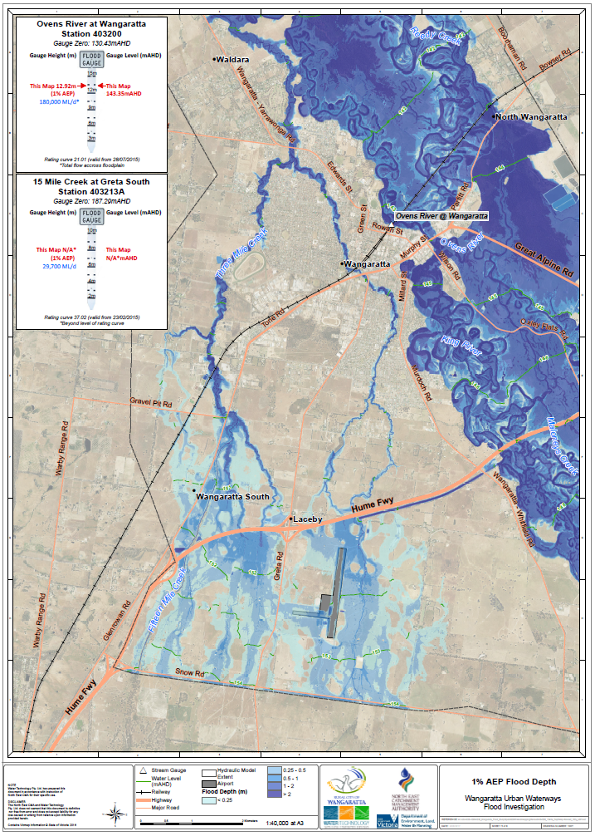
The full range of design flood extents overlaid in central Wangaratta
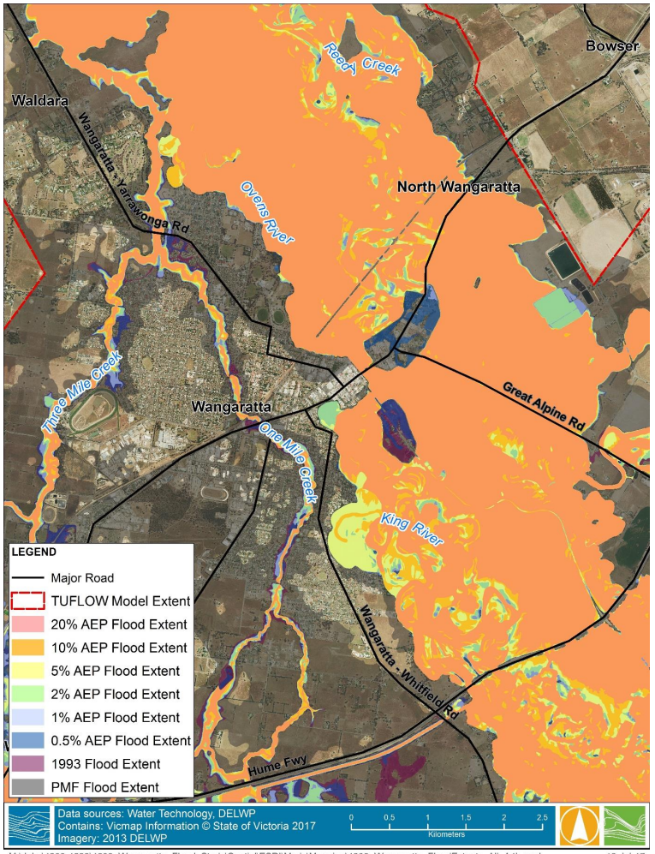

Parfitt & Wilson Road levees at 1% AEP Flood extent
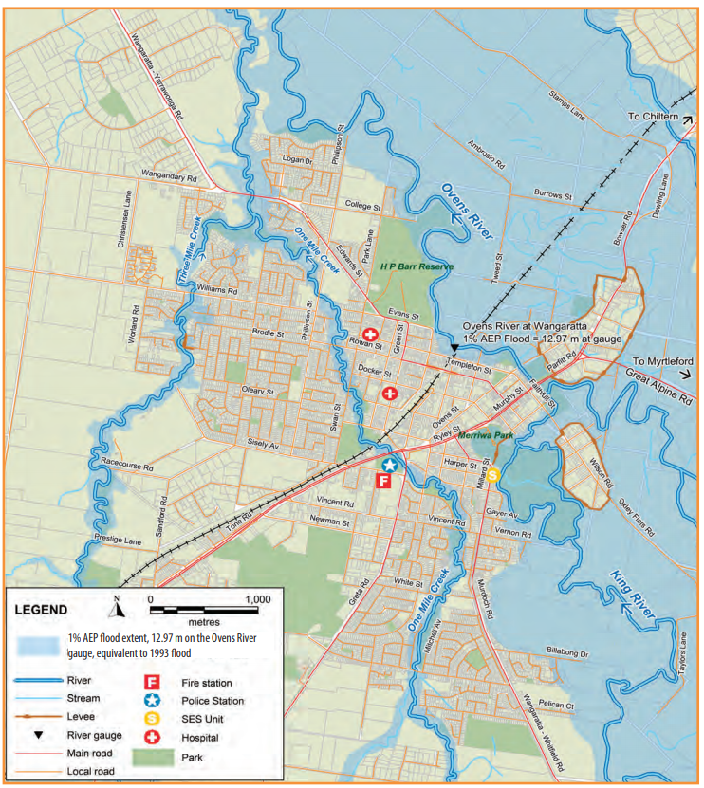

Wangaratta Flood Study 2017 Floor Level impacts by location – Wangaratta Township
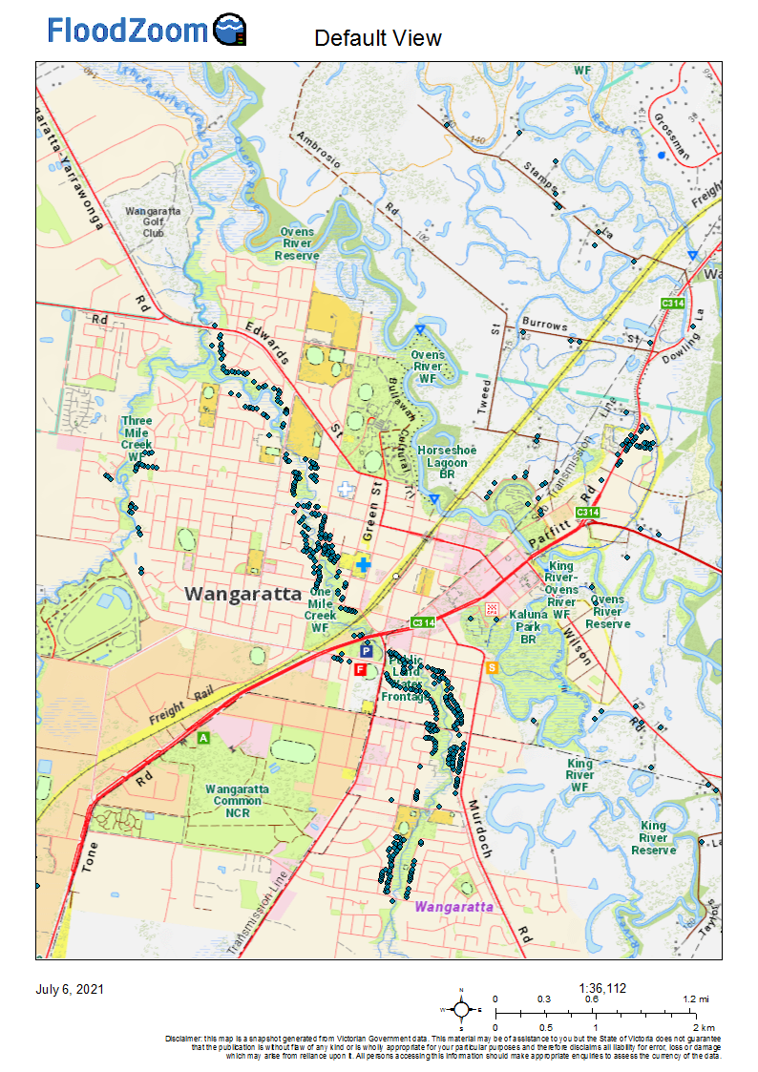
Wangaratta Flood Study 2017 Floor Level impacts by Location – Wangaratta, Greta and Oxley
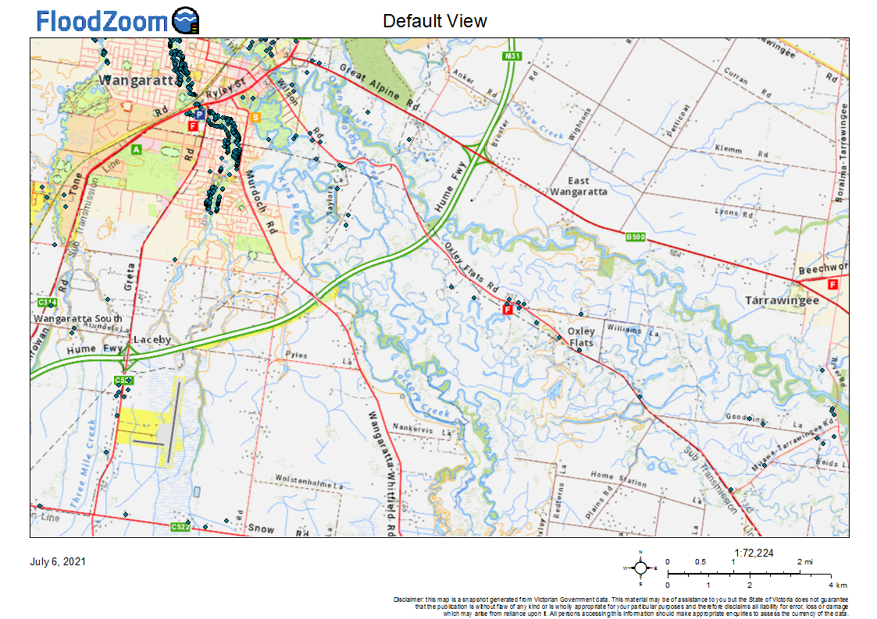
Wangaratta Flood Study 2017 Floor Level by location – Oxley Flats, Milawa, Markwood
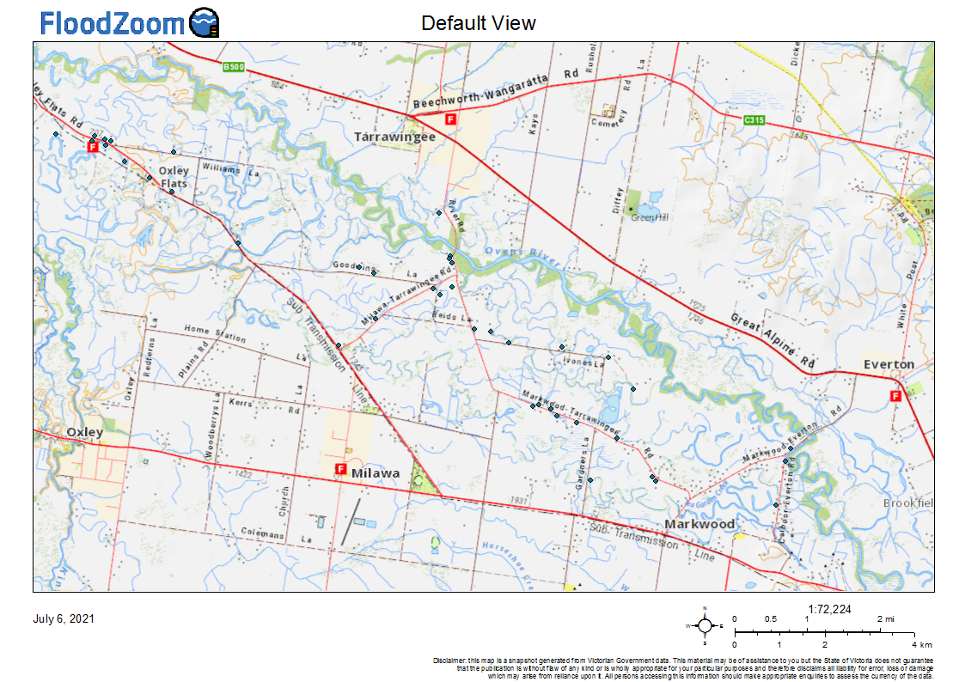

Appendix G: Local knowledge arrangements
As control agency for flood in Victoria, VICSES is committed to ensuring the incorporation of local knowledge in decision making before, during and after incidents.

Snap Send Solve

The gathering of local flood intelligence during an event is varied and inefficient. It creates a frustrating and difficult environment for intelligence teams in an Incident Management Team (IMT) to sift through relevant information. VICSES has teamed up with Snap Send Solve to pilot a flood observation App and Portal.
Snap Send Solve is an existing app currently used by the community to notify local councils and other authorities of issues that need addressing such as cracked pavements, parking problems, dumped rubbish, graffiti etc.
The existing functionality of the smartphone app has been adapted for VICSES in a well presented and user-friendly way. The app is used to capture flood observations by filling in a simple form on a smartphone and using the camera to upload photos, this information is then displayed through an administration portal to collate and view the flood data .
The app component will be made available to trusted flood observers in the community, and their observations will be visible EMCOP where Intelligence personnel in Incident Management Teams can access them during flood events. The intent is that better access to local knowledge will add to information sources in order to maximise public information communications and flood response efforts.
Trusted flood observers include both internal and external stakeholders (community members, ESOs eg CFA/VICPOL) who can be activated and deployed by the VICSES RDO to use the app during a flood event and to report on valuable flood information with a level of accuracy.
The portal has been successfully integrated with EMCOP, both platforms are available to use in an IMT. The Snap Send Solve logo also appears within the intelligence section on the EM-COP desktop for easy access to the portal.

Appendix H: Local flood & Storm information

Local Flood Guides
Communities can use local flood guides to identify and better understand their local flood risk. They include information about flood history, how to prepare & respond to floods and who to contact.
The Rural City of Wangaratta Local Flood Guide (LFG) can be found on the VICSES website by visiting the ‘Your Local Flood information’ section or by visiting the link below:
https://www.ses.vic.gov.au/documents/8655930/9320202/VICSES+Local+Flood+Guide_Wangaratta_29.01.18.pdf/55174a8c-0fb8-dccb-5732-416b316e2916?t=1620860566023
LFG’s currently under development (2021-): King Valley, Whorouly/Milawa/Oxley.

How to use Sandbags to protect your home
There are a number of things that you can do to make sure you and your property stay safe during flooding.
Sandbags will not stop the water completely but can reduce the amount of water entering your home. During low-level flooding, sandbags placed in the right locations around your home can reduce the impact of flooding.
Further information on Sandbagging can be found on the VICSES website by visiting the ‘How to use sandbags to protect your home’ section or by visiting the links below:

VICSES sandbag quick reference guide
https://www.ses.vic.gov.au/documents/8655930/8700895/sandbagging+guide.pdf/c1e56ac5-198f-ae1e-8507-70d8e896afba?t=1621231534359

Sandbagging demonstration video
https://www.youtube.com/watch?v=-_T--I3b-34&t=1s

Storms – Plan and stay safe

There are a number of things that you can do to make sure you and your property stay safe during storms. For information on how to plan to be safe during a storm, what to do during a storm, and recovery after a storm visit the VICSES website on the link below for more information
https://www.ses.vic.gov.au/plan-and-stay-safe/emergencies/storm

Appendix I: Victoria State Emergency Service Statewide Guideline – Sandbags

Introduction

The Victoria State Emergency Service (VICSES) is the control agency for flood emergencies. VICSES’ responsibilities include the management of the statewide procurement and storage of sandbags for flood emergencies. This includes providing sandbags to local areas for distribution based on the requirements identified in the Municipal Flood and Storm Emergency Plan (MFSEP).

The final report of the 2010/2011 Victorian Flood Review observed that during the floods there was inadequate access to sandbags and a lack of knowledge about the filling and use of sandbags. VICSES also noted similar problems during the 2012 North East floods.

Prior to the development of this guideline, sandbag management was not regulated and there was no formal arrangement in place to define the roles and responsibilities for funding the procurement, storage, use and distribution of sandbags.

VICSES, in conjunction with Municipal Association of Victoria (MAV) and local councils, has developed this guideline to assist emergency managers and the community to plan for effective use of sandbags during flood emergencies.

Emergency managers are guided by the state strategic control priorities for flood emergencies. Incident Controllers will apply the strategic control priorities when considering the supply and distribution of sandbags to the community in preparation for and during flood emergencies (Refer to Section 8).

Purpose

The guideline will assist in ensuring that a consistent approach to the procurement, storage, distribution, safe use and disposal of sandbags is applied at a state level. Further, it is intended to assist in the development of regional and local sandbag guidelines and agreements.

Use of sandbags for flood emergencies

Sandbags can be used to block doorways, drains and other openings into properties as well as to weigh down manhole covers, garden furniture and to block sinks, toilets and bath drains to prevent water backing up. They have proven to be successful in keeping water out for short periods of time.

Sandbagging is not always the most effective option and should be considered in the context of a Flood Emergency Plan which includes alternatives for managing flood risk. Other alternatives include moving possessions to higher places, securing objects so they do not float away and placing valuables in water tight containers. The Incident Controller and operational staff in the flood affected community will assess the overall risk to communities and allocate sandbag resources based on risk. Sandbags have also been used as temporary levees through the construction of sandbag walls.

This guideline does not address the use of sandbags in the construction of temporary levees.

Partnership arrangements

The success of this guideline is dependent on establishing strong partnerships at the regional and local level between local councils, CFA, MFB and DEPI to support the sandbag management arrangements. Local councils have a key role to assist VICSES through the flood emergency planning process and their ability to support operations. Operational arrangements for the procurement, storage and distribution of sandbags at the local and regional level will be included as an appendix in the MFSEP, VICSES is responsible for leading the development of the MFSEP.

Responsibilities

VICSES responsibilities include:

- The management of the state-wide procurement and storage of sandbags for flood emergencies
- Providing sandbags to local areas for distribution based on requirements identified in the MFEP
- Identifying distribution arrangements in the MFEP
- Community education and awareness on sandbag management and safe use
- Identifying Critical Infrastructure and Community Critical Facilities in the MFEP
- Providing a support role in flood recovery.

Council responsibilities include:
- Supporting VICSES in developing the MFSEP
- Providing a support role during flood response
- Identifying Community Critical Facilities at a municipal level
- Procuring sandbags to protect council owned facilities including Community Critical Facilities managed by council
- Providing locations, plant and equipment, where available and capable, to support sandbagging operations as agreed in the MFSEP
- Coordinating the clean-up and community recovery arrangements (refer to Section 9)

Community Critical Facility owners’ responsibilities include:
- Working with VICSES to develop an effective flood mitigation plan for their property as part of the MFEP with a priority for permanent structures.

Other ‘Response’ agencies responsibilities include:
- Supporting VICSES in their response role.

Residential and commercial property owners’ responsibilities include:
- Understanding their own flood risk
- Preparing an emergency plan for their home or business
- Procurement and storage of sandbags to protect their own property
- Filling and movement of sandbags for to protect their property
- Following advice from their local council regarding the removal of sandbags from their property, as part of the community recovery.

Community and business education about sandbags

VICSES has an established community education program to support community and business in responding to flood emergencies. See Flood - Plan and stay safe https://www.ses.vic.gov.au/plan-and-stay-safe/emergencies/flood

VICSES will use the existing community education tools and programs (such as the Local Flood Guides and the Flood - Plan and stay safe program to promote:
- Practical information on:
  - The purpose, use and disposal of sandbags (see www.ses.vic.gov.au/prepare/floodsafe/ floodsafe-resources/sandbag-referenceguide )
  - Obtaining sandbags
  - Safety considerations e.g. OHS, manual handling, safe use and disposal
  - Alternative flood mitigation strategies to sandbagging
  - Where to get information – Phone 1300 842 737 for the VICSES Information Line.

- The responsibilities of critical infrastructure owners, businesses and private individuals to understand their flood risk and develop a flood plan
- Key messages
  - Emergency response agencies will not always have the capacity to provide sandbags due to other competing priorities
  - Businesses and individuals need to understand the flood risk to their property and, where appropriate, develop a Flood Emergency Plan
  - Sandbagging is only one way of protecting properties against floodwater and not always the most effective option. Sandbagging should be considered in the context of a Flood Emergency Plan which considers alternatives for managing flood risk

Procurement of sandbags

VICSES will maintain a supply of sandbags to support the effective readiness and response to flood emergencies as identified in MFSEPs.

The number of sandbags required at a State and regional level will be determined from information provided through the MFEP planning process. There may be occasions where the supply of sandbags is limited and priorities for distribution will need to be determined through local emergency management arrangements.

VICSES will maintain the current cross-border and mutual aid arrangements for flood emergencies. VICSES will also work with local councils to access the resource sharing arrangements established between councils during emergencies

Storage of sandbags

Sandbags will be stored by VICSES in appropriate locations across Victoria. Through the application of risk-based assessments, VICSES will work with councils to identify the quantities of sandbags required. This process will be aligned to the MFSEP review cycle. Sandbags will normally be located in a VICSES facility.

Arrangements to store sandbags in other facilities will be identified as part of the local MFSEP planning process. VICSES will monitor the condition of all its sandbags for deterioration

Distribution of sandbags

Priorities for sandbags during flood emergencies

The Incident Controller may make sandbags and sand available for flood mitigation activities during declared flood emergencies.

Sandbags will be issued consistent with the Strategic Control Priorities within the State Flood Emergency Plan, in the following order of priority to protect:

- Critical Infrastructure and Community Critical facilities identified:
  - In the MFSEP or
  - By the Incident Management Team
- Residential properties identified in the potential flood area
- Commercial properties identified in the potential flood area
- Environmental and conservation areas identified in the potential flood area.

Properties identified as being outside the potential flood area, will be referred to an alternative source of sandbags (e.g. local hardware store or sandbag supplier) by VICSES.

Distribution points

In preparation for a significant flood emergency, VICSES will work with local councils and other agencies to identify appropriate locations for sandbag collection points. Location considerations will include access, safety, human resources and machinery requirements. These locations and local arrangements will be identified in the MFSEP.

The Floodsafe Sandbag Quick Reference Guide (see www.ses.vic.gov.au/prepare/floodsafe/floodsaferesources/sandbag-reference-guide ) provides details to community members about the indicative number of sandbags required for residential property protection and guidance on the safe use, for the filling and laying of sandbags.

As part of the response arrangements, the Incident Controller will track the distribution of sandbags through the Incident Management Team (IMT). This information will be provided to the recovery team as part of the transition from response to recovery

Provision of sand

VICSES will have plans in place to acquire sand through its own supply arrangements and where necessary through the emergency management arrangements. These arrangements will be identified in the MFSEP. Sand suppliers may be identified in the MFSEP.

Disposal and relocation of used sandbags

Sandbags may be contaminated after use and local councils should ensure that clean up and disposal is considered as part of recovery. Removal and disposal of sandbags used for flood mitigation shall be dealt with under the clean up and community recovery arrangements as outlined in the Emergency Management Manual Victoria. The disposal of sandbags is a shared responsibility between different agencies.

Incident Controllers will provide information on sandbag locations to councils, to assist with clean-up. VICSES will continue to work with relevant agencies to develop protocols for the safe and environmentally responsible disposal of sandbags

Transitioning to this guideline

Successful implementation of this guideline may take several years and progress will be reviewed periodically. VICSES will introduce a process for including the local area arrangements for sandbag management in the MFSEP. This process will then be rolled out as each MFSEP is reviewed.

Flood Education Links

Flood - Plan and stay safe https://www.ses.vic.gov.au/plan-and-stay-safe/emergencies/flood

VICSES guidelines on the safe use, for filling and laying of sandbags: www.ses.vic.gov.au/prepare/ floodsafe/floodsafe-resources/sandbagreference-guide

Further Information

Contact:

Victoria State Emergency Service
Victorian Head Office
168 Sturt Street, Southbank, Victoria 3006

Telephone: (03) 9256 9000
Email: vicses@ses.vic.gov.au

